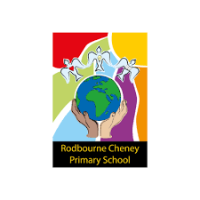

**History Intent, Implementation and Impact Statement**



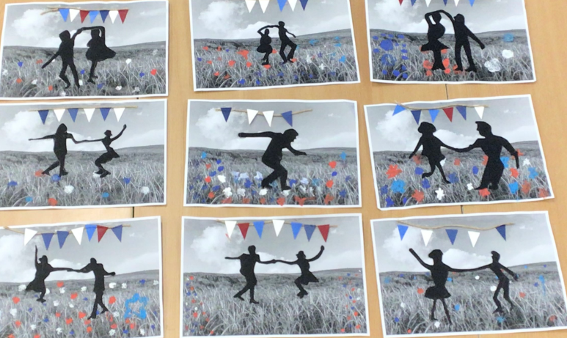

Key areas for development:

* To ensure consistent vocabulary definitions are used across the school for key historical vocabulary.
* To develop a skills based assessment to help inform teachers planning and skills coverage for their next history topics.

Impact: What are the outcomes and strengths?

Learners are able to:

* Use creativity and imagination through sensory experiences and personal expression.
* Use music as a way of understanding and responding to the world.
* Understand music is a way of communicating ideas, feelings and meanings.
* Make thoughtful judgements about life and life in different times and cultures.
* Shape the environment and making a positive impact.
* Enjoy the enrichment of our lives through music.

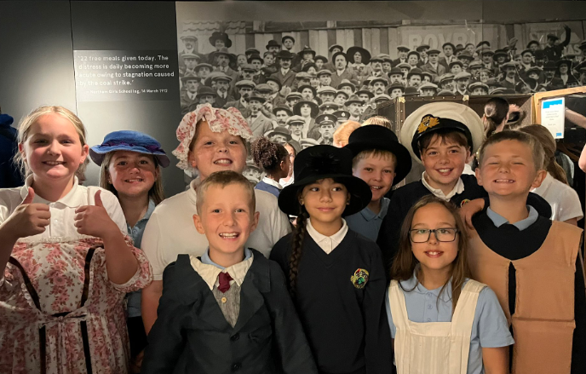

Implementation: How do we do it at Rodbourne Cheney?

* A stepped progression that will build on and consolidate prior knowledge and skills, staring in EYFS into KS1 and KS2.
* Cross curricular links to the wider Rodbourne Cheney Primary curriculum, providing opportunity to re-visit and expand on prior learning, facilitating greater knowledge and skills retention.
* Planning for each block and year group, which identify hooks, vocabulary, prior learning, learning objectives, skills and knowledge to be incorporated into each unit of work.
* Knowledge Organisers for each block of work and year group, which identify key vocabulary, target embedded ‘sticky’ knowledge. These will be used by teachers and students throughout the units of work, and will also be shared with parents.
* Children are given opportunities, where possible, to study artefacts leading to enquiry, investigation, analysis, interpretation, evaluation and presentation.
* We plan for effective use of educational visits and visitors, to enrich and enhance the pupil’s learning experience and the History curriculum.
* Teachers will use effective Assessment for Learning strategies within their teaching to ensure misconceptions are highlighted and addressed. The use of KWL grids and children creating their own individualised double page spread knowledge organiser will support with the assessment of children’s understanding of their unit of work.

Intent: What do we want children to learn?

We aim to make all children aware of the actions of important people in history and enable children to know about significant events in British history, whilst appreciating how things have changed over time. History will also ensure our children understand how Britain developed as a society, contributing to their understanding of their country of residence. Furthermore, our children will learn about aspects of local, British and Ancient history.

This wider awareness leads to the children having some knowledge of historical development in the wider world. We believe that by allowing the children to understand the importance and enjoyment of History through different opportunities, they will become enthused learners in History. In History at our school, we will also give children opportunities to develop their skills of enquiry, investigation and analysis.