

Example of working walls.

Creating quarters using real life objects.

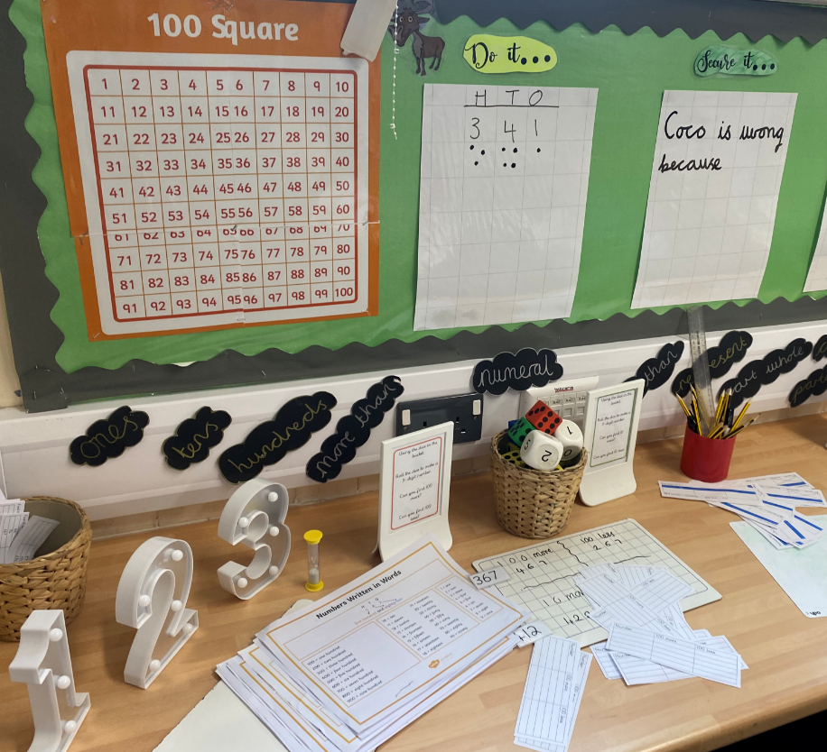

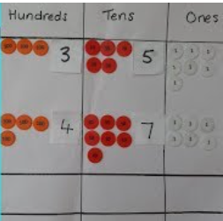

**Key areas for development:**

* KS1 to master number knowledge including number facts and counting.
* KS2 to master multiplicative bonds to enhance positive problem solving.
* Whole School to secure strategies and models which enable confident problem solving.

**Impact: What are the outcomes and strengths?**

* Children who feel like they can be successful in mathematics and able to express positive attitudes to mathematics when given the opportunity to express theirs views of their learning (pupil voice).
* Children developing conceptual understanding of the mathematics they are learning through their experiences in maths lessons and the links to real life maths that enable them to make connections.
* Children are able to explain their mathematical thinking using appropriate mathematical language and representations which is demonstrated within the lessons as well as through the recording of learning

and their ability to apply learning during informal and formal assessments.

* Equitable provision to meet the needs of individuals and groups within each setting through carefully planned lessons and adaptive teaching.

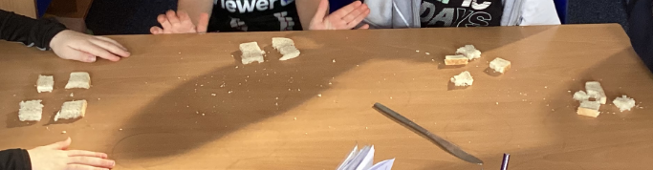

**Mathematics Intent, Implementation and Impact Statement**

**Implementation: How do we do it at Rodbourne?**

Mathematics is an important part of the curriculum we deliver at Rodbourne Cheney Primary school. Through carefully planned and sequenced whole class teaching, adult-led activities and independent tasks, the children are able to follow a clear mathematical journey through the learning.

New learning is taught through the daily maths lessons. We ensure the ability to further practicing, consolidation and revisiting of prior learning through daily ‘Maths on Track’ sessions. Counting, mastering number and multiplicative facts are also prioritised as independent, number fluency sessions. Prioirtising oracy and key vocabulary use through all maths sessions link to our school’s golden threads.

**Intent: What do we want children to learn?**

To achieve our golden threads of being confident learners and active problem solvers we aim for the children to:

* Enjoy learning mathematics and develop a ‘can do’ attitude and belief in their mathematical ability which enables them to persevere with all aspects of mathematics.
* Understand how mathematics relates to real life, everyday experiences through ensuring that they see examples of mathematics in everyday life.
* Become fluent in the fundamentals of mathematics so that they develop secure and deep understanding of mathematical concepts which they can rapidly recall and apply.
* Solving problems by applying their mathematical knowledge to a range of problems from a variety of contexts.
* Use mathematical reasoning and vocabulary to develop knowledge so that they can rationalise, justify or prove their understanding.