India
Key Vocabulary
Population | The number of people living there.
Landmarks | Important objects or features of the landscape.
Climate | What weather is like over a long period of time.
Compass | A tool for finding the right direction.
Capital City | A major city where the country’s government is located.
Culture | The ‘way of life’ of a country or group of people, e.g. traditions, dress, language, religion.
Human Feature | Something made by people.
Physical Feature | Something made by nature.
Woodland | A place filled with bushes, trees and leaves in a colder place.
Jungle | A place filled with bushes and trees in a hotter place.
Continent | A large, solid area of land made up of different countries.
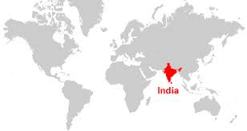
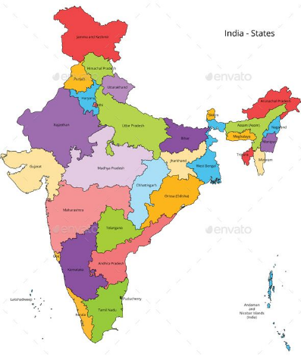
Year Two Knowledge Organiser
Key Facts:
- India is located in the continent of Asia.
- It is the seventh-largest, and the second most populated country in the world.
- Its capital city is New Delhi.
- India has a population of 1.2 billion people.
- The two official languages of India are Hindi and English.
- The main currency in India is Rupee.
- India has a President and a Prime Minister.
The Himalayan Mountains (physical) | The Himalayan Mountain is 7,200m above sea level. It is the highest mountain range in the world.
Taj Mahal (human) | It is one of the new Seven Wonders of the World. It is made out of white marble.
River Ganges (physical) | The river flows through Northern India. It is the third largest river in the world, being 2704km long.
Lotus Temple (human) | It is a house of worship, and it’s called the Lotus Temple because it looks like a lotus flower.

