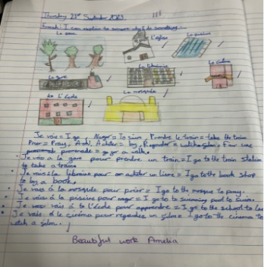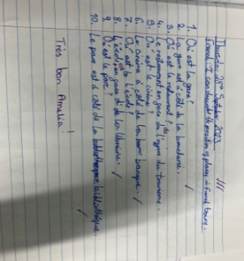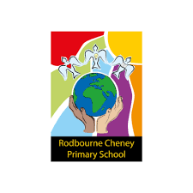

**Key area/s for development:**

To continue with the implementation of an assessment framework to ensure all children are reaching their full potential in Languages. Teachers to use this assessment to support their next teaching cycle. Subject co-ordinator to use analysis of the data to show areas of development. Assessements to be completed in Term 1, 3 and 5.

Subject co-ordinator to monitor and evaluate the MTP and planning for Languages to ensure it is clearly sequenced and quality learning is evident by completing a planning audit. Subject co-ordinator to use this to develop the planning format for Langauges if necessary.

As a result of clearly sequenced and planned lessons, children will have evidence of quality language learning in their books. This will take the form of pictures with annotations, WOW moments, written activities.

Photo/s

**Impact: What are the outcomes and strengths?**

As a result of clearly sequenced lessons using the scheme, pupils will be able to speak confidently about their learning in Languages. This was evident in a pupil voice that was carried out in 2023-2024 academic year. Staff became more confident in their language teaching last year after we employed a Secondary Languages teacher from Wroughton to support in the teaching and learning of languages. In the last academic year staff took on the teaching of Languages, which has been a positive step in the CPD of all staff. Staff were able to improve their French knowledge which they can use in their French teaching this year.

* 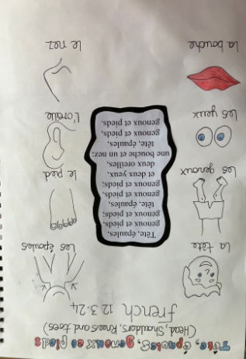t an assessment framework to ensure all children are reaching their full potential in Languages.
* As a result of cl early sequenced and planned lessons, children will have evidence of quality language learning in their books. This will take the form of pictures with annotations, WOW moments, written activities.

**French Intent, Implementation and Impact Statement**

**Implementation: How do we do it at Rodbourne?**

At Rodbourne Cheney we want to ensure that our pupils develop the skills and confidence to consider themselves as ‘World Citizens’ who belong in a multicultural, mutually respectful world. We aim to support students to understand other countries and cultures so that they can be more open and adaptable to new experiences; ensuring that each topic contains an element of cultural reference. We are committed to developing strong, lifelong linguistic skills and to encourage pupils to become curious and interested in the world.  We want our pupils to have a love of languages, and aim to achieve this by nurturing a linguistic curiosity and an intrinsic motivation to explore and respect other cultures and people. To begin their language learning, we use some incidental French within the classroom in Key Stage 1 to ignite their curiosity, expose children to Language learning and make sure they have a positive start to Language learning in Year 3. From Year 3 to Year 6 we teach French weekly. We believe this will give the children a fantastic base to start their KS3 and Secondary School Language career on if they are positive and enthusiastic about language learning in KS2.

**Intent: What do we want children to learn?**

At Rodbourne Cheney Primary School we aim to give the children in our care as wide a range of opportunities and experience as possible. We acknowledge the influence that Europe has on our lives and as the UK is becoming an increasingly multi-cultural society, we have a duty to provide our children with an understanding of other cultures and languages.

We believe that learning a language enriches the curriculum, providing excitement, enjoyment and challenge for children and teachers, helping to create enthusiastic learners and to develop positive attributes to language learning throughout life. The skills, knowledge and understanding gained make a major contribution to the oracy and literacy and their understanding of their own culture and those of others. Language also lies at the heart of ideas about individual identity and community, and learning another language can do a great deal to shape children’s ideas in this critical area as well as giving them a new perspective on their own language.

It is widely believed that the early acquisition of a foreign language facilitiates the learning of other foreign languages later in life. At Rodbourne Cheney Primary School, we believe that the earlier a child is exposed to a foreign language the faster the language in question is acquired. Therefore, we use incidental language learning in Key Stage 1 as well as weekly language lessons in Key Stage 2.