Class Newsletter: Year 3 Penguins
Date: Monday 30th October 2023

Dear Parents and Children,
Welcome back to Term 2!
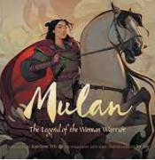
This term our topic is ‘How do we live around the World?’. We will continue with our book-based curriculum. We will be reading:
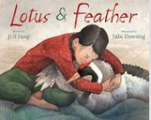

Here are some book recommendations to help with learning at school this term:
China
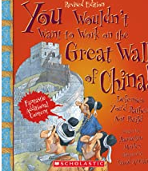
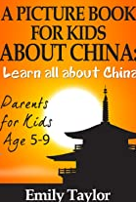
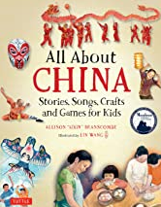

Maths Learning
In Maths term we will continue to look at the properties of 2D shapes. We will also look at the 3, 4 and 8 times tables. We will be using our times tables knowledge to work out the inverse for division facts. We will also begin to look at addition and subtraction with 3-digit number.
English Learning
In English this term we will be reading ‘Mulan and Lotus and Feather’. We will be retelling the story of Mulan and writing a set of instruction on how to make an Origami Crane.. We will be focusing on questions, paragraphs and subordinate clauses. For our Christmas topic we will be reading ‘Velveteen Rabbit’ and we will be retelling the story in English.
Values
This term we will be focusing on the values, Equality and Hope and this will continue to link into our whole school Values ethos and our 3 school rules. These are; Be safe, be kind, be respectful. We will use on these rules to enable us to keep safe around school, with our peers and the adults around the school.
Reading Books and Home Learning
Home Learning, will continue in Term 2 and it will be set each Monday, to be handed in and marked on the Friday. It will be based on prior learning and used as a way of consolidating what the children have already been taught, including weekly spellings and should practice their times tables at home. It remains our expectation that the children read regularly at home and record what they read in their Reading Records; thank you again for your support with this. Please see the end of the letter for some recommended reads for Year 3 children.
The children will now also have their login for Purple Mash and TT Rockstars to complete at home.

PE

Our PE days are on Monday and Wednesday your child can come to school in their PE kit. Their PE kit must include blue or black shorts or trousers, a white or sports PE top and trainers. Please make sure trousers and a jumper are worn in the winter months.

School uniform
It is important that our children come to school in correct school uniform.
Blue jumper
White or blue polo shirt
Black or grey shorts
Black or grey skirt
Blue summer dress
Children are able to wear all black footwear.

Warm regards,
Miss Barham

Year 3 and 4 Book recommendations:
