Pre-School Medium Term Plan – Autumn Term 1
Term 1 (8 weeks) Pre-School
Book Immersion Focus: Goldilocks and the Three Bears;
Nursery Rhyme Immersion Focus: Pre-school- Twinkle, Twinkle, Little Star and Jack and Jill
Additional Focus: Book baskets- All about me, Diversity, Autumn, Harvest, Diwali
 | Book, Rhyme and Oracy  Immersion Focus | Nursery Rhyme  Immersion | Additional books to support | Additional songs and rhymes to support
Week 1 and 2 | Twinkle, Twinkle Little Star  Jack and Jill | Twinkle, Twinkle, Little Star and Jack and Jill | How to Catch a Star  Shine like Stars  Draw Me a Star  I Wonder Why Stars Twinkle  Mae Among the Stars  Can You See the Stars at Night?  My Pet Star | Star Light, Star Bright  5 Little Stars and the Moon, Too  Now the Day is Over
 | Enhancements (See weekly plans for more details) : Twinkle Twinkle  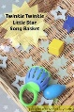  ￼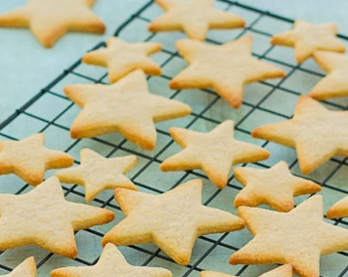 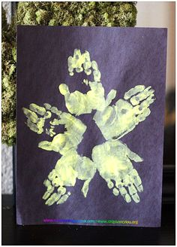 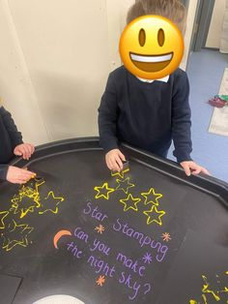 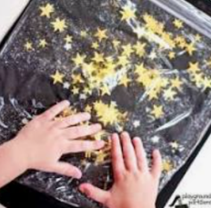  Twinkle, Twinkle  -star printing; handprints/cutters  -star sensory bags  -galaxy playdough  Twinkle twinkle little star- rhyme basket  - Star biscuits  - Wax resist artwork |  | Enhancements (See Weekly plans for more details) Jack and Jill  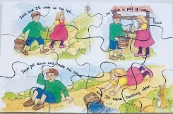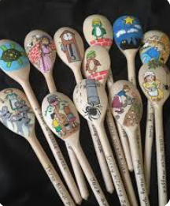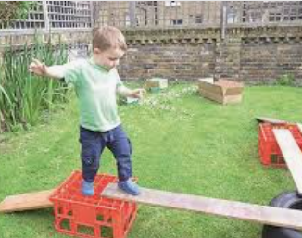  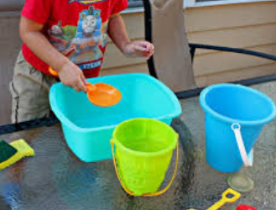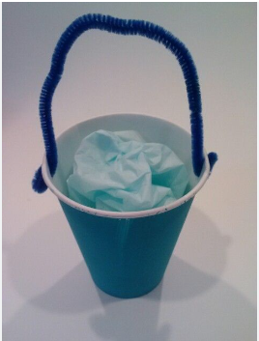  Jack and Jill  - Jigsaws  - Water play- buckets of water  - Puppets  - Story spoons  - Making buckets in craft area  - Creating hills / obstacle course
 | Book, Rhyme and Oracy  Immersion Focus | Nursery Rhyme  Immersion | Additional books to support | Additional songs and rhymes to support
Week 3 and 4 | Goldilocks and the Three Bears | Twinkle, Twinkle, Little Star and Jack and J ill | Where is Mr Bear?  Eat Your Greens Goldilocks  Goldilocks and Just One Bear  Big Bear, Little Bear  I Might be Little  Baby bear’s Chair | When Goldilocks Went to the House of the Bears  Poor Little Baby Bear
Enhancements (See weekly plans for more details)
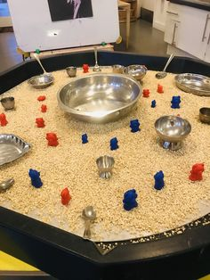
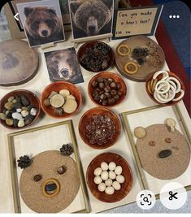
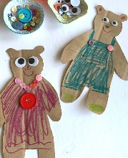
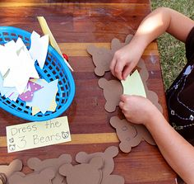
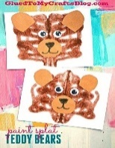
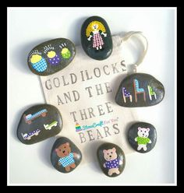
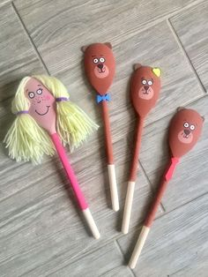
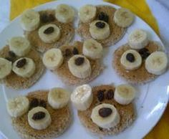

- Sorting hard/ soft items
- Sorting big/ small items
- Oats and spoons in sensory bins
- Story stones/spoons
- Puzzles
- Make porridge
- Make a game
 | Book, Rhyme and Oracy  Immersion Focus | Nursery Rhyme  Immersion | Additional books to support | Additional songs and rhymes to support
Week 5 and 6 | We Are Going on a Bear Hunt | Twinkle, Twinkle, Little Star and Jack and Jill | The Everywhere Bear  There’s a Bear in my Book  Where’s my Teddy / My friend bear/ It’s a bear (trilogy) | We’re going on a Bear Hunt- Michael Rosen  The Bear Went Over the Mountain
Enhancements (See weekly plans for more details)
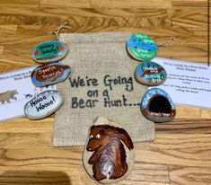
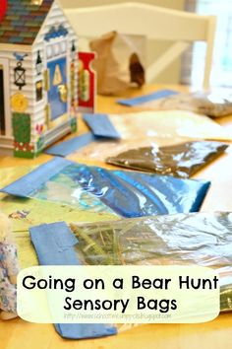
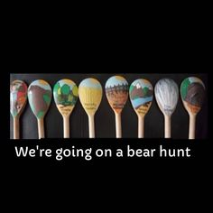
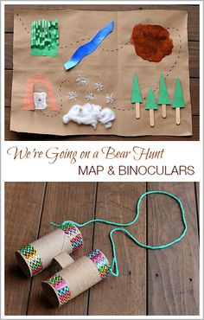

- Book props
- Sensory obstacle course
- Local walks
- Building caves
- Outdoor area- children can enact the story outside using loose parts
 | Book, Rhyme and Oracy  Immersion Focus | Nursery Rhyme  Immersion | Additional books to support | Additional songs and rhymes to support
Week 7 and 8 | Brown Bear, Brown Bear.  Autumn themed books | Twinkle, Twinkle, Little Star and Jack and Jill | Fletcher and the Falling Leaves  The Leaf Thief  After the Storm | Autumn Leaves are falling down  Five Little Leaves  Five Shiny Conkers  Dingle, Dangle Scarecrow
 | Enhancements (See weekly plans for more details)  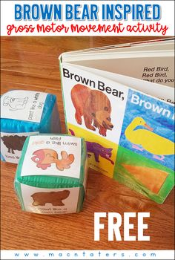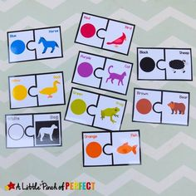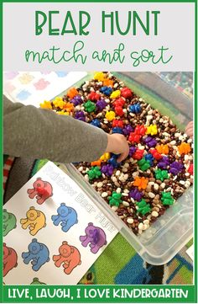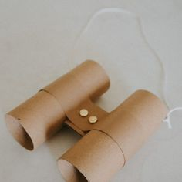  - Animals from the book – children can then sequence and match  - Fabrics of the colours from the animals  - Go on a walk and see what you can see – eg child’s name what do you see....I can see a green leaf etc Sequence  - Making binoculars’  - Roll an animal  - Colour sorting |  | Enhancements (See weekly plans for more details)  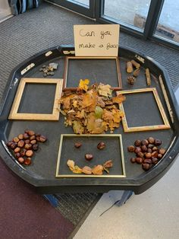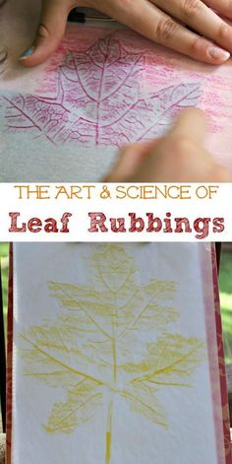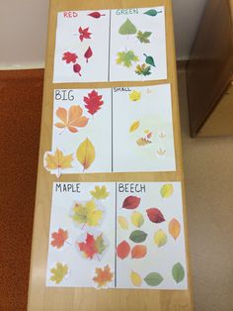  - Leaf rubbings  - Sorting objects summer/autumn  - Making faces using natural resources collected on nature walks

