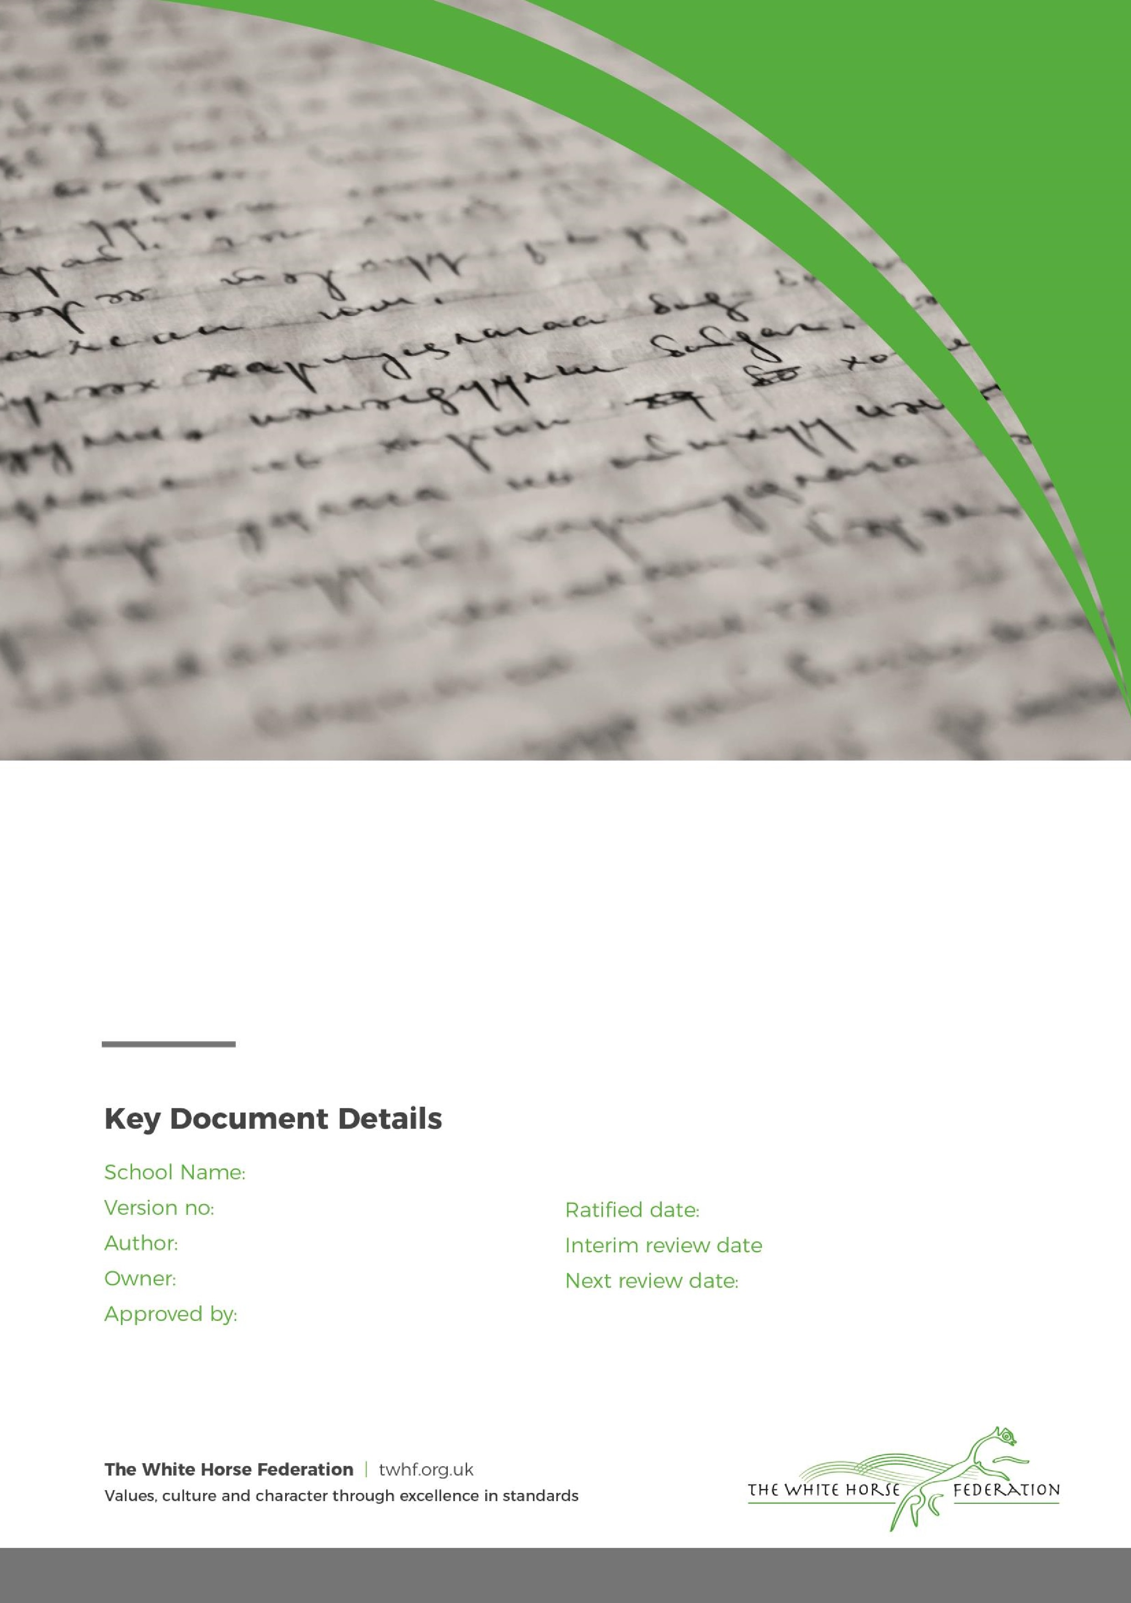

PSHE Policy

1

Elaine Murphy

Elaine Murphy

September 2024

n/a

September 2025

Rodbourne Cheney Primary School

|  |  |  |  |
| --- | --- | --- | --- |
| Key Document details: | | | |
| Author: | Sarah Harris | Approver: |  |
| Owner: | Sarah Harris | Version No.: | 1 |
| Date ratified: | September 2024 | Next review: | September 2025 |

**Introduction**

The National Curriculum has identified personal, social and health education as a dimension that permeates the whole curriculum with an important cross-curricular theme.

Taken together, personal, social and health education ‘is the entitlement of all young people and the

responsibility of all the teachers’.

At Rodbourne Cheney Primary School we recognise the importance of education for the development of the whole child. PSHE helps to give pupils the knowledge and understanding they need to lead healthy, independent lives and to become active and responsible citizens.

Section 1 of the 1988 Education Reform Act requires schools to provide a broad and balanced curriculum, which ‘promotes the spiritual, moral, cultural, mental and physical development in school and society’ and ‘prepares pupils for the opportunities, responsibilities and experiences of adult life’. In order to achieve this, PSHE is taught throughout the school, giving children the skills and knowledge that they will need in later life. It is our aim to assist parents in preparing children through the acquisition of knowledge, attitudes and skills for the challenges of maturity, to help them make informed decisions for the health and welfare of themselves and others. The school is fully committed to the Every Child Matters agenda.

**How PSHE contributes to our school aims**

• Teaching children about their rights and responsibilities using British values and Parliament sessions.

• Providing the knowledge, skills and understanding they need to lead confident, healthy independent lives.

• Providing the knowledge, skills and understanding they need to become informed, active and

responsible citizens.

• Promoting and fostering social skills, self-esteem and responsibility for their own learning.

• Supporting and promoting attitudes, practises and understanding conducive to personal and

social development, tackling many of the spiritual, moral, social and cultural issues that are part

of growing up.

• Educating and providing information about the main political and social institutions that affect their responsibilities, rights and duties as individuals and members of communities.

• Helping children to understand and respect our common human diversity and differences so that they can go on to form the effective fulfilling relationships that are an essential part of life and learning.

**The National Curriculum Framework for PSHE**

At Rodbourne Cheney Primary School, PSHE is designed to meet the needs of our pupils. In order to achieve this, we have used the National Curriculum Framework as guidance for our continual good practice and we use the Jigsaw PSHE scheme.

**Planning, Teaching and Learning**

**Foundation Stage**

We teach PSHE in the foundation classes as an integral part of the topic work covered during the year. As part of the Foundation Stage of the National Curriculum, we relate the PSHE aspects of the children’s work to the objectives set out in the Early Learning Goals (ELGs). Our teaching in PSHE matches the aim of developing a child’s personal, social and emotional development as set out in the ELGs.

**Key Stage 1 and 2**

PSHE is taught through cross-curricular links, Values education, Children’s Rights and the Jigsaw teaching resources. The Jigsaw scheme shows development through each Key Stage and ensures continuity and

progression. All planning considers catering for differing needs and abilities, multi-cultural and

gender issues and assessment and monitoring procedures. There are also opportunities for teachers to build in PSHE to any subject being taught if the need arises. We use a range of teaching and learning styles to meet the PSHE requirements of the National Curriculum.

We emphasise active learning by including the children in discussions, circle time, investigations and problem-solving activities. We encourage children to take part in a range of tasks that promote active citizenship, for example charity fundraising, the planning of special school events (such as an assembly or open evening), involvement in helping other individuals or groups less fortunate them themselves. We organise classes in such a way that pupils are able, through discussion, to set agreed classroom rules of behaviour, and resolve any conflicts. We offer children to hear visiting speakers, such as health workers, police, and local clergy, whom we invite into the school to talk about their role in creating a positive and supportive local community. We also develop PSHE through activities and whole-school events, e.g., the school council representatives from each class meet regularly to discuss school matters. We offer a residential visit in Key Stage 2, where there is a particular focus on developing pupils’ self-esteem and giving them opportunities to develop leadership and co-operative skills.

# The Learning Environment

Establishing a safe, open and positive learning environment based on trusting relationships between all members of the class, adults and children alike, is vital. To enable this, it is important that ‘ground rules’ are agreed and owned at the beginning of the year and are reinforced in every Piece – by using The Jigsaw Charter. (Ideally, teachers and children will devise their own Jigsaw Charter at the beginning of the year so that they have ownership of it.) It needs to include the aspects below:

The Jigsaw Charter

* We take turns to speak
* We use kind and positive words
* We listen to each other
* We have the right to pass
* We only use names when giving compliments or when being positive
* We respect each other’s privacy (confidentiality)

**Resources**

The Jigsaw scheme offers a range of resources to support the teaching of PSHE. In addition to this, a variety of resources are available in school including recommended books and packs linked to specific subjects. These are kept in the PSHE section within the school, and in the PSHE section on the teacher’s server.

**Equal Opportunities**

At Rodbourne Cheney Primary School, we provide an equal opportunity for learning about all areas of

the curriculum. Every child, regardless of gender, culture, religion, race or social factors, is to take an active role in PSHE. Everyone is encouraged to actively participate, to have opinions, feelings and problems listened to and responded to in a classroom that is conducive to a feeling and atmosphere of equality and the importance of everyone.

**PHSE and Inclusion**

At Rodbourne Cheney School we recognise the needs of ALL our pupils and meet their learning needs through effective differentiation. We consider the emotional, social and personal needs of our pupils and these are identified through pupil involvement in different PSHE activities. We use the context of the school and experiences in and around the school in order to effectively organise PSHE in our curriculum. We take into consideration the home backgrounds of our pupils and will consult parents or guardians if

applicable. If necessary, we will split boys and girls especially for some issues of sex education but we will provide equal opportunities for all pupils, including those with diverse cultural or ethnic needs.

**Safeguarding / Confidentiality**

Teachers need to be aware that effective PSHE may lead to disclosure of a child protection issue. Equally that it may be a very difficult and personal subject for some children.

If a disclosure was to arise, staff will follow our safeguarding procedures:

* The staff member will inform the DSL and follow the school’s child protection policy
* Ask the DSL if there are any concerns of any children when teaching PSHE
* A member of staff cannot promise confidentiality if concerns exist.

We will:

* Reassure pupils that their best interests will be maintained;
* Encourage pupils to talk to their parents/carers and provide support in this if necessary;
* Ensure that pupils are aware that teachers cannot offer unconditional confidentiality;
* Inform pupils that if other professionals need to be informed, they will be told first and supported appropriately;
* Uphold Child Protection guidelines and procedures if there is any possibility of abuse;
* Ensure that pupils are informed of sources of confidential help.

**Scheme of Work**

Jigsaw covers all areas of PSHE for the primary phase, as the table below shows:

|  |  |  |  |  |
| --- | --- | --- | --- | --- |
| **Term** | **Puzzle name** | | **Content** | |
| **Autumn 1:** | Being Me in My World | | Includes understanding my place in the class, school and global community as well as devising Learning Charters | |
| **Autumn 2:** | | | Celebrating Difference | | Includes anti‐bullying (cyber and homophobic bullying included) and diversity work |
| **Spring 1:** | | | Dreams and Goals | | Includes goal‐setting, aspirations, working together to design and organise fund‐raising events |
| **Spring 2:** | | | Healthy Me | | Includes drugs and alcohol education, self‐esteem and confidence as well as healthy lifestyle choices |
| **Summer 1:** | | | Relationships | | Includes understanding friendship, family and other relationships, conflict resolution and communication skills |
| **Summer 2:** | | | Changing Me | | Includes Sex and Relationship Education in the context of looking at change |

# Policy Review

This policy is reviewed annually.