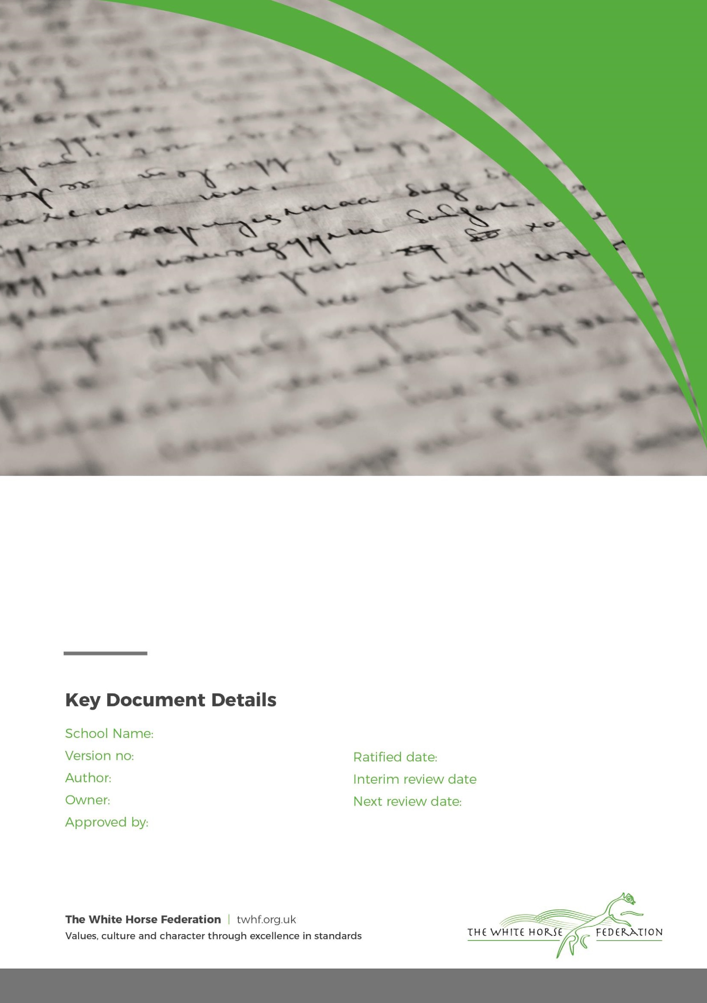

Relationships Education, Relationships and Sex Education (RSE) and Health Education Policy

1

Elaine Murphy

Elaine Murphy

September 2024

n/a

September 2025

Rodbourne Cheney Primary School

|  |  |  |  |
| --- | --- | --- | --- |
| Key Document details: | | | |
| Author: | Sarah Harris | Approver: |  |
| Owner: | Sarah Harris | Version No.: | 1 |
| Date ratified: | September 2024 | Next review: | September 2025 |

**Introduction**

In February 2019, the Department for Education (DfE) published guidance for schools on Relationships Education, Relationships and Sex Education (RSE) and Health Education. This guidance replaced the Sex and Relationship Education guidance (2000). Since September 2020, all schools are expected to teach according to this guidance.

Relationship and Health Education (RHSE) will reflect the school’s core values and aim of our school in delivering a broad, balanced and ambitious curriculum. RHSE is taught in the context of relationships, responsibilities and growth. RHSE will promote self-esteem and emotional literacy, healthy living and wellbeing, and help our children form and maintain positive and healthy relationships, based on respect for themselves and for others, at home, school, work and in the community. We aim to provide a holistic education for all children. Every pupil will receive their full entitlement to RHSE regardless of their educational ability, gender, race, disability, ethnicity or faith.

We aim to support children in their emotional, cultural and social, as well as academic development. Through our curriculum, children will learn to understand and respect our British Values; diversity and differences so that they can go on to form the effective, fulfilling relationships that are an essential part of life and learning.

**Definition**

Relationship, Health and Sex Education (RHSE) is about the emotional, social and cultural development of pupils, and involves learning about relationships, physical and mental health, healthy lifestyles, diversity and personal identity. RHSE involves a combination of sharing information, and exploring issues and values.

Relationship education in primary school is teaching the fundamental building blocks and characteristics of positive relationships, with particular reference to friendships, family relationships, and relationships with other children and with adults. This starts with pupils being taught about what a relationship is, what friendship is, what family means and who the people are who can support them. For more information on Relationships Education and to view the full DfE guidance please look at [Relationships Education, Relationships and Sex Education and Health Education guidance (publishing.service.gov.uk)](https://assets.publishing.service.gov.uk/media/62cea352e90e071e789ea9bf/Relationships_Education_RSE_and_Health_Education.pdf) and refer to pp.19-22.

**Why is RHSE in schools important?**

High quality RHSE helps create safe school communities in which pupils can grow, learn, and develop positive, healthy behaviour for life. It is essential for the following reasons: ▪Children and young people have a right to good quality education and to protection from any kind of exploitation (being taken advantage of), as set out in the United Nations Convention on the Rights of the Child.

▪Children and young people want to be prepared for the physical and emotional changes they undergo at puberty, and young people want to learn about relationships. Older pupils frequently say that sex and relationships education was ‘too little, too late and too biological’. Ofsted reinforced this in their 2013 Not Yet Good Enough report.

▪RHSE plays a vital part in meeting schools’ safeguarding obligations. Ofsted is clear that schools must have a preventative programme that enables pupils to learn about safety and risks in relationships.

▪Schools maintain a statutory obligation under the Children Act (2004) to promote their pupils’ wellbeing, and under the Education Act (1996) to prepare children and young people for the challenges, opportunities and responsibilities of adult life. A comprehensive RHSE programme can have a positive impact on pupils’ health and wellbeing and their ability to achieve and can play a crucial part in meeting these obligations.

▪The Department of Health set out its ambition for all children and young people to receive high quality RHSE in the Sexual Health Improvement Framework (2013), while the Department for Education’s paper The Importance of Teaching (2010) highlighted that ‘Children need high quality sex and relationships education so they can make wise and informed choices’.

Rodbourne Cheney Primary School wishes to provide RHSE that prepares our pupils to lead safe, fulfilling and enjoyable lives and is in accordance with DfE guidelines.

**Intent**

RHSE, as part of the children’s Personal, Social and Health Education (PSHE) curriculum, is an important part of each child’s physical, emotional and spiritual education, which is designed to equip them with the understanding, knowledge and skills they need in the real world to safely make new meaningful relationships. The children are encouraged to reflect on their learning, build upon ideas and beliefs and challenge or are challenged in regards to their views.

The core purpose of the curriculum is to provide pupils with the knowledge, understanding, attitudes, values and skills they need in order to reach their potential as individuals and within the community, enabling confident, emotionally intelligent and reflective citizens.

Our RHSE and PSHE curriculum ensures that our children develop the knowledge and understanding, skills, capabilities and attributes which they need for mental, emotional, social and physical wellbeing now and in the future.

We have developed a clear coverage and progression of skills and content in RHSE and PSHE.

**Implementation**

At Rodbourne Cheney Primary School, we choose to deliver RHSE through our PSHE curriculum using Jigsaw, the mindful approach to PSHE. The school will also use other recommended schemes where relevant that complement our approach and the policy.

RHSE is also delivered through the Science and RE curriculum. A planned and co-ordinated approach to each subject area provides an appropriate framework for the objectives of RHSE to take place.

RHSE is taught by class teachers who have received training in delivering the content to their classes. The sessions will be underpinned by the mindfulness approach and will be taught using range of teaching methods including philosophical questioning, debate, use of ICT, discussions, looking at case studies, drama and role-play.

RHSE is usually delivered in mixed gender groups, however, there may be occasions where single gender groups are more appropriate and relevant. On these occasions, parents will be communicated with and made aware.

RHSE will be taught across the school year in PSHE lessons and within elements of the Science curriculum. Curriculum coverage has been updated and reviewed in-line with the new RHSE statutory Guidance.

**Impact**

Through the PSHE Curriculum design, we have ensured robust coverage, progression and planning for all units. Each series of lessons has a clear structure and an end of unit assessment/end of unit evaluation that’s based on age-related expectations that are in line with National Curriculum objectives. The assessments and/or evaluations of the units will inform the planning process, children’s next steps and support us in refining and developing our curriculum further.

**Statutory requirements**

The Department for Education passed legislation to include mandatory Relationships and Health Education in the National Curriculum for primary schools from September 2020. New school guidance was ratified in March 2019 and sets out to schools what they are expected to teach.

Primary aged children will learn that not all families are the same and to respect these differences. They will also learn about bullying and how to treat others with respect, whether this is within their immediate relationships, or in the wider community (this is covered in the Jigsaw unit ‘Celebrating differences’).

The guidance also states that when learning about different families, care should be taken to avoid stigmatisation of children based on their home circumstances. It also reaffirms the duty for schools to comply with the law (including the Equality Act 2010 and the Marriage Act 2013) as it applies to relationships, so that children and young people clearly understand what the law allows and does not allow.

The Relationships and Health Education guidance does not suggest a specific age when LGBTQ should be brought into the curriculum, but there is an expectation for it to be included in a sensitive and age-appropriate manner.

Schools are also required to promote fundamental British values including democracy, the rule of law, individual liberty, mutual respect and tolerance of those with different faiths and beliefs.

**What does the Relationship and Health Education cover?**

Relationship Education in primary schools will cover ‘Families and people who care for me’, ‘Caring friendships’, ‘Respectful relationships’, ‘Online relationships’, and ‘Being safe’. The new guidance states that by the end of primary school all children should know: ‘how to report concerns or abuse, and the vocabulary and confidence needed to do so’.

The guidance states that Relationships Education should promote equal, safe and enjoyable relationships and be taught in a way which fosters LGBTQ+ and gender equality, in line with the Equalities Act 2010. It should equip children and young people with the information, skills and positive values to have safe, fulfilling relationships, to enjoy their relationships and to take responsibility for their sexual health and wellbeing. At Rodbourne Cheney, RHE enables children to understand what good practice in being inclusive looks like and reflecting difference through teaching, creating a positive culture and ensuring that any incidents of negative behaviour are not tolerated. Opportunities within the curriculum might arise, for example, when considering different types of family, the law around marriage or different marriage customs.

Underpinning this work with the fundamental British values of acceptance, tolerance and valuing difference will allow us to make clear that the views of different faiths can vary but difference will be accepted and valued within the law.

**The Department for Education is very clear that parents do not have the right to dictate or veto the content of Relationships and Health Education on the grounds of protected characteristics. We will ensure that fundamental British values are promoted and protected characteristics are reflected to ensure that no one characteristic is seen to be valued over another.**

**Teaching children to accept difference and to foster good relationships with others**

RHSE will raise children’s awareness that some people in society are LGBTQ. This is not done in isolation. When discussing similarity and difference in lessons, children learn about a whole range of differences, such as difference in physical appearance and personality, likes and dislikes, and that people can have differences of opinion. This helps them to understand that we are all unique human beings. Within the context of these lessons, they will also be introduced to different cultures and ethnicities, people with different religions and beliefs, and about people with disability or special needs. They will also be aware that some people are from the LGBTQ community.

When discussing any differences between people, Jigsaw helps teach children to form opinions about others based on whether they are kind, law-abiding, respectful, trustworthy, and responsible people. Children also learn about discrimination and prejudice including racism, sexism, and ageism.

**Relationship, Health and Sex Education Curriculum**

Sex education should ensure that both boys and girls are prepared for the changes that adolescence brings and that this should draw on knowledge of the human life cycle set out in the National Curriculum for science. Health Education includes a section for primary schools on puberty, the changing adolescent body, menstrual wellbeing and the menstrual cycle.

Relationships Education, Health Education and science together, protect children by ensuring they have knowledge of their bodies, the human life-cycle, emotions, acceptable behaviour and right and wrong. Effective RHSE can make a significant contribution to the development of the personal skills needed by pupils if they are to establish and maintain relationships. It also enables children and young people to make responsible and informed decisions about their health and wellbeing.

**Safeguarding / Confidentiality**

Teachers need to be aware that effective RHSE, which brings an understanding of what is and is not acceptable in a relationship, may lead to disclosure of a child protection issue. Equally that it may be a very difficult and personal subject for some children.

If a disclosure was to arise, staff will follow our safeguarding procedures:

* The staff member will inform the DSL and follow the school’s child protection policy
* Ask the DSL if there are any concerns of any children when teaching RHSE in regards to puberty and reproduction
* A member of staff cannot promise confidentiality if concerns exist.

We will:

* Reassure pupils that their best interests will be maintained;
* Encourage pupils to talk to their parents/carers and provide support in this if necessary;
* Ensure that pupils are aware that teachers cannot offer unconditional confidentiality;
* Inform pupils that if other professionals need to be informed, they will be told first and supported appropriately;
* Uphold Child Protection guidelines and procedures if there is any possibility of abuse;
* Ensure that pupils are informed of sources of confidential help.

**Dealing with difficult topics / questions**

Each year group will be taught subject matter that is appropriate to their age and developmental stage. Please note, at no point will a child be taught something that is inappropriate; if a question from a child arises and the teacher feels it would be inappropriate to answer (for example, because of its mature or explicit nature) the child will be encouraged to ask his/her parents or carers at home, and the question will not be answered to the child or class if it is outside the remit of that year group’s programme.

Establishing a safe, open and positive learning environment based on trusting relationships between all members of the class, adults and children alike, is vital. All teachers are aware of the ground rules which provide an agreed structure to answering sensitive or difficult questions. Sensitive and controversial issues are certain to arise in learning from real-life experience. Teachers will be prepared to handle personal issues arising from the work, to deal sensitively with and to follow up appropriately, disclosures made in a group or individual setting.

Teachers will take all reasonable, practical steps to ensure that, where political or controversial issues are brought to pupils’ attention, they are offered a balanced presentation of opposing views. Teachers will adopt strategies that seek to avoid bias on their part and will teach pupils how to recognise bias and evaluate evidence. Teachers will seek to establish a classroom climate in which all pupils are free from any fear of expressing reasonable points of view that contradict those held either by their class teachers or their peers.

*‘Silly questions’* - Children are testing boundaries and have no interest in the answer. In this case, teachers will not answer questions, and will explain that they are inappropriate.

*‘Concerning questions’* - These could possibly be indicative of safeguarding issues. In this case, teachers will follow the school safeguarding procedures.

*‘Genuine questions’* - The child has a genuine but age-inappropriate question. In this case, the child’s question will be acknowledged, with a promise to return to it later. The class teacher will then consult with the child’s parents so that they can speak to their child about this.

**The use of outside visiting speakers and health professionals**

Visitors are made fully aware of the school’s RHSE Policy. All visitors are subject to the school’s Child Protection and Safeguarding Policy.

**Parental Engagement**

The RHSE policy will be shared on the school website and full details are available on request. The school will inform parents of when non-statutory aspects of the Relationship and Health Education programme are taught.

**Parental right to withdraw their child from RHSE**

Parents/carers are not able to withdraw their child from Relationships and Health Education. This includes lessons on puberty, prejudice and discrimination, bullying, difference and diversity and different families. Therefore, if parents and carers have any concerns, they are encouraged to come to a meeting at the school to review the content and resources before the sessions are taught.

Parents do not have the right to withdraw their child from any statutory elements of RHSE, including those elements taught through the Science curriculum.

**Parental right to withdraw their child from non-statutory sex education**

Parents do have the right to withdraw their children from the sex education part of the RHSE programme (non-statutory objectives taught in Year 5 and 6) and alternative arrangements will be made for their child’s supervision. The request to withdraw must be made in writing to the Principal. Alternative work will be given to children who are withdrawn from sex education.

**Monitoring & Evaluation**

In order to effectively evaluate this policy, the school’s Governing Body will ask the following questions on an annual basis or in light of any developments and changes in school:

* Are our aims being met?
* How can we tell?
* Have there been any difficulties? Why have they arisen?
* What have been the successes? What made these possible?
* What do parents and pupils think about our policy?
* Are there any local or national initiatives in which the school should join?
* How can the policy be improved?

Monitoring is undertaken by the PSHE Subject Leader and SLT.

This policy will be reviewed every three years, or sooner if government guidance changes.