Rodbourne Cheney Primary and Nursery School
Handwriting Policy
2023/2024

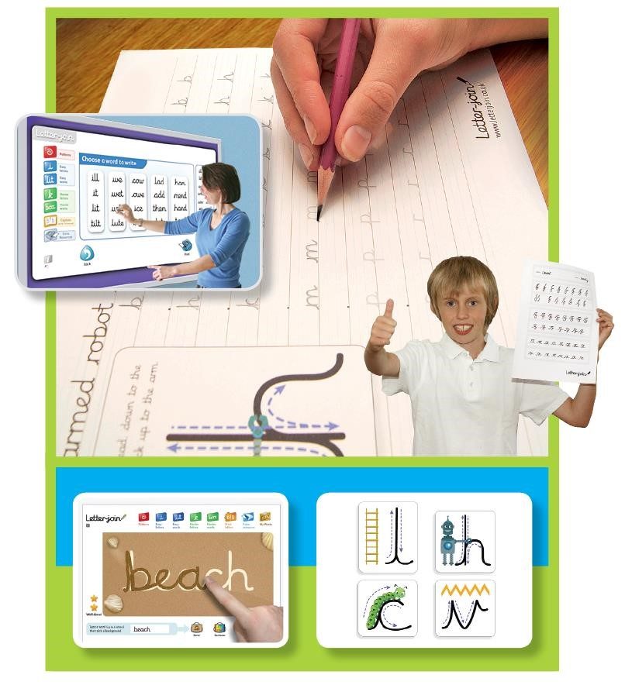

Here is an example of the alphabet that the children will be learning.

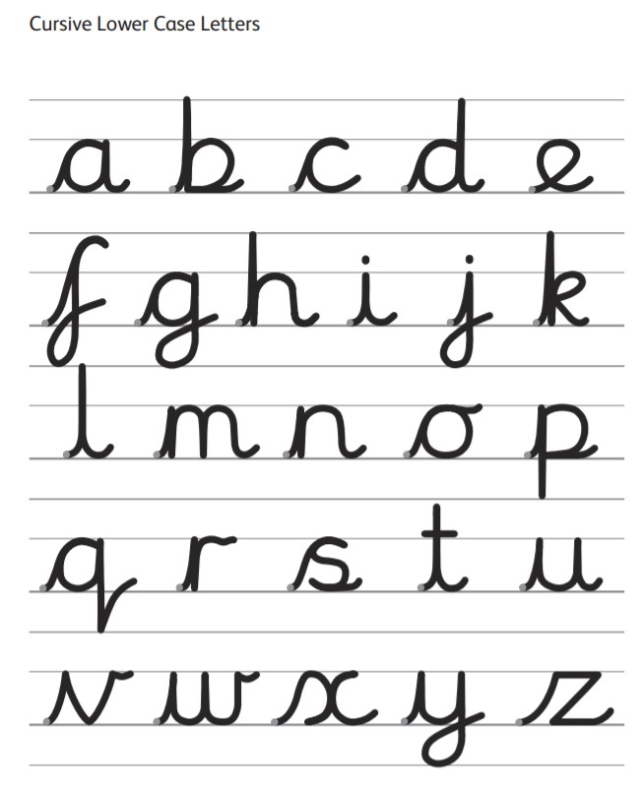

Handwriting Policy
At Rodbourne Cheney Primary Nursery School we are very proud of our pupil’s handwriting and take particular care in our cursive handwriting style. We use Letter-join’s on-line handwriting resource and Lesson Planners as the basis of our handwriting policy as it covers all the requirements of the National Curriculum.

Objective
Handwriting is a basic skill that influences the quality of work throughout the curriculum. By the end of Key Stage 2 all pupils should have the ability to produce fluent, legible and, eventually, speedy joined-up handwriting, and to understand the different forms of handwriting used for different purposes.
Our intention is to make handwriting an automatic process that does not interfere with creative and mental thinking.
Aims:
- To develop a neat, legible, speedy handwriting style using continuous cursive letters, which leads to producing letters and words automatically in independent writing.
- To establish and maintain high expectations for the presentation of written work.
- For pupils to understand, by the end of Year 6, the importance of neat presentation and the need for different letterforms (cursive, printed or capital letters) to help communicate meaning clearly.

Expectations
Consistency throughout the school
Pupils should experience coherence and continuity in the learning and teaching of handwriting across all school years and be encouraged to take pride in the presentation of their work. Our objective is to help pupils enjoy learning and developing their handwriting with a sense of achievement and pride.

Handwriting frequency
Handwriting is a cross-curricular task and will be taken into consideration during all lessons. Formal teaching of handwriting will be carried out regularly and systematically to ensure Key Stage targets are met.

Pens and pencils
Children will start handwriting using a soft pencil. When fine motor skills have been established a handwriting pen can be used.

Inclusion
For children who experience handwriting difficulties due to fine motor development, including those who are left-handed and those with special educational needs, the appropriate additional support will be put into place. Letter-join’s Lesson Planners all include differentiation activities for extra practice/challenge.

Handwriting at Home
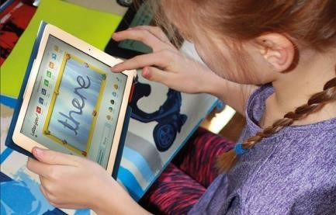
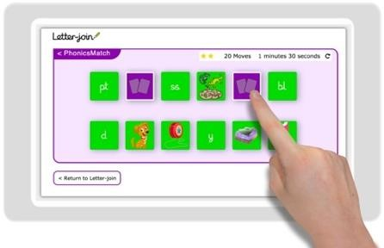
Pupils are encouraged to practise their handwriting at home by using the Pupil log-in for Letter-join. Teachers will set specific tasks such as:
- Magic Patterns
- Magic Words
- PhonicsMatch
- Word Search
- Word Bank
- Write it Right!
Children can also watch the word and letter animations and practice and explore other handwriting resources on Letter-join.

Key Stage Teaching

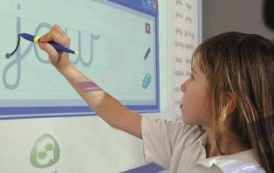
Early Years
For our youngest pupils we teach short handwriting lessons on a daily basis, which will include the following:
- enhancing gross motor skills such as air-writing, pattern-making and physical activities
- exercises to develop fine motor skills such as mark-making on paper, whiteboards, sensory trays, iPads, tablets, etc.
- becoming familiar with letter shapes, their sounds, formation and vocabulary
- correct sitting position and pencil grip for handwriting
Lesson Planner Module 1 for EYFS teaches pre-cursive patterns and cursive, lower case letters. It starts with Getting Ready for Handwriting including fine and gross motor skills warm-up exercises, correct sitting position and tripod pencil grip.
The first module is divided into three sections covering:
- pre-cursive patterns
- easy letters and words
- harder letters and words
At the end of this module, children should be able to recognise and form all the lowercase letters of the alphabet and write words using the correct joining techniques.

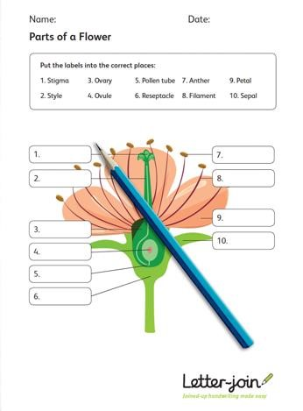
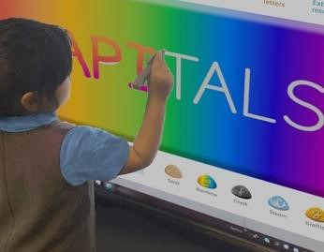
Key Stage 1: Years 1 and 2
Teaching progresses from five short, to two longer lessons per week:
- continuing with gross and fine motor skills exercises
- strengthening cursive handwriting, learning and practice
- numerals, capitals and printed letters; where and when to use, learning and practice
- KS1 SATs SPaG exercises
Lesson Planner Module 2 for Year 1 contains lessons for teaching how to write capital letters, printed letters, numbers and symbols, whilst reinforcing cursive handwriting using Letter-join’s on-line and printed resources. It is divided into three sections covering:
- capital letters
- printed letters
- numbers and symbols
On finishing this module, children should be confident in writing all the capital and printed letters, numbers and symbols and start to become familiar with their use.

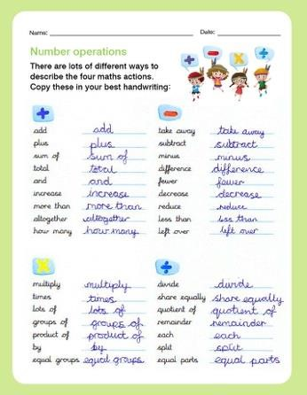
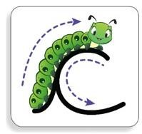
Lesson Planner Module 3 for Year 2 includes lessons to improve letter formation and orientation of letters through regular practice and to support spelling, grammar and punctuation in readiness for KS1 SATs. The sections in this module cover:
- letter families
- high frequency words
- joining techniques
- sequencing sentences
- dictation exercises
- times table facts
- SPaG practice for KS1 SATs
With the regular handwriting practice throughout this module, children should now be developing the fluency and speed of their writing.

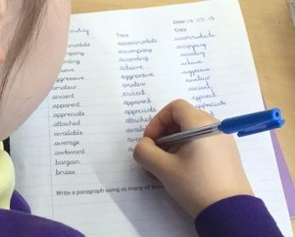
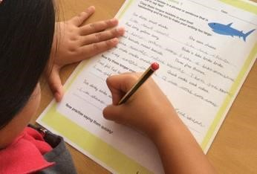
Lower Key Stage 2: Years 3 and 4
Handwriting lessons will continue twice a week in Lower Key Stage 2.
Lesson Planner Module 4 for Year 3 is targeted at children in lower KS2 where pupils should be using a cursive style throughout their independent writing in all subjects, helping to refine their handwriting in line with the requirements of each lesson. This module covers topics such as dictation, double letters, number vocabulary, palindromes, tongue twisters, MFL (French and Spanish), onomatopoeia, simile and statutory spellings.
Completion of Module 4 should ensure improvement in the legibility, consistency and quality of the children’s handwriting through a variety of resources which link handwriting to other areas of the curriculum.
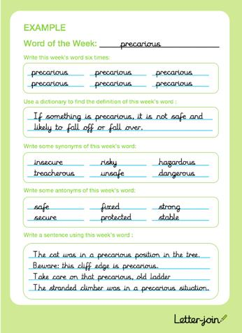
Lesson Planner Module 5 for Year 4 focuses on using handwriting practice to support other subjects in the curriculum and, at the same time, builds on fluency and consistency. This module aims to promote meaningful links with other subjects such as English, maths, science, geography, French and Spanish. Making such links enables children to apply the skills they are learning in context and also provides depth to the curriculum.
Learners will continue to build on producing fluent, consistent and legible handwriting through the regular practice offered in this module’s lessons.
On concluding this module, children will have practised applying sizeappropriate handwriting to all areas of the curriculum whilst maintaining fluency and legibility.

Upper Key Stage 2: Years 5 and 6
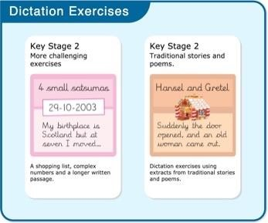
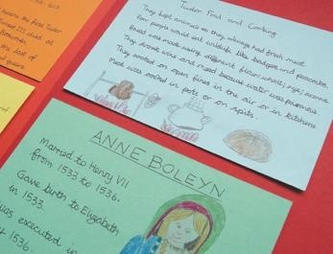
Handwriting will be taught as an intervention for those that need it. The following resources will be available:
- reinforcing cursive handwriting across the curriculum
- form-filling/labelling using printed and capital letters
- dictation exercises promoting quick note-taking and speedy handwriting writing skills
- KS2 SATs SPaG practice
Lesson Planner Module 6 for Year 5 continues to build on combining fluent handwriting with other subjects across the curriculum.
In this module, learners will have plenty of opportunity to develop the stamina and skills to write at length, with accurate spelling and punctuation. With Letter-join’s wide range of resources they will be able to work towards producing consistently neat and well-presented handwriting in all curriculum subjects.
On completing this module, children should be producing cursive writing automatically, enabling them to focus on the content of their work rather than the process of writing.

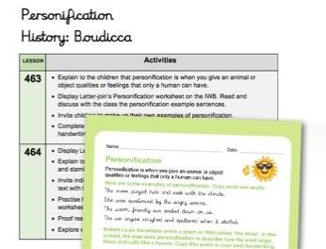
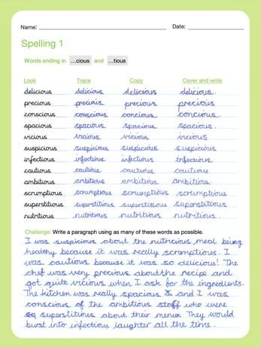
Lesson Planner Module 7 Year 6 presents learners with a range of tasks where they have to decide on an appropriate style of handwriting. Promoting speedy, fluent writing continues to be a strong feature. Challenging dictation exercises will refine pupils’ revising and checking skills as well as boosting their handwriting speed, stamina and fluency. A range of curriculum-based worksheets will give pupils the opportunity to practise writing at length.

Module 7 also contains a series of worksheets to aid KS2 SATs SPaG revision. They are designed to support year 6 pupils in meeting expected standards for spelling, punctuation and grammar, with lots of SPaG preparation and plenty of handwriting practice.
By the end of this module, children should be able to adapt their handwriting for a range of tasks and purposes and to create different effects. They should be clear about what standard of handwriting is appropriate for a particular task, for example, quick notes, a final handwritten version, an un-joined style or capital letters. All of these writing styles are covered in this module.

Correct posture and pencil grip for handwriting
Pupils should be taught to sit correctly at a table, holding a pencil comfortably and correctly.

SITTING POSITION

The table reaches
to below elbow
Sit with a straight
back, not leaning
over the page

Sit right back
in the seat

Pull the chair
close in to the
table

Keep feet flat
on the floor

Paper position for right
-
handed children
.

height

LEFT-HANDED CHILDREN
Left-handed children may find it difficult to follow the movements of right-handed teachers as they model letter formation (and vice versa). Teachers should demonstrate to left-handers on an individual or group basis.
- Left-handed pupils should sit to the left of a right-handed child so that they are not competing for space.
- Pupils should position the paper/book to their left side and slanted, as shown.
- Pencils should not be held too close to the point as this can interrupt pupils’ line of vision.
- Extra practice with left-to-right exercises may be necessary before pupils write left-to-right automatically.

Paper position for left
-
handed children
.

The Tripod Pencil Grip
Both right and left handed children should be encouraged to use the tripod grip which allows the pen/pencil to be held securely whilst allowing controlled movements of the pen/pencil nib. We use the Tripod Grip Rhyme:

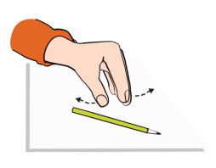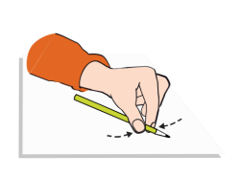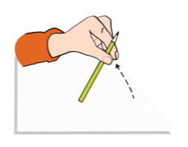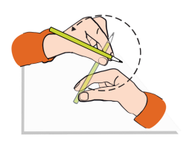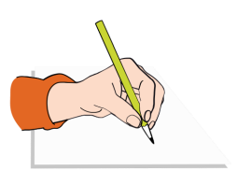
Point away the pencil,

Pinch it near the tip,

Lift if off the

table,

Spin it round...

and grip.

Right
-
handed pencil grip

Point away the pencil,

Pinch it near the tip,

Lift if off the table,

Spin it round...

and grip.

Left
-
handed pencil grip

