Music development plan summary:
Rodbourne Cheney Primary School

Overview
Detail | Information
Academic year that this summary covers | 2024-2025
Date this summary was published | September 2024
Date this summary will be reviewed | September 2025
Name of the school music lead | Hannah Pajak
Name of school leadership team member with responsibility for music (if different) | Sarah Harris
Name of local music hub | Swindon Music Service
Name of other music education organisation(s) (if partnership in place)

This is a summary of how our school delivers music education to all our pupils across three areas – curriculum music, co-curricular provision and musical experiences – and what changes we are planning in future years. This information is to help pupils and parents or carers understand what our school offers and who we work with to support our pupils’ music education.

Part A: Curriculum music
This is about what we teach in lesson time, how much time is spent teaching music and any music qualifications or awards that pupils can achieve.
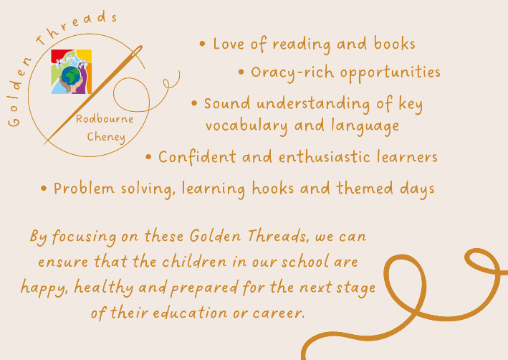
In our whole school curriculum, we have five ambitions for our curriculum intent and these are at the core of what we do across the school. We call these our Golden Threads. It is important that these threads are embedded in our whole school curriculum, and are also a common dominator in all that we do.

Intent
At Rodbourne Cheney Primary School, we follow the National Curriculum for music to ensure that all pupils:
- Perform, listen to, review and evaluate music across a range of historical periods, genres, styles and traditions, including the works of the great composers and musicians.
- Learn to sing and to use their voices, to create and compose music on their own and with others, have the opportunity to learn a musical instrument, use technology appropriately and have the opportunity to progress to the next level of musical excellence.
- Understand and explore how music is created, produced and communicated, including through the inter-related dimensions: pitch, duration, dynamics, tempo, timbre, texture, structure and appropriate musical notations.
At Rodbourne Cheney Primary School we ensure that our pupils develop the skills needed to be able to participate, appreciate and express themselves through music. They should have knowledge taught to them that allows them to build on prior learning and be able to make links between their learning. We have designed a curriculum that builds bridges so that a depth of learning is experienced, and schemes of work and music tuition are not in isolation but build overtime. Where possible, we link subject areas to provide a purpose for music; this is only done where it is relevant. We want music to be real for our pupils and so want to expose them to a range of musical styles and genres within the classroom. We want music to be part of our classrooms and its benefits to be felt in other areas of the curriculum. We use a tiered approach to vocabulary that gives pupils the technical language of the subject and builds on what they already know. We endeavour to build in bitesize exposure to music in the classroom within schemes of work in order to allow pupils to apply their skills and knowledge. This might be having a piece of ‘Music of The Week’ and discussing how it makes us feel, using nursery rhymes to develop vocabulary and putting routines and instructions to music to include the children in classroom expectations.

Implementation
At Rodbourne Cheney Primary School, we use the ‘Music Express’ scheme of work which provides the basis of music lesson content from Foundation Stage to Year 6. Music is timetabled weekly to ensure all children have access to music lessons. This informs the medium-term planning as to what is taught within Music teaching units. The short-term plan lists specific learning objectives that are to be covered and success criteria to support both children and adults in assessing their work. The planning focuses on how children will be supported and challenged in their learning to ensure that all children can access the provision. Each year, a group of children with SEND are invited to take part in drumming sessions with Swindon Music Service; these sessions are tailored to the needs of the children to ensure that they can access the provision. Every two weeks, we have a whole-school focus on a particular genre; this enables the children to be exposed to a wide range of musical genres. The tiered vocabulary is used by teachers to ensure that correct vocabulary is modelled to the children at all times and that they have the opportunity to use this vocabulary in their lessons. By doing this, children feel confident in their subject knowledge and enthusiastic about taking part. Swindon Music Service provide roadshows every year to the whole school; this exposes the children to a number of performances, as well as learning about different instruments and different instrument families.

Impact
Through our carefully planned curriculum, learners are able to:
- Use creativity and imagination through sensory experiences and personal expression.
- Use music as a way of understanding and responding to the world.
- Understand music is a way of communicating ideas, feelings and meanings.
- Make thoughtful judgements about life and life in different times and cultures.
- Shape the environment and making a positive impact.
- Enjoy the enrichment of our lives through music.

Part B: Co-curricular music
This is about opportunities for pupils to sing and play music, outside of lesson time, including choirs, ensembles and bands, and how pupils can make progress in music beyond the core curriculum.
All children take part in twice weekly assemblies; all assemblies include singing and children have the opportunity to celebrate a range of music and genres during this time. These songs are often chosen for their meaning, because they link to a specific value or because they celebrate something specific. The reason for selecting each song is discussed within the assemblies, further embedding the children’s music knowledge.
Swindon Music Service deliver singing lessons to Reception, Year 1 and Year 2. These classes also take part in a nativity performance every year where they learn new songs and perform to the rest of the school, and parents and carers. In Year 4, all children learn the ukulele and perform to parents at the end of the year. Children in Preschool also learn songs in the lead up to Christmas and these are performed to parents.
Through Swindon Music Service, all children have the opportunity to have individual instrument lessons. These lessons take part during the school day and there is a reduced fee for Pupil Premium children.

Part C: Musical experiences
This is about all the other musical events and opportunities that we organise, such as singing in assembly, concerts and shows, and trips to professional concerts.
All children take part in twice weekly assemblies; all assemblies include singing and children have the opportunity to celebrate a range of music and genres during this time. These songs are often chosen for their meaning, because they link to a specific value or because they celebrate something specific. The reason for selecting each song is discussed within the assemblies, further embedding the children’s music knowledge.
All children experience music roadshows in school every year and children in Year 5 attend a local secondary school every year where the children put on a musical performance for them to enjoy.
In Reception, all children are invited to take part in the Make A Noise Festival. All children learn the songs in school and then parents are invited to bring their child to perform to parents and carers, with children from other Swindon schools.
To celebrate Harvest and Easter, children learn songs in school and then visit the local church for a celebration and to sing these songs with the whole school, and parents and carers.
At Christmas, the school hosts a Christmas carol evening where we invite members of the community to sing carols on the playground. The children learn these songs in school during assembly time.

In the future
This is about what the school is planning for subsequent years.
At Rodbourne Cheney, we intend to offer a school choir to children who would wish to take part in additional singing opportunities.

Further information (optional)
Swindon Music Service
Swindon Music Service (smscio.org)

