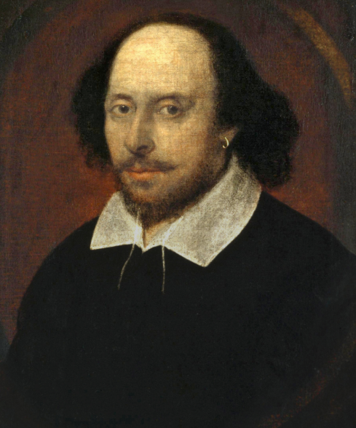

-William Shakespeare was a British playwright and poet (he wrote plays and poems).

- He is often considered to be the most talented writer of all time. His plays and poems are still studied and performed 400 years later!

- Shakespeare lived in the 16th and 17th centuries, throughout the reigns of Queen Elizabeth I and James VI. They are both known to have watched his plays.

-Some of his most famous plays include Romeo and Juliet, Macbeth, Hamlet and Much Ado About Nothing.

**Overview**

**Year 5 Knowledge Organiser**

|  |  |
| --- | --- |
| **Key vocabulary** | |
| playwright | A person who writes plays |
| poet | A person who writes poems |
| Chamberlain’s men | A company of actors for which Shakespeare wrote plays for. |
| The Globe Theatre | An Elizabethan Playhouse for which Shakespeare wrote his plays. |
| sonnet | A poem of 14 lines using a rhyme scheme. |
| Stratford-Upon-Avon | Shakespeare’s birth place. |
| tragedy | An event causing suffering and distress – many of Shakespeare’s plays included this theme. |
| Elizabethan | Relating to the reign of Queen Elizabeth I. |
| King’s men | The new name of the acting company that Shakespeare belonged to during James VI’s reign. |
| Romeo and Juliet | Arguably Shakespeare’s most famous play of all time. |

**1564** – Shakespeare is born in Stratford -upon-Avon.

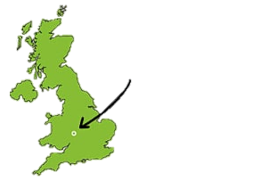

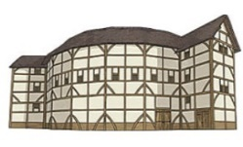

**1603 –** James becomes King and Shakespeare starts performing for him in a theatre group known as The King’s Men.

**1616 –** Shakespeare dies.

**1594** – Shakespeare’s plays were first performed.

**1582** – Shakespeare married Anne Hathaway.

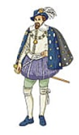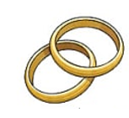

**1599 –** The Globe Theatre was built.

**1590**– Shakespeare wrote his first play– Henry VI

**1609 –** Shakespeare’s sonnets were published.

|  |
| --- |
| **Key facts** |
| - Shakespeare’s three children were called Susanna, Hamnet and Judith.  -In total, Shakespeare wrote 154 sonnets and around 40 plays.  - Some of Shakespeare’s phrases that are still used today include ‘wild goose chase’, ‘green-eyed monster’, and neither here nor there.’  -A Midsummer Night’s Dream is Shakespeare’s most performed play.  - The Globe Theatre was shaped like an octagon, with eight sides. |

|  |
| --- |
| **Elizabethan times** |
| The reign of Queen Elizabeth was a largely happy time in Britain, and this is shown in Shakespeare’s works from the time, he wrote lots of comedies.  His plays began to be performed by his theatre group, the Lord Chamberlain’s Men, in 1594. They were known to be popular.  Shakespeare wrote many sonnets at this time, and Romeo and Juliet in 1595. |

|  |
| --- |
| **Jacobean times** |
| After the death of Queen Elizabeth, her relative King James of Scotland came to rule in England. This was a darker time, and Shakespeare wrote more tragedies.  James became the official patron of The Chamberlain’s Men, and so their name was changed to ‘The King’s Men.’ The Globe Theatre had been built at this point, and so most of Shakespeare’s plays were performed there – a sign of his popularity. |

