Manipulatives and strategies
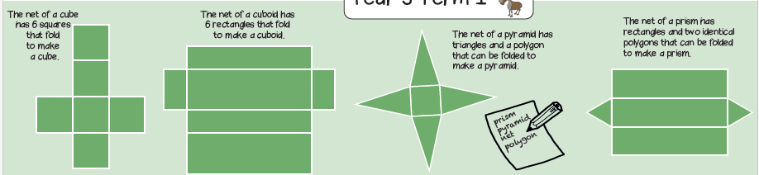
Vocabulary and meanings
net | A pattern that you can cut and fold to make a model of a solid shape.
square | A flat shape with 4 straight sides where:  • all sides have equal length, and  • every interior angle is a right angle (90°)  It is a quadrilateral and a regular polygon.
rectangle | A 4-sided flat shape with straight sides where all interior angles are right angles (90°).  Opposite sides are parallel and of equal length.
polygon | A two-dimensional shape with straight sides.
cube | A box-shaped solid object that has six identical square faces.
cuboid | A box-shaped solid object.  • It has six flat sides  • All angles are right angles  • All of its faces are rectangles
Place Value
Manipulatives and strategies
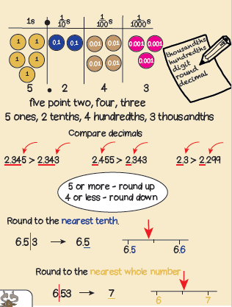
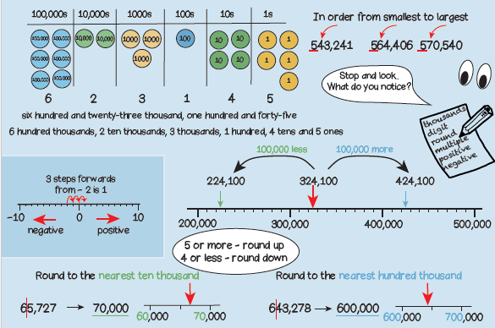

Vocabulary and meanings
Digit/numerals | A single number to represent values in mathematics.
zero | Holds a place in a number or represents nothing.
ones | 1-digit number = 1 - 9
tens | 2-digit numbers = 10 - 99
hundreds | 3-digit numbers = 100 - 999
thousands | 4-digit numbers = 1000 - 9999
ten thousands | 5-digit numbers = 10,000 – 99,999
hundred thousands | 6-digit numbers = 100,000 – 999,999
exchange | Changing a larger value number into a smaller value number. For example, 1 ten = 10 ones so to change 1 ten to get 10 ones is exchanging
columns | Vertical lines to the left and right to separate number values.
position | Where a number is placed on a number line.
increase | A number gets bigger in value; 8 10 12 14
decrease | A number gets smaller in value; 12 10 8 6
round | Adjusting a number up or down. Used mostly for estimating.
negative | Numbers less than zero, with a minus sign. 0 -1 -2 -3
positive | Any number more than zero. 1, 2, 3, 4, 5
multiple | The answer you get when you multiply one number by another.

