Key vocabulary
Continent | A large landmass made up of many countries.
Climate | The usual or average weather conditions over a long period of time.
Human | Geography affected by human activity.
Physical | Geography dealing with natural features.
Population | The amount of people who live in a particular place.
Capital city | A major city where the country’s government is located.
Biome | Biomes are regions of the world with similar climate (weather, temperature) animals and plants e.g. tundra and forest.
Maasai | An ethnic group inhabiting Kenya and Tanzania.
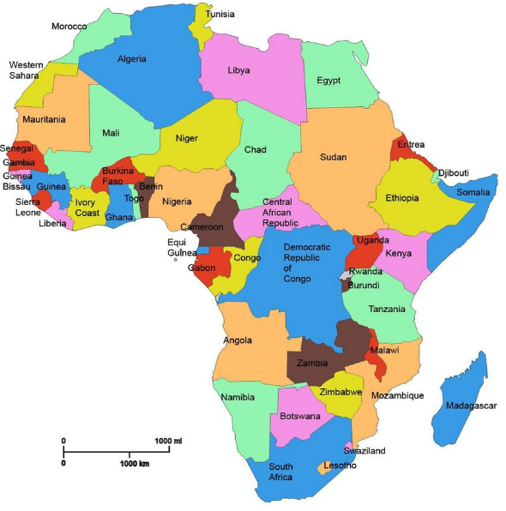
Africa
-Africa is the second largest continent in the world.
-It has a population of about 1.2 billion people (16% of the world’s population).
- It is made up of 54 different countries.
- It is believed that humans first evolved and originated in Africa.
-The longest river in Africa is the river Nile.
Key facts
Year 5 Knowledge Organiser
Climate
Africa has a warm and hot climate. It consists of a number of biomes including grasslands, savannah, rainforest and desert.
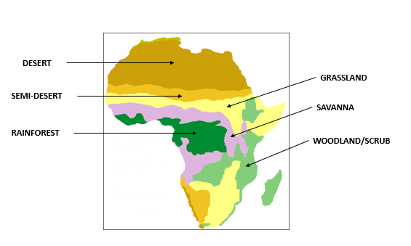

Human and Physical geography features in Africa
River Nile (physical) | The longest river in Africa. It flows through Sudan and Egypt and into the Mediterranean Sea. It is 6,650 kilometres long.
The Pyramids of Giza (human) | These pyramids are located in Egypt and they were built around 2550 BC.
Victoria Falls (physical) | Victoria falls is a waterfall on the Zambezi river. It is located on the border of Zambia and Zimbabwe.
Great Mosque of Djenné (human) | The great mosque of Djenné, which is located in Mali, is made of mud bricks coated with clay. It was built in the early 1900s

Capital cities
A capital city is a major city in a country and it is usually where the countries government is located.
Cairo is the capital city of Egypt with a population of over 20 million people.
Addis Ababa is the capital city of Ethiopia with a population of 4.8 million people.
Kinshasa is the capital city of The Democratic Republic of Congo. with a population of over 16 million people.
Nairobi is the capital city of Kenya with a population of over 4 million people.

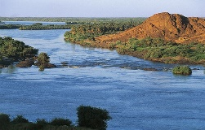

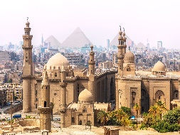

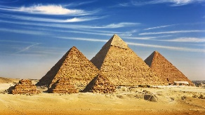
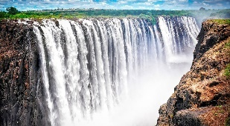
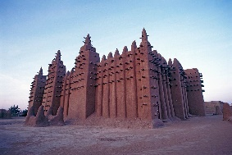
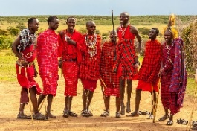
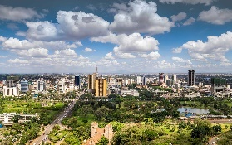
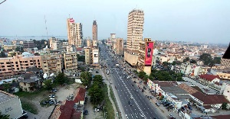
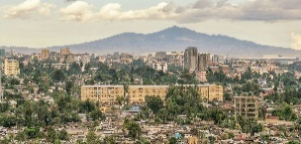
The Maasai tribe
The Maasai tribe live in Kenya and Tanzania. They live in the African Savannahs and use the land as their home where they all live together. Men are traditionally in charge of the tribe

while women take care of the children. The men perform a special jumping dance.

