**In our whole school curriculum, we have five ambitions for our curriculum intent and these are at the core of what we do across the school. We call these our Golden Threads. It is important that these threads are embedded in our whole school curriculum, and are also a common dominator in all that we do.**

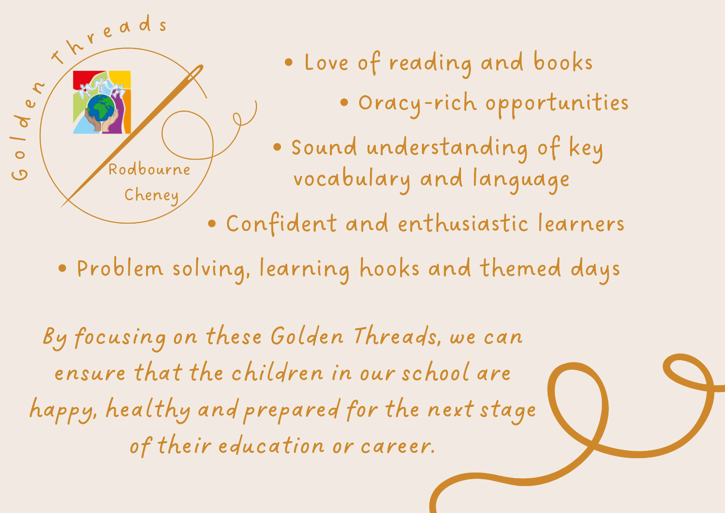

|  |
| --- |
| **School context:**  Our FSM is higher than national and Swindon averages.  Our children are from predominantly white, working-class families.  **Our demographic survey shows:**  42% of our children from financially stretched or low-income families.  57% of our families live in the in the most 30% of deprived postcodes in the UK.  **Our Acorn study shows that:**  There is a higher proportion of single parents than the base.  Financial profile shows more families making ends meet/ struggling than the base.  Number 1 Dominant Acorn Group titled ‘Limited Budgets’. 23% of our families fall into this category compared to 5% base.  20% of our demographic have an income less than 20K (the lowest grade measured).  **We have to ensure our children leave our school having had a high-quality, ambitious and well-planned curriculum. This means that all of our children, no matter what their starting points are, will achieve their best not only at our school, but in their future education setting, and then in working and adult life.** |

|  |  |  |
| --- | --- | --- |
| **Whole School** | | |
|  | **Whole School Golden Thread** | **Why this is important?** |
| 1. | **Love of reading and books** | We know that we need to develop the children’s reading, language and oracy to ensure they have the best possible outcomes. Reading and language is a crucial aspect to learning. Studies have proven that reading and language acquisition are key to all elements of learning, and later life.  It is essential that we encourage children to love books, teach them to be able readers and ensure they have a good understanding of vocabulary and language. |
| 2. | **Oracy-rich opportunities** | Research shows that oracy is key to high performers. Research also shows that children, especially boys, benefit from drama and oracy opportunities to plan and gain increased understanding. It is essential that oracy opportunities are across all subjects and all phases. |
| 3. | **Sound understanding of key vocabulary and language** | Research has proven that children from lower socio-economic backgrounds have a word gap, and also have less vocabulary than their peers. To ensure cultural capital of our children, we need to enable our children to have sound understanding of vocabulary. |
| 4. | **Confident and enthusiastic learners** | Being confident will help our children with their learning; not being afraid to make mistakes or to give things a go. They will be confident with their friends and this will help them achieve in their next stage of life. This links to the children having good self-esteem, which will encourage RCPS children to try new things and find their passion, which will allow them to develop a sense of identity and build confidence in facing whatever comes their way.  It’s important that our children are enthusiastic learners, who want to know and remember more. If our children are excited and enthused about their learning, they will be actively engaged and in turn display excellent learning behaviours which also maximises learning. |
| 5. | **Problem solving, learning hooks and themed days** | By solving problems, our children will be happy, confident and independent learners. They will be able to make sense of, and understand, the world around them. They can make connections and they can apply this to other areas of life through new experiences.  Enrichment of learning is key! This gives our children cultural capital to their learning, and also means that they will enjoy their learning more. If children enjoy their learning, they will be more engaged and actively participate in lessons and experiences. |

***By focusing on these Golden Threads, we can ensure that the children in our school are happy, healthy and prepared for the next stage of their education or career.***