|  |
| --- |
| **Class Newsletter: Year 1 Penguins**  **Date: Tuesday 4th September 2024** |

Dear Parents and Children,

Firstly, we would like to take this opportunity to say a huge welcome to Year 1. I am really excited to welcome you back to school and to start term 1.

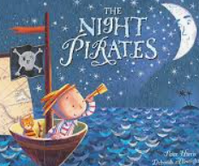This term our topic is ‘Who has changed our world?’. We will continue with our book-based curriculum. We will be reading ‘The Night Pirates’ and a number of pirate-based stories.

Maths Learning

In Maths this term we will be looking at place value of numbers up to 50. We will be counting, counting objects, counting forwards and backwards and finding and representing number facts and counting up to 5. We will also be ordering numbers and finding 1 more and 1 less of numbers.

English Learning

In Writing this term we will be reading 2 books. We will be reading ‘Leaf’ and ‘Stuck’. We will be building up to writing a setting description and a recount. We will be practicing using capital letters, full stops, finger spaces and the use of adjectives.

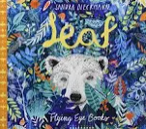

In reading this term we will continue with our Phonics Journey and our weekly Guided Reading sessions. We will also be reading ‘Coming to England’ and ‘The proudest blue’ in our weekly story time sessions.

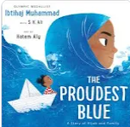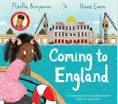

Values

This term we will be focusing on the values, Respect and Courage and this will continue to link into our whole school Values ethos and our 3 school rules. These are; Be safe, be kind, be respectful. We will use on these rules to enable us to keep safe around school, with our peers and the adults around the school.

Reading Books and Home Learning

Home Learning, will resume in Term 1 and it will be set on Friday, to be handed in and marked on the Friday. It will be based on prior learning and used as a way of consolidating what the children have already been taught, including weekly spellings and should practice their times tables at home. It remains our expectation that the children read regularly at home and record what they read in their Reading Records; thank you again for your support with this.

PE

Our PE days are on **Tuesday and Thursday** your child can come to school in their PE kit. Their PE kit must include blue or black shorts or trousers, a white or sports PE top and trainers. Please make sure trousers and a jumper are worn in the winter months.

School uniform

It is important that our children come to school in correct school uniform.

Blue jumper

White or blue polo shirt

Black or grey shorts

Black or grey skirt

Blue summer dress

Children are able to wear **all black** footwear.

Warm regards,

**Miss Barham and Miss Pajak**