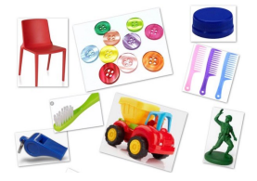
Materials
Words to describe materials
- Waterproof
- Absorbent
- Transparent
- Opaque
- Shiny
- Hard
- Soft
- Shiny
- Smooth
- Rough
- Metal
- Wood
- Plastic
- Fabric
- Rock
- Wood
- Rubber

Year 1 Science Knowledge Organiser
Everyday Materials

Key knowledge

Materials can be grouped based on similar properties.
An object is different to the materials it is made from.

Key vocabulary
Material | A material is what something is made of, such as wood or plastic.
Properties | The properties of a material tell us what it is like and how it behaves, such as whether it is soft, rough or transparent.
Sorting | Grouping materials based on similar properties.
Transparent | If a material is opaque light can pass through it so you can see through the material clearly.
Opaque | If a material is opaque light cannot pass through it so you can not see through the material.
Absorbent | If a material is absorbent it will soak up liquid.
Waterproof | If a material is waterproof it will not absorb liquid, the liquid will sit on the material or run off.
Experiment | Experiments are tests scientists do to check their ideas.

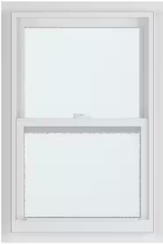
Window
Object
Materials
Plastic
Glass.
