Key vocabulary
Amphibian | Amphibians are animals that live part of their lives on land and in water and usually lay eggs.
Bird | Birds are animals that have feathers and wings and lay eggs.
Reptile | Reptiles are animals that have dry scaly skin and most lay eggs.
Fish | Fish are animals that live in water, breathe through gills and usually lay eggs.
Mammals | Mammals, including humans, are animals that have hair or fur and most give birth to live babies.
Herbivore | Animals which eat plants
Carnivore | Animals which eat meat
Omnivore | Animals which eat plants and meat.
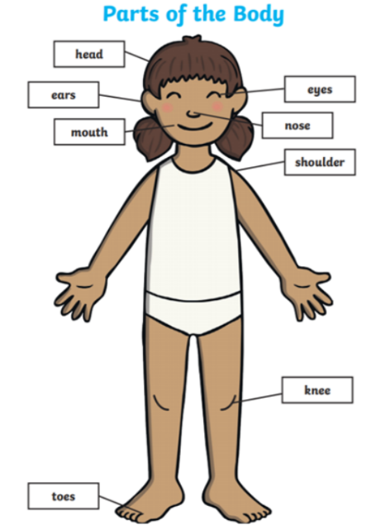
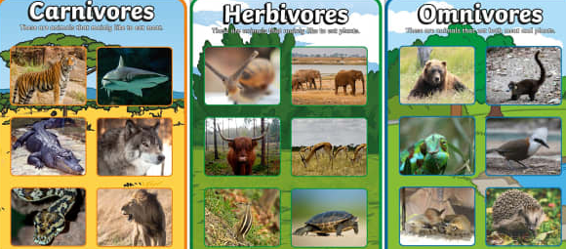
Year 1 Science Knowledge Organiser
Animals including humans

I know that animals can be classed into different groups and idenitify their features.

Key knowledge
I know the five senses and relate them to parts of the body.

