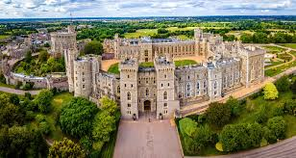
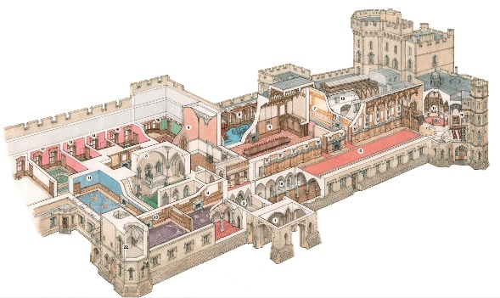
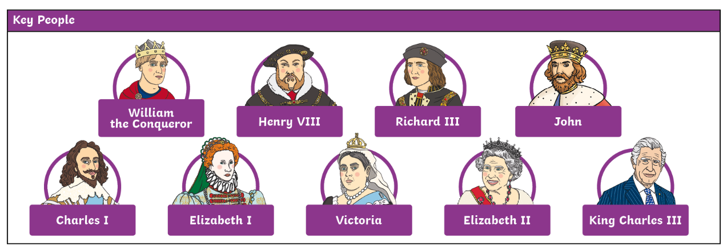
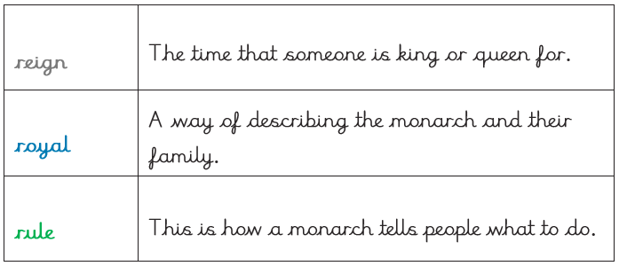
Knowledge Organiser – Term 3 – Kings and Queens
Key Vocabulary
monarch | A monarch is a king or queen, an emperor or  a sultan.
Parliament | This is where politicians meet to decide laws.
succession | This is the order in which a monarch’s family will take over the throne.
crown | Crowns are usually made of metal and are worn on the heads of kings and queens.
power | Something kings and queens have to make people do what they say.

