Key vocabulary
Autumn | The season between summer and winter where leaves fall from the trees and the weather gets colder.
Winter | The season between autumn and spring, which is our coldest season.
Spring | The season between winter and summer, where plants begin to grow again and baby animals are often born.
Summer | The season between spring and autumn, our hottest season.
Hibernate | =When animals become inactive to save energy during winter.
Migrate | When animals travel to a warmer place for winter.
Weather Vane | A piece of equipment that shows which direction the wind is blowing.
Thermometer | A piece of equipment which measures the temperature, how hot or cold something is.
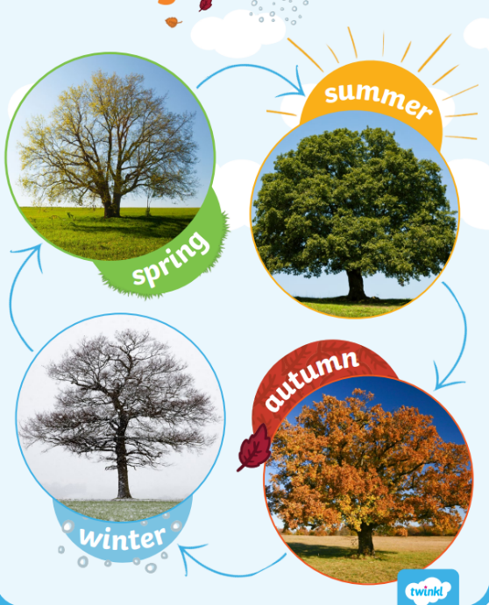
Seasonal Changes
Key skill
Year 1 Science Knowledge Organiser
I can use different pieces of equipment, including a rain gauge, weather vane, thermometer and wind flag, to investigate the weather.

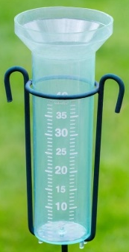
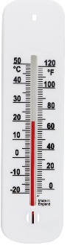
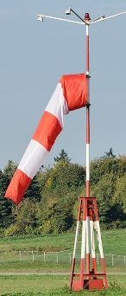
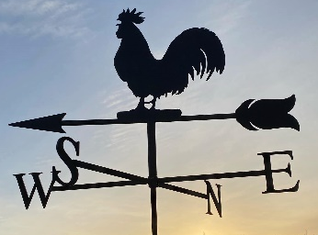

I know that the weather changes as the seasons change, which affects the plants and animals.

Key knowledge
I know that in winter some animals hibernate and some animals migrate.

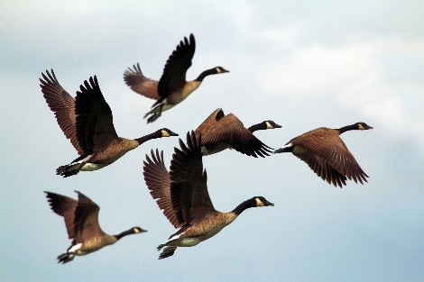
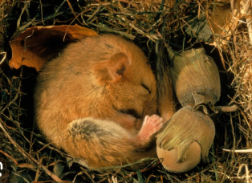
Hibernation

Migration

