Place Value |  | Geometry
Manipulatives and strategies |  | Manipulatives and strategies
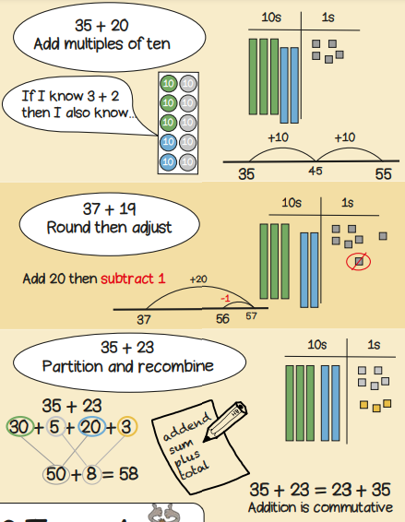  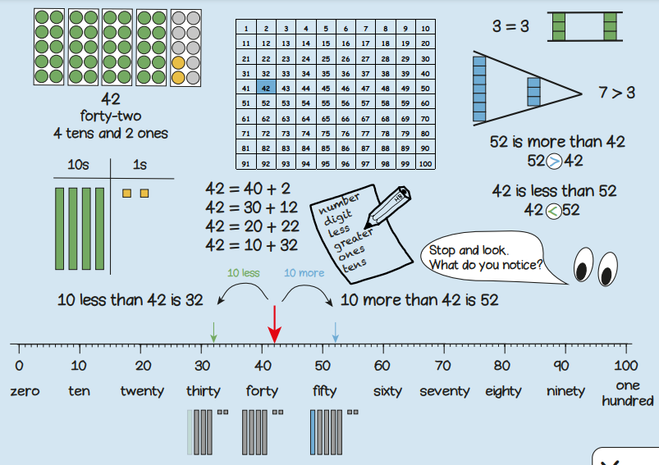 |  | 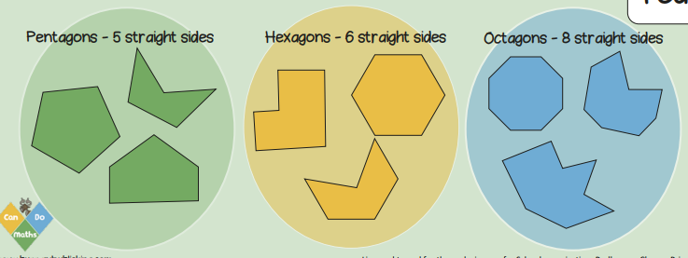  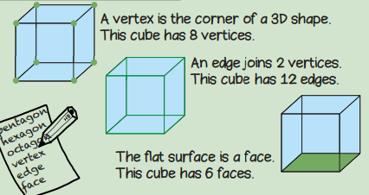  Year 2, Term 1 Knowledge Organiser for Place Value and Geometry.
Vocabulary and meanings |  | Vocabulary and meanings
Digit/numerals | A single number to represent values in mathematics | 2D shape | A flat shape that has two dimensions – width and length.
zero | Holds a place in a number or represents nothing.
ones | 1-digit number = 1 - 9
tens | 2-digit numbers = 10 - 99 | pentagon | A shape with 5 straight sides.
value | How much each digit/numeral is representing. | hexagon | A shape with 6 straight sides.
exchange | Changing a larger value number into a smaller value number. For example, 1 ten = 10 ones so to change 1 ten to get 10 ones is exchanging
 |  | octagon | A shape with 8 straight sides.
columns | Vertical lines to the left and right to separate number values. | symmetry | Something is symmetrical when it has two matching halves.
position | Where a number is placed on a number line.
more | A number gets bigger in value; 8 10 12 14 | vertex | The corner of a 3D shape.
less | A number gets smaller in value; 12 10 8 6 | 3D shape | 3D shapes are solid and are measured by length, width and depth.
 |  | edge | An edge joins two vertices.

