Addition and Subtraction |  | Multiplication and Division
Manipulatives and strategies |  | Manipulatives and strategies
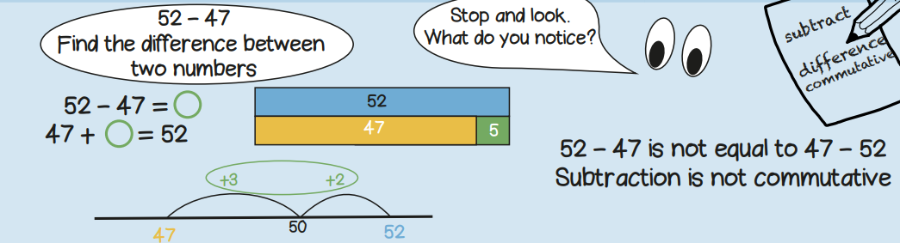  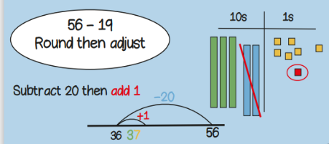  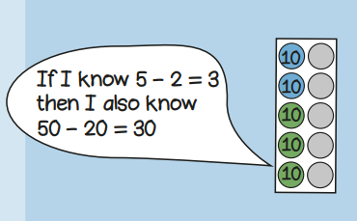  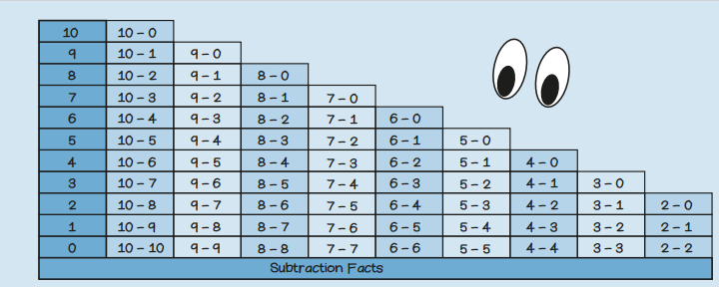 |  | 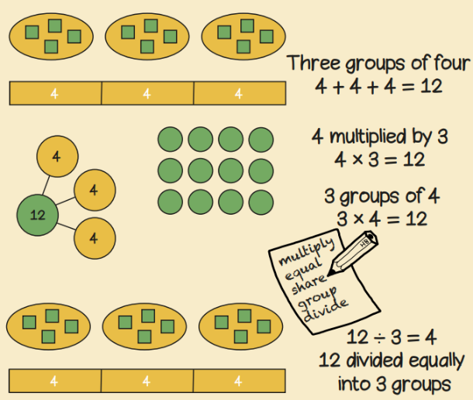  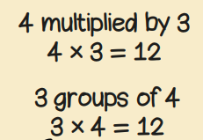  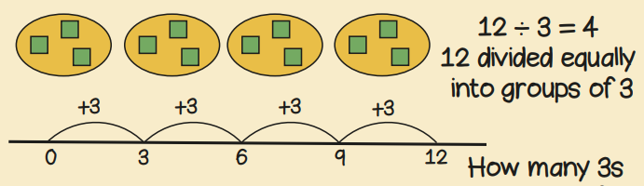  Year 2, Term 1 Knowledge Organiser
Vocabulary and meanings |  | Vocabulary and meanings
Digit/numerals | A single number to represent values in mathematics | Multiply | To add a number to itself many times to get a bigger number.
zero | Holds a place in a number or represents nothing. | Multiply | To add a number to itself many times to get a bigger number.
ones | 1-digit number = 1 - 9 | Multiply | To add a number to itself many times to get a bigger number.
tens | 2-digit numbers = 10 - 99 | Divide | To split something into equal parts.
subtraction | Taking away, the number will always get smaller. | array | Objects set up in rows and columns.
exchange | Changing a larger value number into a smaller value number. For example, 1 ten = 10 ones so to change 1 ten to get 10 ones is exchanging | array | Objects set up in rows and columns.
exchange |  | groups | A collection of objects together.
columns | Vertical lines to the left and right to separate number values. | equally | To have the same amount of something.
position | Where a number is placed on a number line. | equally | To have the same amount of something.
more | A number gets bigger in value; 8 10 12 14 | Repeated addition | Numbers repeatedly added together, 4 + 4 + 4 + 4
less | A number gets smaller in value; 12 10 8 6

