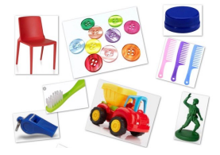
Some materials can change shape when you squash, bend, twist or stretch them. Materials that are soft, bendy or stretchy are often easier to change the shape of than materials that are hard, rigid or strong.
Squashing | 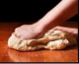 | Crush something so that it becomes flat, soft, or out of shape.
Bending | 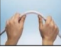 | Change a straight object so that it is curved.
Stretching | 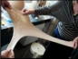 | Make something longer or wider without tearing or breaking it.

Historical Scientests
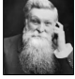 | John Dunlop - famous for developing air filled tyres. He did it to improve his son’s bike!
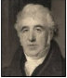 | Charles Macintosh - invented the raincoat. He put rubber between two layers of cloth to make it waterproof.
 | John McAdam - was the first person to think of tarmac roads. It made roads smooth and easier to travel on.

- Metal
- Wood
- Plastic
- Fabric
- Rock
- Wood
- Rubber

Materials
Key knowledge
Year 2 Science Knowledge Organiser
Everyday Materials

Key vocabulary
Material | A material is what something is made of, such as wood or plastic.
Suitability | Suitability means having the right properties for a  certain use
Properties | The properties of a material tell us what it is like and how it behaves, such as whether it is soft, rough or transparent.
Recycle | To recycle means to change waste (rubbish) into a material that can be used again.
Translucent | If a material is translucent, some light passes through it. You might be able to see through the material but not clearly.
Strong | Strong materials do not change shape or break easily.
Flexible | Flexible materials can bend easily without breaking.
Breakable | Breakable materials can break easily.
Brittle | Brittle materials are often hard and rigid. They can break easily, for example when bent.

