Addition, subtraction, multiplication, division | Geometry
Manipulatives and strategies | Manipulatives and strategies
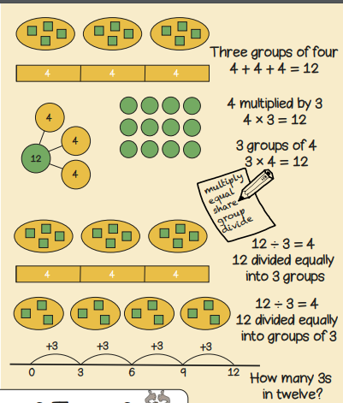  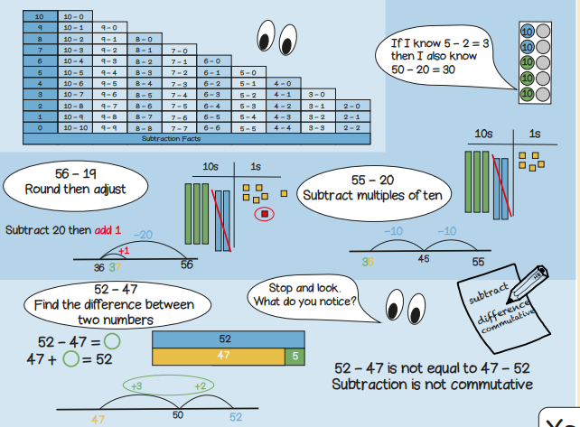 | 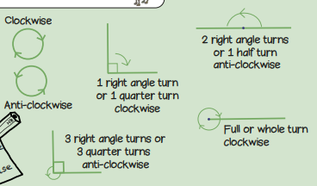  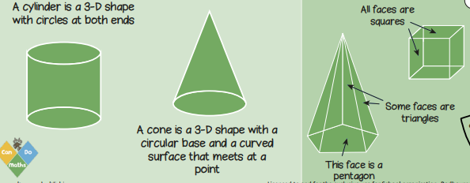  Year 2, Term 2 Knowledge Organiser for Addition, Subtraction, Multiplication, Division and Geometry.
Vocabulary and meanings |  | Vocabulary and meanings
Ones | 1-digit number = 1 - 9 | 2-D shape | A flat shape that has two dimensions – width and length.
Tens | 2-digit numbers = 10 - 99 | 3-D shape | 3D shapes are solid and are measured by length, width and depth.
Commutative | When 2 numbers can be added or multiplied and the same answer will be found no matter what order they are in. 6+3=9 3+6=9. 4+2=6 2+4=6. | Vertex | The corner of a 3D shape.
Sum/total/altogether | It is the total of the numbers of the numbers added together. | Edge | An edge joins two vertices.
Partition | Partitioning is used to separate larger numbers into smaller units. 24 = 20 + 4. 71= 70 + 1 | Cylinder | A cylinder is a 3D shape with two circular faces at each end, one curved side, and no edges or vertices.
Regroup | Rearranging numbers into groups by place value to make it easier to carry out operations. | Cone | A cone is a 3D shape with a circular base and 1 curved surface.
difference | Result of subtracting one number from another. | Clockwise | Clockwise involves a turn to the right, and it follows the hands of a clock.
Array | An arrangement of objects or pictures in rows and columns. | Anti-clockwise | Anti-clockwise involves a turn to the left, against the direction of a clock.
Grouping/sharing | Dividing things into equal groups. | Right angle | A right angle is a 90 degree angle, most commonly forming a perfect ‘L’ shape.

