|  |
| --- |
| **Key Facts** |
| * The seas that surround the British Iles are: the English Channel, the North Sea, the Irish sea and the Atlantic Ocean. * The coastline around the UK is where you can find seaside resorts. Our nearest seaside towns are Weston Supermare and Clevedon. * There are many towns around the coast of the UK that are popular seaside holiday destinations. * There are human features, such as a harbour, lighthouse, pier and promenade that we can see at coastal locations. * There are natural features such as cliffs, caves, bays and beaches that we can see at coastal locations. |

The Great British Coast

|  |  |
| --- | --- |
| **Key Vocabulary** | |
| Coast | The part of land joining the sea. |
| Seaside | A place by the sea, especially a beach area or holiday resort. |
| Human feature | A feature that has been made or changed by humans. |
| Physical feature | A feature that has been formed by nature. |
| Town | An area larger than a village but smaller than a city. |
| Pier | A structure built out into the water for people to walk on. |
| Promenade | A paved public walk, typically along the seafront. |
| Bay | Part of the coast where the land curves in and is surrounded by the sea on three sides. |
| Cliff | A steep rock face, especially at the edge of the sea. |

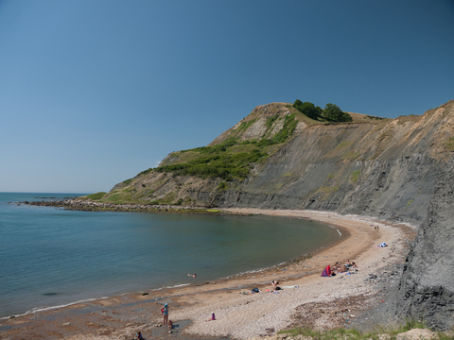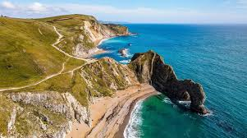

|  |  |
| --- | --- |
| **Physical features of coastal areas** | **Human features of coastal areas** |
|  |  |

