Fractions | Time and Money
Manipulatives and strategies | Manipulatives and strategies
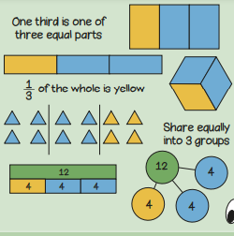  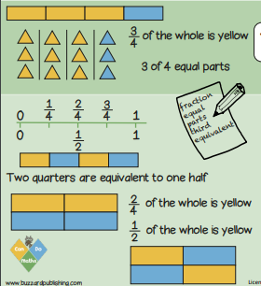  Year 2, Term 4 Knowledge Organiser for Fractions, Time and Money. | 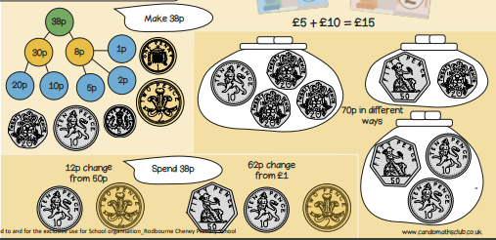  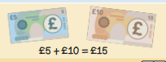  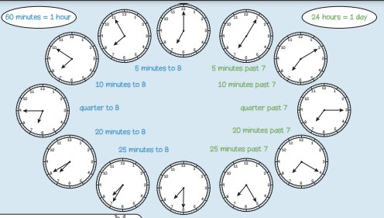
Vocabulary and meanings |  | Vocabulary and meanings
Denominator | The number below the line in a fraction. | Minute | A unit of time equal to 60 seconds. There are 60 seconds in 1 minute.
Numerator | The number above the line in a fraction. | Hour | A period of time lasting 60 minutes. There are 60 minutes in 1 hour.
Third | 1 part of something that has been divided into 3 equal parts. | Total/Sum | A whole or complete amount. You find the total by adding numbers.
Quarter | 1 part of something that has been divided into 4 equal parts. | Pence | A unit of money. There are 100p in £1.
Three-quarters | 3 parts of something that has been divided into 4 equal parts. | Pounds | The unit of money used in Britain. £1 is the equivalent to 100p.
Half | 1 part of something that has been divided into 2 equal parts. | Change | Subtracting the old value from the new value.

