|  |  |
| --- | --- |
| Key vocabulary | |
| Heir | A person who will inherit the throne when the current King or Queen dies. |
| Monarch | A person who rules over a place, usually a king or queen. |
| reign | To rule over a country as a monarch |
| throne | The position of a king or queen. |
| The Age of Exploration | A time when European nations began exploring the world. Also known as The Age of Discovery. This was from the 1400s to 1600s |
| Annul | To cancel a marriage |
| Treason | A crime of betraying your country |
| Execution | To be put to death |
| Reformation | The idea of reforming the church to make it less corrupt |
| Divorce | The legal end of a marriage |
| Catholic | A form of Christianity under the control of the Pope |
| Protestant | Followers of Christianity who are separate from the Roman Catholic Church |

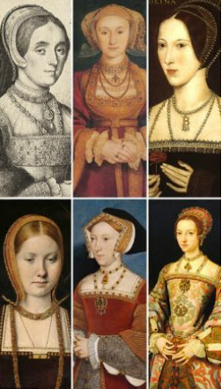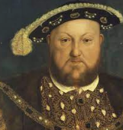

**Henry VIII**

Catherine of Aragon

Jane Seymour

Anne Boleyn

Henry VIII’s six wives

Henry VIII

**Year 3 Knowledge Organiser**

Timeline of Monarchs

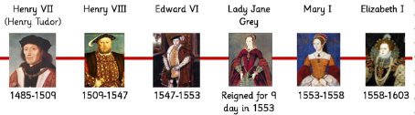

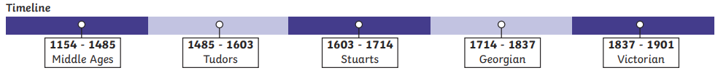

* *There were six Tudor monarchs who ruled England from 1485 - 1603 Tudor England had two of the strongest monarchs ever to sit on the English throne. Henry VIII and his daughter Elizabeth I.
* *The Tudor Rose was created when Henry VII bought an end to the War of the Roses. He joined the White Rose of York with the Red Rose of Lancaster to create the Tudor Rose. *Religion was very important in Tudor times. Everyone had to go to church. If you didn’t attend the same church as the monarch you might get arrested, thrown into the Tower or London or executed.
* *Henry VIII broke away from the Catholic Church and created the Protestant Church of England so that he could divorce his first wife. He went onto have six wives and beheaded two of them.

Key Facts

Catherine Parr

Catherine Howard

Anne of Cleeves