Place Value |  | Geometry: Properties of Shapes
Manipulatives and strategies |  | Manipulatives and strategies
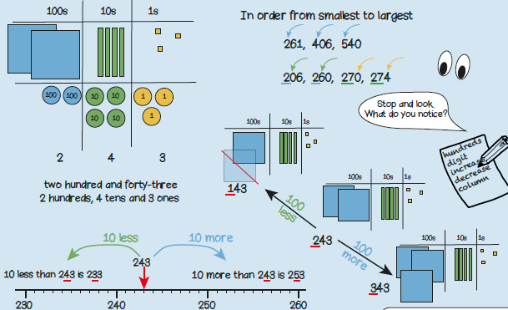  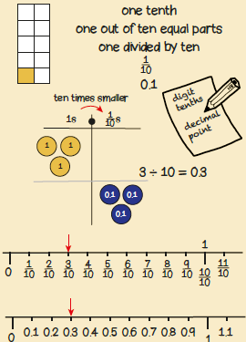 |  | 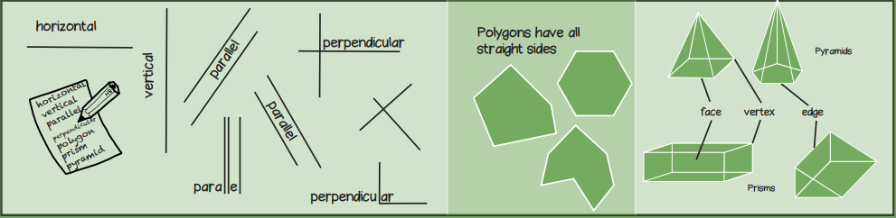
Vocabulary and meanings |  | Vocabulary and meanings
Digit/numerals | A single number to represent values in mathematics | perpendicular | A straight line at an angle of 90 degrees.
zero | Holds a place in a number or represents nothing.
ones | 1-digit number = 1 - 9
tens | 2-digit numbers = 10 - 99 | equi-distant | When two things are the same distance apart from a certain point.
hundreds | 3-digit numbers = 100 – 999
 |  | polygon | A 2-D shape with sides that are straight and create a fully enclosed space.
value | How much each digit/numeral is representing.
exchange | Changing a larger value number into a smaller value number. For example, 1 ten = 10 ones so to change 1 ten to get 10 ones is exchanging
 |  | polyhedron | A 3-D shape with flat polygon faces, sharp corners and straight edges.
columns | Vertical lines to the left and right to separate number values.  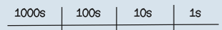 | face | Flat or curved surface on a 3D shape.
horizontal | A line that runs from side to side (left to right, or right to left). | edge | Where two faces meet.
vertical | A line that runs from top to bottom (straight down, or straight up). | vertex | A corner where edges meet.

