Place Value |  | Addition (Mental Strategies)
Manipulatives and strategies |  | Manipulatives and strategies
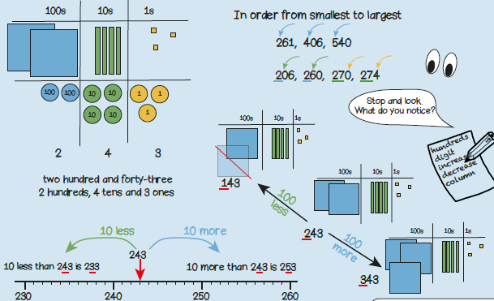  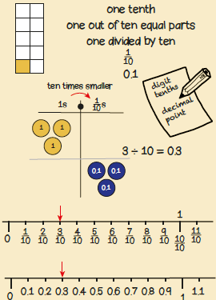 |  | 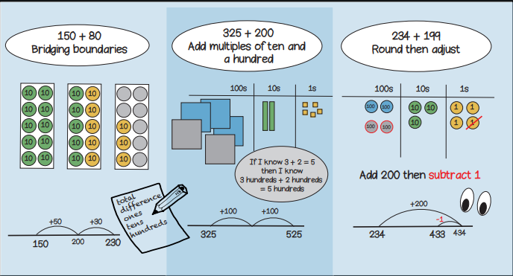  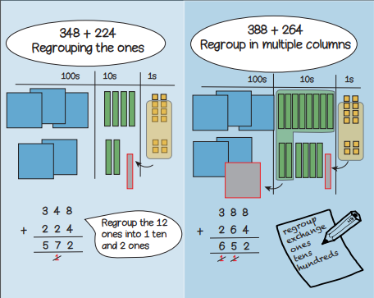
Vocabulary and meanings |  | Vocabulary and meanings
Digit/numerals | A single number to represent values in mathematics | Regroup | Where groups of 10 are moved to a different place value while performing addition or subtraction.  Year 3, Term 1 Knowledge Organiser for Place Value and Addition (mental methods).
zero | Holds a place in a number or represents nothing.
ones | 1-digit number = 1 - 9
tens | 2-digit numbers = 10 - 99 | Total | A whole or complete amount.
hundreds | 3-digit numbers = 100 – 999
 |  | Plus | The operation of addition.
value | How much each digit/numeral is representing.
exchange | Changing a larger value number into a smaller value number. For example, 1 ten = 10 ones so to change 1 ten to get 10 ones is exchanging
 |  | Sum | The result of adding 2 or more numbers together.
columns | Vertical lines to the left and right to separate number values.  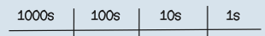 | Addend | Any number that’s added to another.
position | Where a number is placed on a number line.
more | A number gets bigger in value; 8 10 12 14
less | A number gets smaller in value; 12 10 8 6

