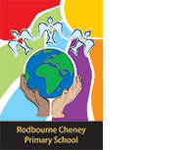
Class Newsletter: Year 3
Date: Thursday 3rd September 2026

Dear Parents and Children,
Firstly, I would like to take this opportunity to say a huge welcome to Year 3. I hope you all had a lovely summer, and I am really excited to welcome you back to school and to start term 1.
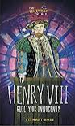
This term our topic is ‘Who has changed our world?’. We will be learning about Henry VIII, and we will be reading:

Here are some book recommendations to help with learning at school this term:
Henry VIII
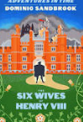
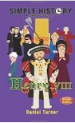
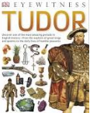
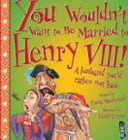
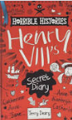

Maths Learning
In Maths this term we will be looking at place value of 3-digit numbers. We will be representing, recognising and partitioning 3-digit numbers. We will also be looking at the properties of shapes.
English Learning
Reading
In Reading this term, we will be reading ‘The Iron Man’ by Ted Hughes.
Writing
In Writing this term, we will be starting with reading the poem ‘Hope’ is a Thing with Feathers’. We will be writing thinking about what hope means, and we will create a class poem of our own adaptation. After this, we will be writing a setting description and a diary entry based on our text ‘The Iron Man’.
Values
This term we will be focusing on the values, Respect and Courage and this will continue to link into our whole school Values ethos and our 3 school rules. These are; Be safe, be kind, be respectful. We will use on these rules to enable us to keep safe around school, with our peers and the adults around the school.
Reading Books and Home Learning
Home Learning, will resume in Term 1. It will be sent out on a Friday and collected in on the following Thursday. It will consist of weekly spellings, and times tables which should both be completed 5 times within the week.
It remains our expectation that the children read regularly at home and record what they read in their Reading Records. We would like the children to be reading at least 4 times a week at home. Please see the end of the letter for some recommended reads for Year 3 children.

PE

Our PE days are on Monday and Wednesday your child can come to school in their PE kit. Their PE kit must include blue or black shorts or trousers, a white or sports PE top and trainers. Please make sure trousers and a jumper are worn in the winter months.

School uniform
It is important that our children come to school in correct school uniform.
Blue jumper
White or blue polo shirt
Black or grey shorts
Black or grey skirt
Blue summer dress
Children are able to wear all black footwear.

Warm regards,
Mrs Hinton

Year 3 and 4 Book recommendations:
