Light is a form of energy that makes it possible to see.

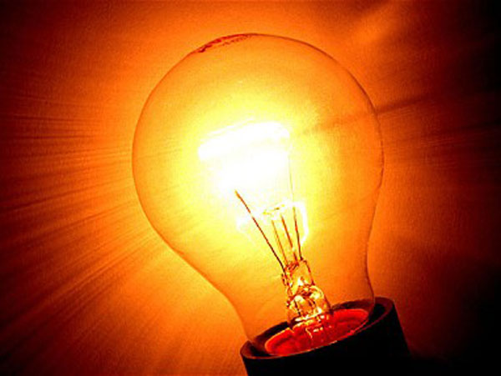

Artificial light sources are human-made devices that produce light. Torches and candles are examples of artificial light sources.

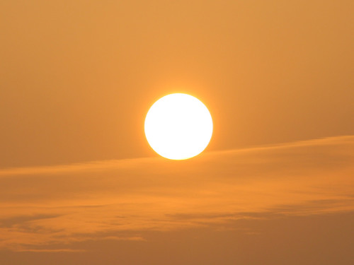

Natural light sources are found in nature. The sun and lightening are examples of natural light sources.

Key knowledge

Year 3 Science Knowledge Organiser -Term 1 - Light

|  |  |
| --- | --- |
| Key vocabulary | |
| Dark | The absence of light. |
| Light source | An object which gives out light. |
| Mirror | A highly reflective surface which shows a reflection. |
| Reflect | To bounce off or throw something back. |
| Opaque | A material light can’t pass through and you can’t see through them. |
| Translucent | A material light can pass through and you can partially see through them. |
| Transparent | A material light can pass through and you can see through them. |
| Shadow | When the path of light from a light source is blocked by an object. |

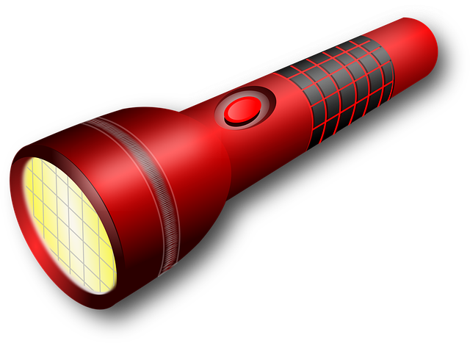

The light from the sun can be dangerous. It can damage our eyes. We must never look directly at the sun. We can protect our eyes by wearing sunglasses or sunhats in bright sunlight.

Key knowledge