Subtraction (Mental Strategies) |  | Multiplication (Tables)
Manipulatives and strategies |  | Manipulatives and strategies
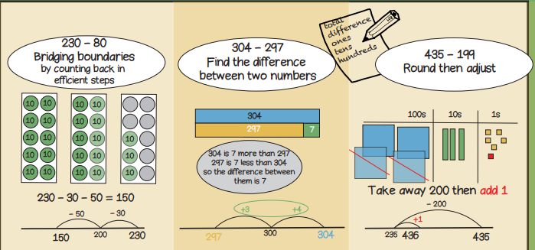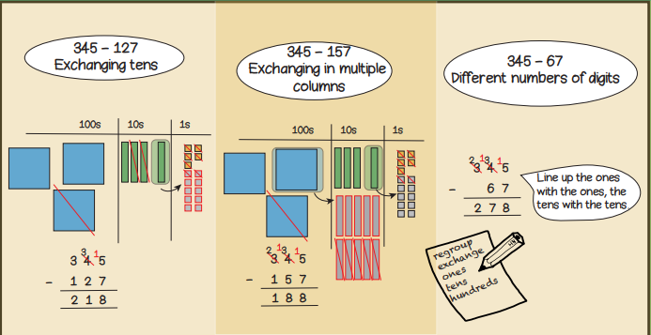  Year 3, Term 2 Knowledge Organiser for Subtraction (Mental Methods), Multiplication tables and Geometry (Properties of Shape)  Geometry (Properties of Shapes)  Manipulatives and strategies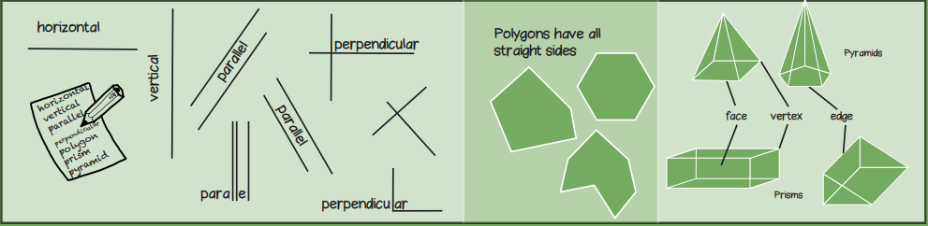 |  | 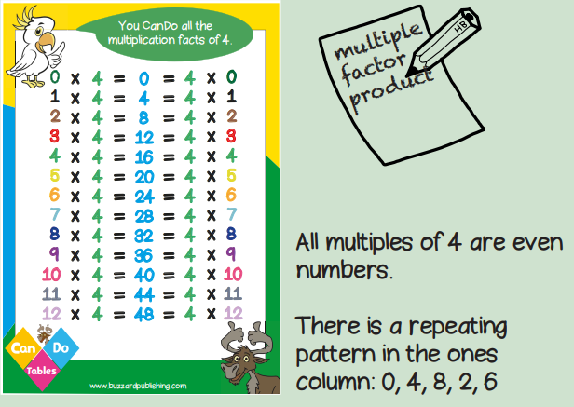  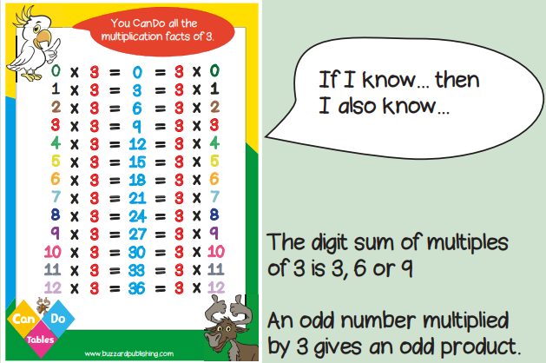  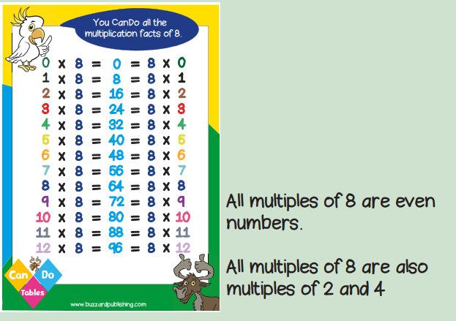
Vocabulary and meanings |  | Vocabulary and meanings
Digit/numerals | A single number to represent values in mathematics | even | A number that can be divided into two equal groups.
zero | Holds a place in a number or represents nothing. | divisible | When one number can be divided by another.
ones | 1-digit number = 1 - 9 | horizontal | A line that runs from side to side (left to right, or right to left).
tens | 2-digit numbers = 10 - 99 | vertical | A line that runs from top to bottom (straight down, or straight up).
hundreds | 3-digit numbers = 100 – 999 | perpendicular | A straight line at an angle of 90 degrees.
 |  | equi-distant | When two things are the same distance apart from a certain point.
regroup | Rearranging numbers into groups by place value to make it easier to carry out operations. | polygon | A 2-D shape with sides that are straight and create a fully enclosed space.
total | A whole or complete amount. | polyhedron | A 3-D shape with flat polygon faces, sharp corners and straight edges.
 |  | face | Flat or curved surface on a 3D shape.
factor | A number that fits exactly into a given number, or divides a particular number with no remainder. | edge | Where two faces meet.
product | The result of multiplying two or more numbers together. | vertex | A corner where edges meet.
odd | A number that can’t be divided into two equal groups.

