Addition and Subtraction (Mental Strategies) |  | Multiplication (Tables)
Manipulatives and strategies |  | Manipulatives and strategies
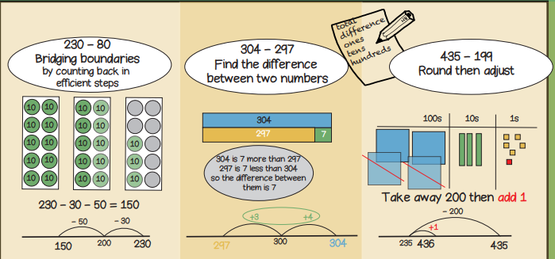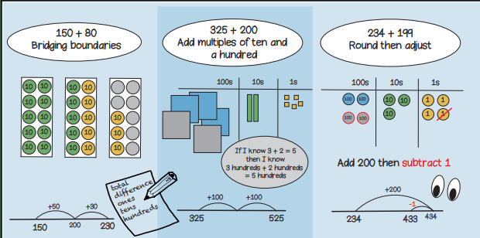 |  | 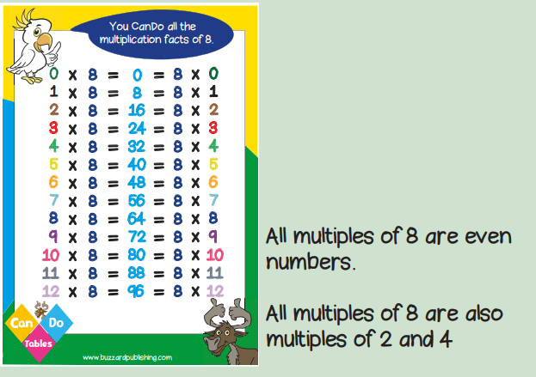  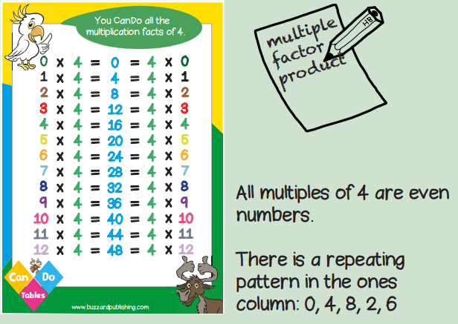  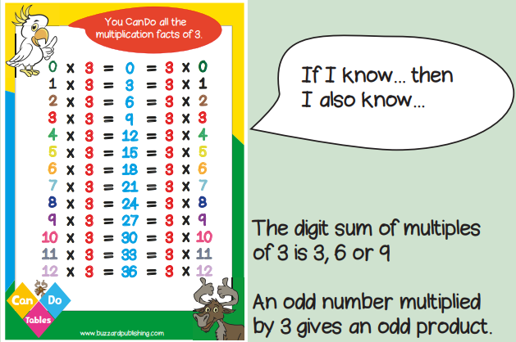  Year 3, Term 2 Knowledge Organiser for Addition and Subtraction (Mental Methods) and Multiplication tables.
Vocabulary and meanings |  | Vocabulary and meanings
Factor | A number that fits exactly into a given number, or divides a particular number with no remainder. | Hundreds | 3-digit numbers = 100 – 999
Product | The result of multiplying two or more numbers together. | Total | A whole or complete amount.
Multiple | 1-digit number = 1 - 9
Odd | A number that can’t be divided into two equal groups. | Sum | The result of adding 2 or more numbers together.
Even | A number that can be divided into two equal groups. | Addend | A number added to another.
Even | A number that can be divided into two equal groups. | Subtract | Taking away one number from another.
Divisible | When one number can be divided by another. | Difference | The result of subtracting one number from another, indicating how much bigger or smaller one number is than another.
Zero | Holds a place in a number or represents nothing. | Bridge | A mental strategy which uses addition or subtraction to cross a number boundary.
Zero | Holds a place in a number or represents nothing. | Partition | Breaking a number into smaller, more manageable parts to make calculations easier.
Regroup | Rearranging numbers into groups by place value to make it easier to carry out operations.
Ones | 1-digit number = 1 - 9
Tens | 2-digit numbers = 10 - 99

