Multiplication and Division |  | Addition and Subtraction
Manipulatives and strategies |  | Manipulatives and strategies
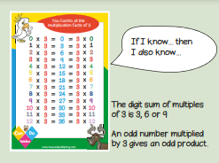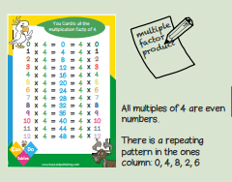  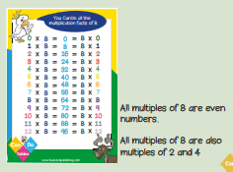  Year 3, Term 2 Multiplication and Division and Addition and Subtraction, |  | 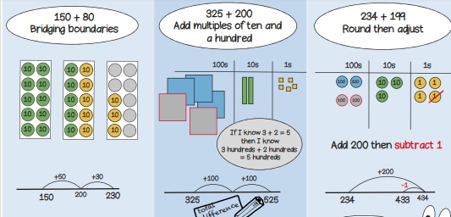  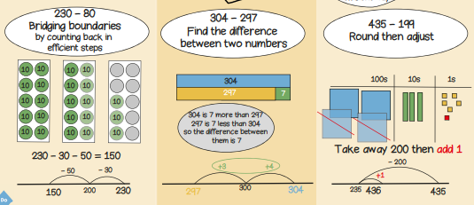
Vocabulary and meanings |  | Vocabulary and meanings
divisible | Capable of being divided. Mathematics. capable of being evenly divided, without remainder. | regroup | Regrouping means rearranging numbers into groups by place value to make it easier to carry out operations
factor | A factor in maths is one of two or more numbers that divides into a number without a remainder, making it a whole number. | ones | 1-digit number = 1 - 9
product | The product meaning in maths is a number that you get to by multiplying two or more other numbers together. For example, if you multiply 2 and 5 together, you get a product of 10. | tens | 2-digit numbers = 10 - 99
Multiple | A multiple in math are the numbers you get when you multiply a certain number by an integer. For example, multiples of 5 are: 10, 15, 20, 25, 30… | hundreds | 3-digit numbers = 100 – 999
odd | Odd numbers are the numbers that cannot be divided by 2 evenly. It cannot be divided into two separate integers evenly. | total | The answer to a timsing or adding problem.
even | A number that is divisible by 2 and generates a remainder of 0 is called an even number. | plus | Adding numbers together, the amount will get larger.
 |  | sum | The answer to a timsing or adding problem.

