
Class Newsletter: Year 3
Date: Monday 3rd November 2025

Dear Parents and Children,
Welcome back to Term 2!
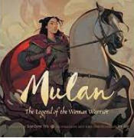
This term our topic is ‘Around the World’. Our topic based books for this term are:
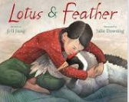

Here are some book recommendations to help with learning at school this term:
China
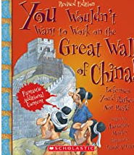
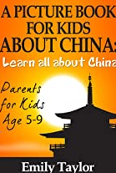
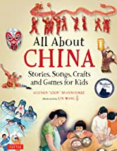

Maths Learning
In Maths term we will be looking at building our 3, 4 and 8 times tables. We will then be learning mental methods for both addition and subtraction.
English Learning
Reading
In Reading this term, we will be reading ‘Winter’s Child’ by Angela McAllister.
Writing
In Writing this term, we will be writing a character description and a persuasive letter based on our class text ‘Winter’s Child.’
Values
This term we will be focusing on the values, Equality and Hope and this will continue to link into our whole school Values ethos and our 3 school rules. These are; Be safe, be kind, be respectful. We will use on these rules to enable us to keep safe around school, with our peers and the adults around the school.
Reading Books and Home Learning
Home Learning, will continue in Term 2 and it will still be collected in on a Thursday and sent out on Friday. It will consist of 6 spellings for the children to practice daily ready for their spelling test on Friday. These spellings will coincide with the spelling lessons throughout the week. The children will also be given a times tables test. They will also be tested on these times tables on a Friday. When the children score 36/36 within 3 minutes, they will then move onto the next level. It remains our expectation that the children read regularly at home (at least 5 times a week) and record what they read in their Reading Records; thank you again for your support with this. Please see the end of the letter for some recommended reads for Year 3 children.
The children will also be given their Times Tables Rockstars logins for them to use at home.

PE

Our PE days are on Monday and Wednesday your child can come to school in their PE kit. Their PE kit must include blue or black shorts or trousers, a white or sports PE top and trainers. Please make sure trousers and a jumper are worn in the winter months. This term, we will be learning Dodgeball and Handball.

School uniform
It is important that our children come to school in correct school uniform.
Blue jumper
White or blue polo shirt
Black or grey shorts
Black or grey skirt
Blue summer dress
Children are able to wear all black footwear.

Warm regards,
Mrs Hinton

Year 3 and 4 Book recommendations:
