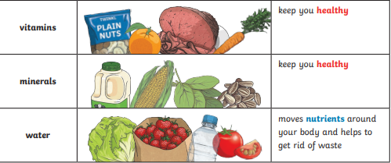
Key knowledge
Year 3 Science Knowledge Organiser -Term 2 – Animals including Humans
Key vocabulary
Healthy | In a good physical and mental condition.
Nutrients | Substances that living things need to stay alive and healthy.
Energy | Strength to be able to move and grow.
Saturated fats | Types of fats, considered to be less healthy, that should only be eaten in small amounts.
Unsaturated fats | Fats that give you energy, vitamins and minerals.
Vertebrate | Animals with backbones.
Invertebrates | Animals without backbones.
Muscles | Soft tissues in the body that contract and relax to cause movement.
Tendons | Cords that join muscles to bones.
Joints | Areas where two or more bones are fitted together.
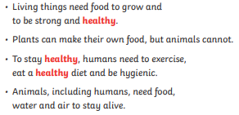
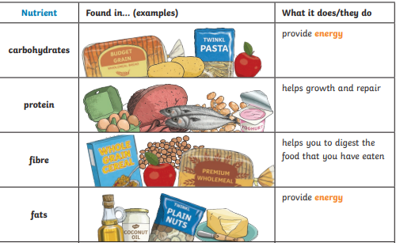
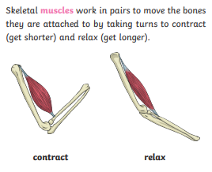
Key knowledge

