Fractions |  | Written Methods (Addition and Subtraction)
Manipulatives and strategies |  | Manipulatives and strategies
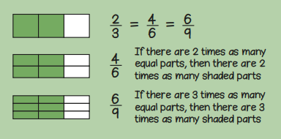  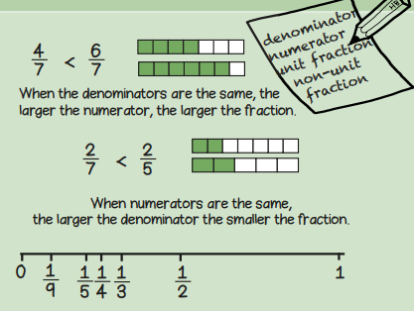  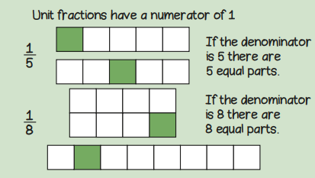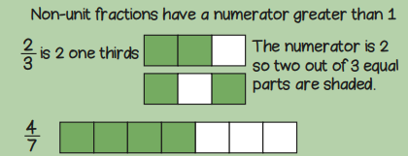 |  | 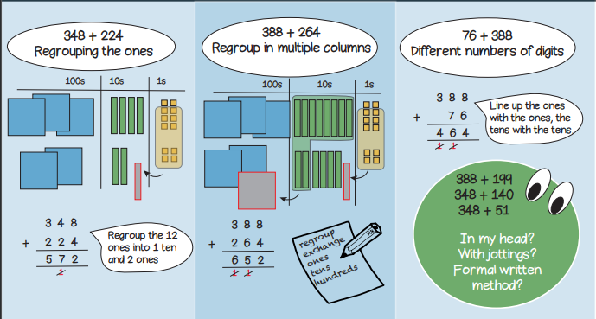  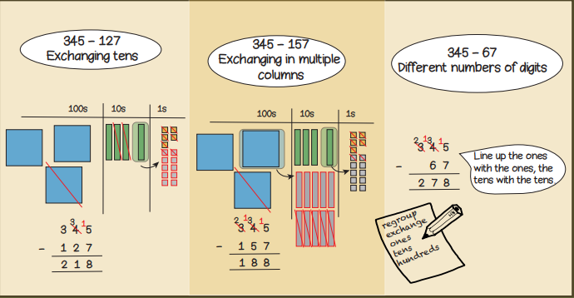  Year 3, Term 3 Knowledge Organiser for Fractions and written methods for addition and subtraction.
Vocabulary and meanings |  | Vocabulary and meanings
Denominator | The bottom number in a fraction. | subtrahend | The number being subtracted from the other.
Numerator | The top number in a fraction. | exchange | Changing a larger value number into a smaller value number. For example, 1 ten = 10 ones so to change 1 ten to get 10 ones is exchanging
Unit fraction | Any fraction where the numerator is 1. | ones | 1-digit number = 1 - 9
Non-unit fraction | Any fraction where the numerator is not 1. | tens | 2-digit numbers = 10 - 99
equivalent | Fractions with the same value. | hundreds | 3-digit numbers = 100 – 999
 |  | regroup | Where groups of 10 are moved to a different place value while performing addition or subtraction.
subtract | Taking away one number from another. | sum | The result of adding 2 or more numbers together.
minuend | The first number, the number which you take the other away from.

