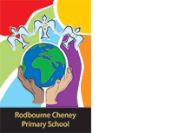
Class Newsletter: Year 3
Date: Tuesday 6th January 2026

Dear Parents and Children,
Welcome back to Term 3! I hope you had an amazing Christmas and restful New Year!
This term our topic is ‘Is the past the key to our future?’. This term, we will be reading:
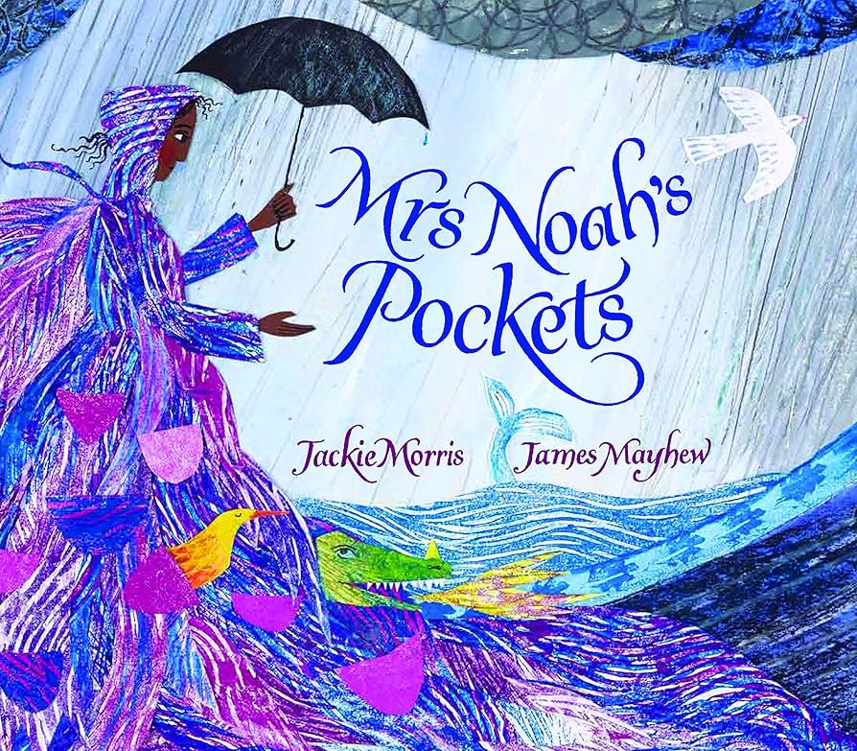
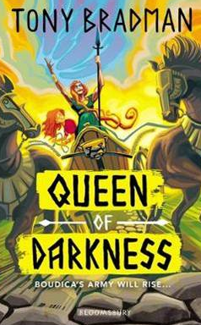
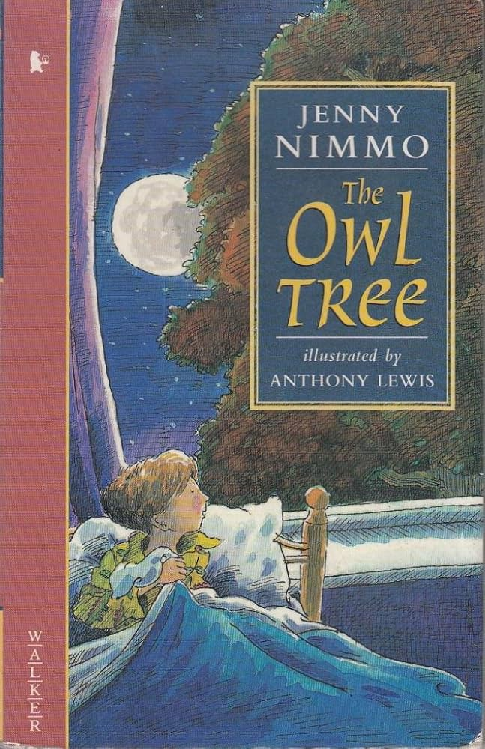
Reading book Writing book Topic book

Here are some book recommendations to help with learning at school this term:
Romans, Celts and Boudicca
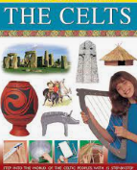
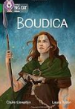
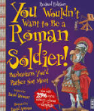
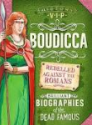
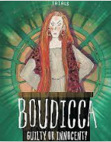

Maths Learning
In Maths this term, we will be learning about fractions. We will also be looking at addition and subtraction again, this time with a focus of written methods.
Reading Learning
In Reading this term, we will be reading ‘The Owl Tree’ written by Jenny Nimmo.
Writing Learning
In Writing this term, we will be reading ‘Mrs Noah’s Pockets’ by Jackie Morris and James Mayhew, and our writing will be based off of this book. The children will be writing a retelling of a section from the story. They will also be writing a non-chronological report about their own troublesome creature.
Values
This term we will be focusing on the values, Freedom and Tolerance and this will continue to link into our whole school Values ethos and our 3 school rules. These are; Be safe, be kind, be respectful. We will use on these rules to enable us to keep safe around school, with our peers and the adults around the school.
Reading Books and Home Learning
Home Learning, will continue in Term 3 and it will be set each Friday, to be handed in and marked on the following Thursday. It will consist of weekly spellings to practice, your child’s current times tables test and a spelling activity. Spellings and Times tables tests will be on Friday’s. The children are timed for 3 minutes in class during their times tables test, once they have got all answers correct, they will move onto the next times tables sheet.
PE

Our PE days are on Monday and Wednesday. Your child can come to school in their PE kit. Their PE kit must include blue or black shorts or trousers, a white or sports PE top and trainers. Please make sure trousers and a jumper are worn in the winter months.

School uniform
It is important that our children come to school in correct school uniform.
Blue jumper
White or blue polo shirt
Black or grey shorts
Black or grey skirt
Blue summer dress
Children are able to wear all black footwear.

Snack

In year 3, the children can bring in their own snack. Please ensure this is a healthy snack.
Warm regards
Mrs Hinton.

Year 3 and 4 Book recommendations:
