|  |
| --- |
| **Class Newsletter: Year 3 Robins**  **Date: Tuesday 7th January 2025** |

Dear Parents and Children,

Welcome back to Term 3! I hope you had an amazing Christmas and restful New Year!

This term our topic is ‘Is the past the key to our future?’. This term, we will be reading:

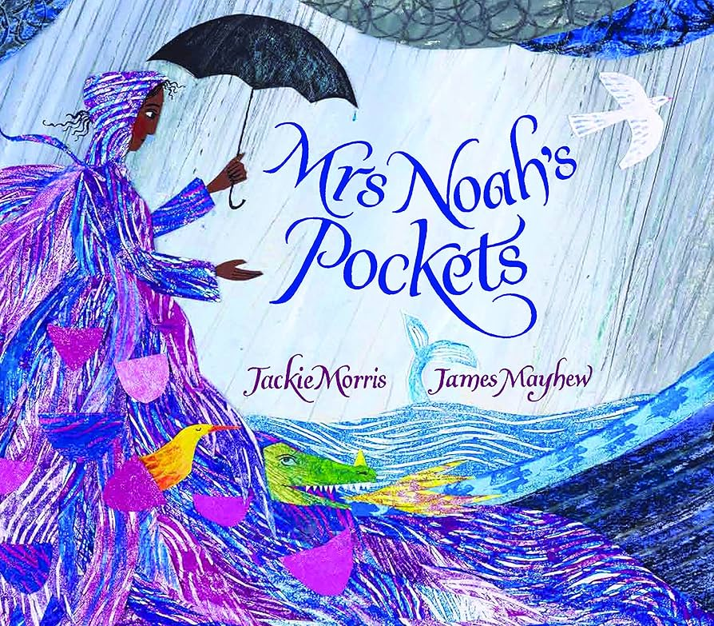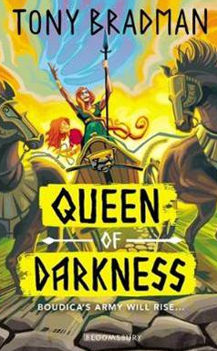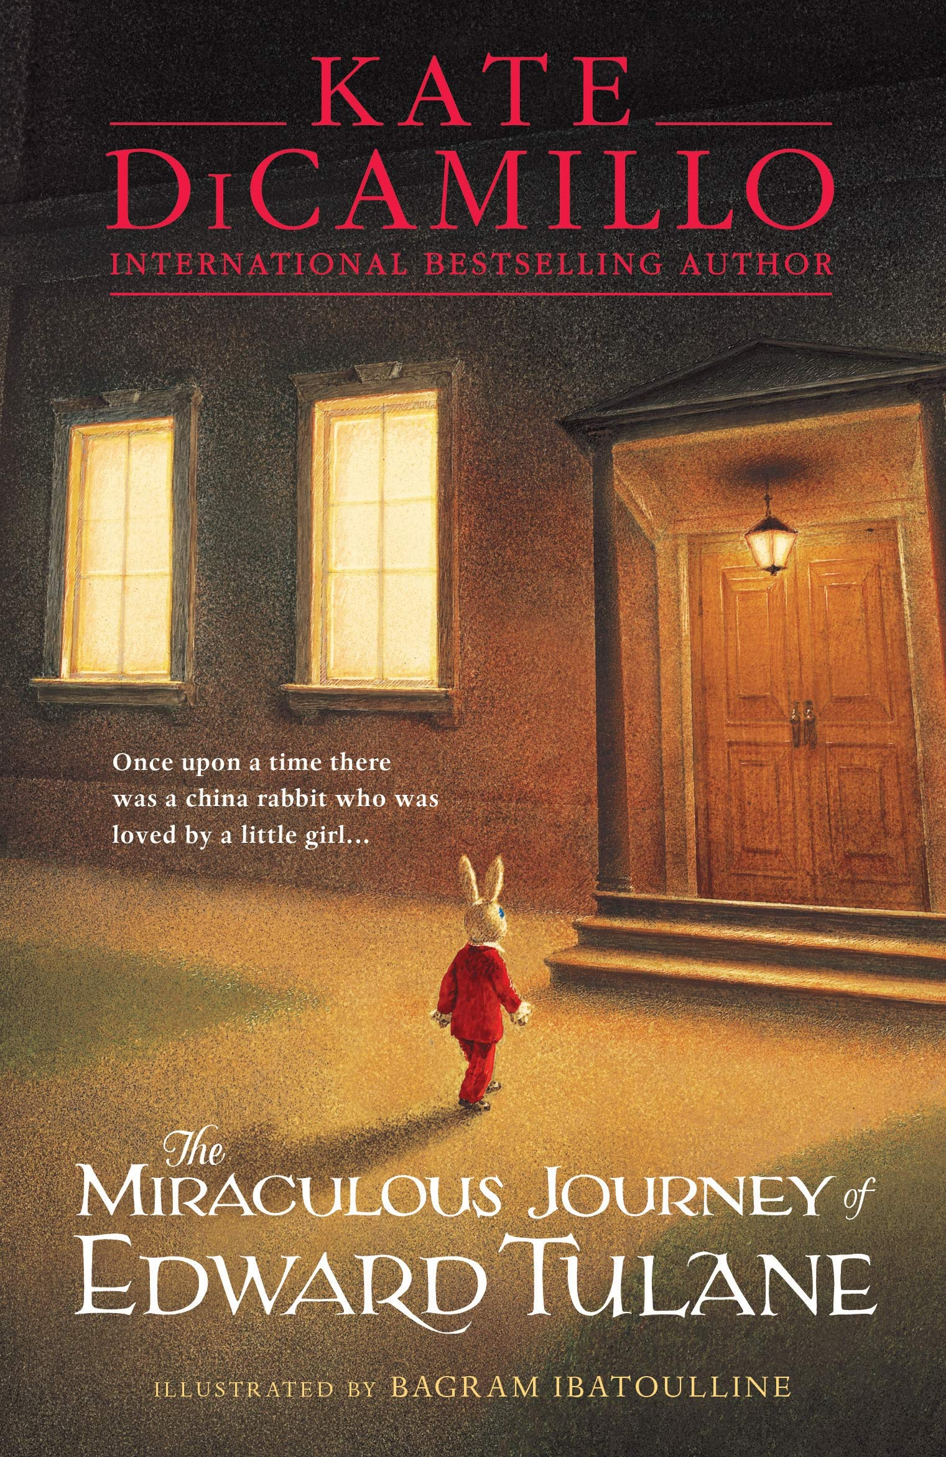

Reading book Writing book Topic book

Here are some book recommendations to help with learning at school this term:

|  |
| --- |
| **Romans, Celts and Boudicca** |
|  |

Maths Learning

In Maths this term, we will be learning about fractions. We will also be looking at addition and subtraction again, this time with a focus of written methods.

Reading Learning

In Reading this term, we will be reading ‘The Miraculous Journey of Edward Tulane’ by Kate DiCamillo.

Writing Learning

In Writing this term, we will be reading ‘Mrs Noah’s Pockets’ by Jackie Morris and James Mayhew, and our writing will be based off of this book. The children will be writing a retelling of a section from the story. They will also be writing a non-chronological report about their own troublesome creature.

Values

This term we will be focusing on the values, Freedom and Tolerance and this will continue to link into our whole school Values ethos and our 3 school rules. These are; Be safe, be kind, be respectful. We will use on these rules to enable us to keep safe around school, with our peers and the adults around the school.

Reading Books and Home Learning

Home Learning, will continue in Term 3. It will be set each **Monday**, to be handed in and marked on the **Friday**. It will be based on prior learning and used as a way of consolidating what the children have already been taught, including weekly spellings and should practice their times tables at home. It remains our expectation that the children read regularly at home and record what they read in their Reading Records; thank you again for your support with this. Please see the end of the letter for some recommended reads for Year 3 children. The children will now also have their login for TT Rockstars to complete at home. Their logins can be found on the inside of the front cover of their homework books.

PE

Our PE days are on **Monday and Wednesday.** Your child can come to school in their PE kit. Their PE kit must include blue or black shorts or trousers, a white or sports PE top and trainers. Please make sure trousers and a jumper are worn in the winter months.

School uniform

It is important that our children come to school in correct school uniform.

Blue jumper

White or blue polo shirt

Black or grey shorts

Black or grey skirt

Blue summer dress

Children are able to wear **all black** footwear.

Snack

In year 3, the children can bring in their own snack. Please ensure this is a **healthy** snack.

Warm regards,

**Miss Gosling**

Year 3 and 4 Book recommendations:

