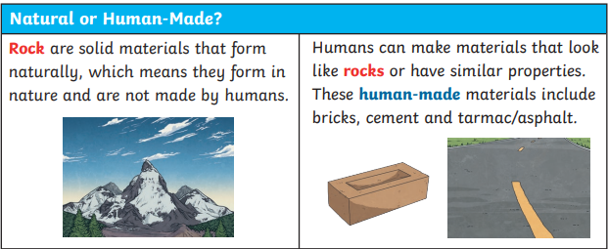
Key knowledge
Year 3 Science Knowledge Organiser -Term 3 – Rocks
Key vocabulary
Rock | Rock is a solid material that forms naturally.
Permeable | A permeable material allows liquid to pass through.
Impermeable | An impermeable material does not allow liquid to pass through it.
Weathering | Weathering is the process where rocks break down into smaller pieces or wear away over time because of rain, wind, plants or animals.
Fossilisation | Fossilisation is the process through which traces or remains of prehistoric living things become preserved.
Soil | Soil is the top layer of the Earth’s surface. It provides nutrients and support for plant life and it’s made up of minerals (from broken-down rocks), air, water and organic matter (living thi
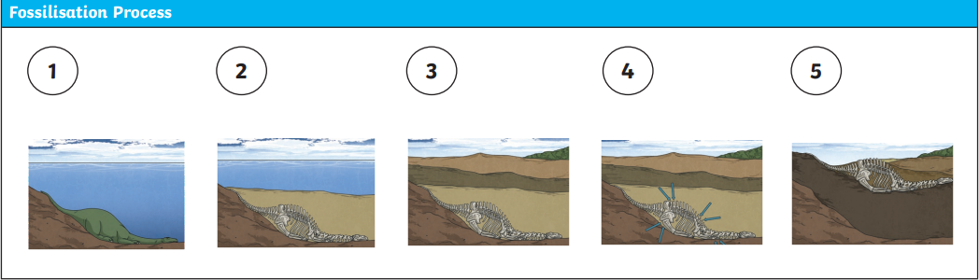
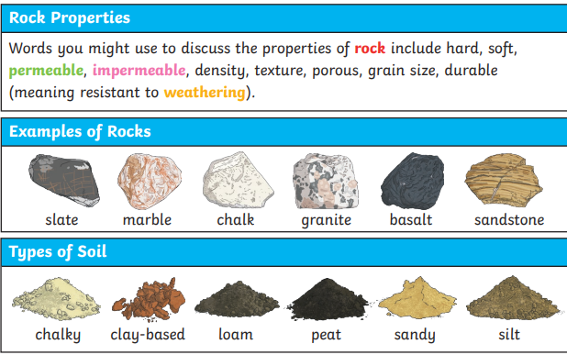
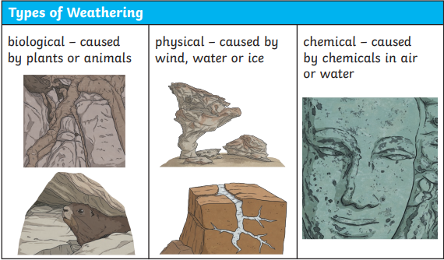
Key knowledge

