Multiplication and Division |  | Money
Manipulatives and strategies |  | Manipulatives and strategies
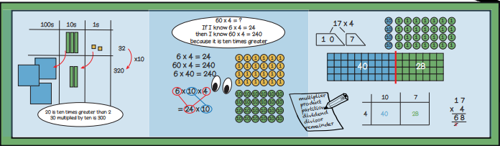  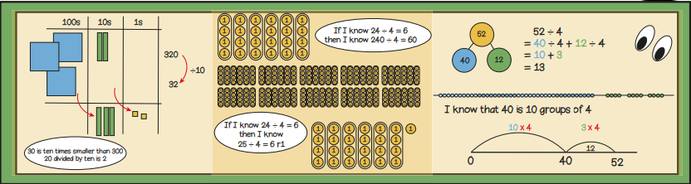  Year 3, Term 4 Knowledge Organiser for Multiplication and Division and Money. |  | 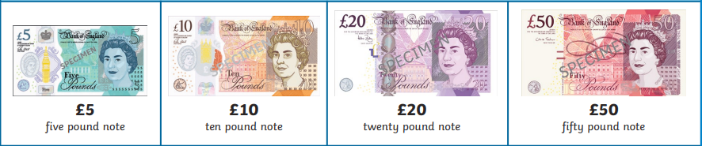  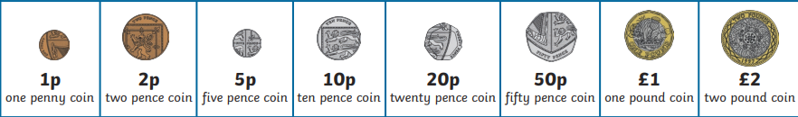  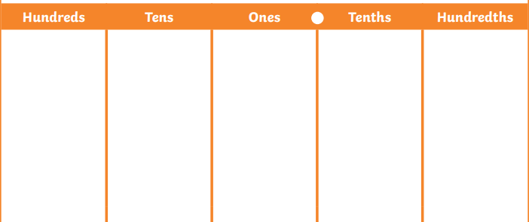            
Vocabulary and meanings |  | Vocabulary and meanings
Partition | Splitting numbers into smaller parts. | Spend | Giving money to pay for something.
Product | The result you get after multiplying numbers together. | Change | Given change when you pay too much money for something.
Regroup | Rearranging numbers into groups by place value to make it easier to carry out operations. | Pence | 100 pence in 1 pound.
Dividend | A number to be devised by another number. | Pounds | A unit of money used in the UK. There’s 100p in £1.
Divisor | The number of groups that a number is to be divided into as part of a division calculation. | Sum | The result of adding two or more numbers together.
Remainder | The amount left over when a number cannot be exactly divided by another number.

