|  |
| --- |
| **Class Newsletter: Year 3 Robins**  **Date: Monday 24th February 2024** |

Dear Parents and Children,

Welcome back to Term 4!

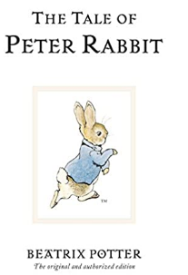This term our topic is ‘Author Study – Beatrix Potter’. We will be reading:

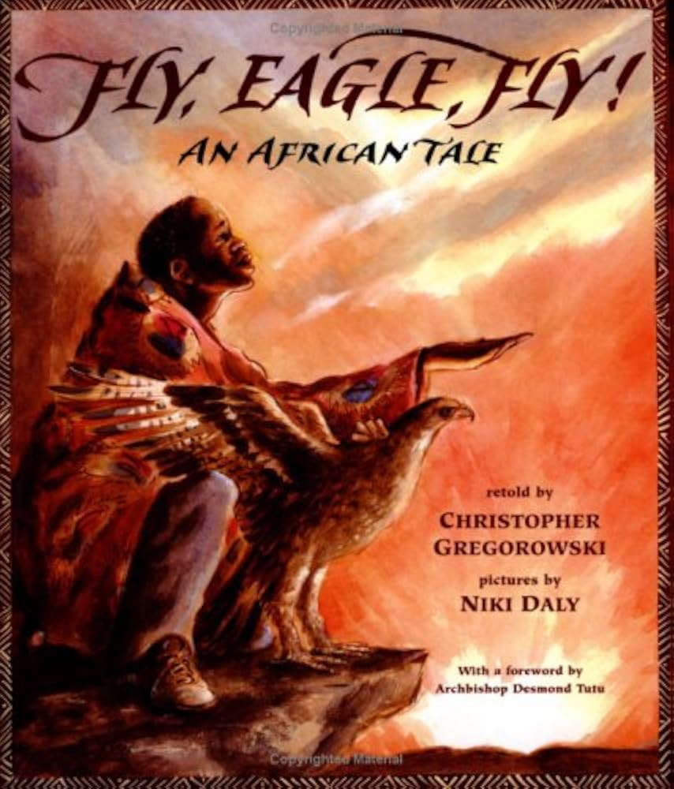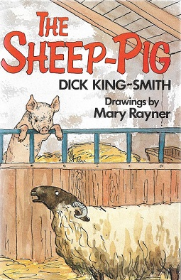

Reading book Writing book Topic book

Here are some book recommendations to help with learning at school this term:

|  |
| --- |
| **Beatrix Potter** |
|  |

Maths Learning

Reading Learning

In Reading this term, we will be reading ‘The Sheep-Pig’ by Dick King-Smith.

Writing Learning

In Writing this term, we will be reading ‘Fly, Eagle, Fly!’ by Christopher Gregorowski. For their fiction writing piece, the children will be retelling the story. For their non-fiction writing piece, they will be writing a persuasive speech.

Values

This term we will be focusing on the values, Love and Appreciation and this will continue to link into our whole school Values ethos and our 3 school rules. These are; Be safe, be kind, be respectful. We will use on these rules to enable us to keep safe around school, with our peers and the adults around the school.

Reading Books and Home Learning

Home Learning, will continue in Term 3 and it will be set each Monday, to be handed in and marked on the Friday. It will be based on prior learning and used as a way of consolidating what the children have already been taught, including weekly spellings and should practice their times tables at home. It remains our expectation that the children read regularly at home and record what they read in their Reading Records; thank you again for your support with this. Please see the end of the letter for some recommended reads for Year 3 children.

The children will now also have their login for TT Rockstars to complete at home.

PE

Our PE days are on **Monday and Wednesday** your child can come to school in their PE kit. Their PE kit must include blue or black shorts or trousers, a white or sports PE top and trainers. Please make sure trousers and a jumper are worn in the winter months.

School uniform

It is important that our children come to school in correct school uniform.

Blue jumper

White or blue polo shirt

Black or grey shorts

Black or grey skirt

Blue summer dress

Children are able to wear **all black** footwear.

Snack

In year 3, the children can bring in their own snack. Please ensure this is a healthy snack.

Warm regards,

**Miss Gosling**

Year 3 and 4 Book recommendations:

