Year 3 Knowledge Organiser

The Lake District and the Alps.

|  |  |
| --- | --- |
| Key vocabulary | |
| Hill | A naturally raised area of land. |
| Mountain | A very tall raised area of land (above 600m) |
| Peak or summit | The very top of a mountain or hill. |
| Range | A group of mountains or hills |
| Valley | A low area of land between hills or mountains |
| Alps | The end of a river |
| Hill | A naturally raised piece of land which isn’t as big as a mountain. |
| The Alps | The Alps are the highest and most extensive mountain range system that lies entirely in Europe. |

Key facts

* The Lake District, also known as the Lakes or Lakeland, is a mountainous [region](https://kids.kiddle.co/Region) in [North West England](https://kids.kiddle.co/North_West_England)
* A popular holiday destination, it is famous for its lakes, forests and mountains
* The **Lake District National Park** was established in 1951 and covers an area of 2,362 square kilometres (912 sq mi).
* It has associations with [William Wordsworth](https://kids.kiddle.co/William_Wordsworth) and other Lake Poets and also with [Beatrix Potter](https://kids.kiddle.co/Beatrix_Potter) and [John Ruskin](https://kids.kiddle.co/John_Ruskin)
* The Lake District is today completely within [Cumbria](https://kids.kiddle.co/Cumbria),
* All the land in England higher than 3,000 feet (914 m) above sea level lies within the National Park, including [Scafell Pike](https://kids.kiddle.co/Scafell_Pike), the highest mountain in England.
* The Alps is the greatest mountain range of Europe. ...
* The highest mountain in the Alps is Mont Blanc, at 4,808 metres (15,774 ft), on the Italian–French border.
* The Alps stretch from Austria and Slovenia in the east, through Italy, Switzerland, Liechtenstein and Germany to France in the west.

The Lake District

|  |  |
| --- | --- |
| Questions | |
| What is the physical geography of the lake district? | The physical geography includes, hills, mountains, forests, valleys, rivers and lakes. |
| What is the human geography of the lake district? | The human geography includes, towns, villages, farming and tourism. |
| What is a national park? | A national park is a park or a area of land officially recognized and protected by a nation's government. National parks are often made to protect the animals that live inside them or the land itself. There are many National Parks in the world. |
| What is the climate like in the lake district? | The Lake District has milder winters and cooler summers. The weather is generally wet and mild. |

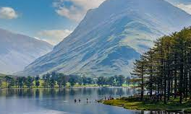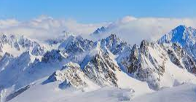

The Alps

