Key knowledge
Forces
Year 5 Science Knowledge Organiser
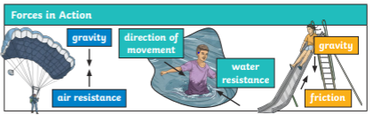

Forces can be pushes or pulls. There are lots of types of forces in action that we see at play in day-to-day life; gravity, air resistance, water resistance and friction.
Levers have three parts; the pivot, the force applied to one end and the load being moved at the other end. The distance between the pivot and where the force is applied affects how easy it is to lift the load.
A pulley with a single wheel allows you to change the direction of the force applied when lifting. The more wheels added to a pulley system, the less force is needed to lift the load.
When gears are connected, they always rotate in opposite direction, allowing them to change the direction of motion. If the first gear is larger than the second, the second gear will rotate faster.

Key vocabulary
force | A force is a push or a pull that can cause an object to start or stop moving or change its speed, shape or direction.
gravity | Gravity is a pulling force exerted by the Earth.
newton | The Newton (N) is a unit of measurement used to measure force, named after Sir Isaac Newton.
friction | Friction is a contact force that occurs between two touching surfaces that are either trying to move or are already moving across each other.
air resistance | Air resistance is a form or friction that occurs between air and an object moving through it.
Water resistance | Water resistance is a type of friction that happens when water (or any liquid) pushes against an object moving through it.

