Key vocabulary
Electricity
Circuit | A path that an electrical current can flow around.
Symbol | A visual picture that stands for something else.
Cell/Battery | A device that stores chemical energy until it is needed. A cell is a single unit. A battery is a collection of cells.
Current | The flow of electrons, measured in amps.
Amps | How electric current is measured.
Voltage | The force that makes the electric current move through the wires. The greater the voltage, the more current will flow.
Resistance | The difficulty that the electric current has when flowing around a circuit.
Electrons | Very small particles that travel around an electrical circuit.
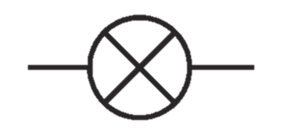
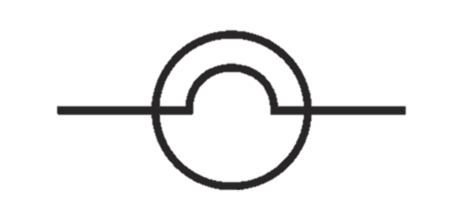

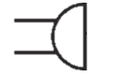
Year 6 Science Knowledge Organiser
Key Knowledge
wire
lamp/bulb (indicator)
lamp/bulb (lighting)
buzzer

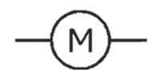


cell
motor
battery
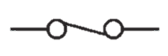
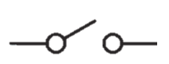

switch (closed)
switch (open)
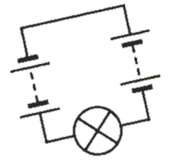



• More batteries or a higher voltage create more power to flow through the circuit.
• Shortening the wires means the electrons have less resistance to flow through

• Fewer batteries or a lower voltage give less power to the circuit.
• More buzzers or bulbs mean the power is shared by more components.
• Lengthening the wires means the electrons have to travel through more resistance

What will make a bulb brighter or a buzzer louder?

Series Circuit
A circuit that has only one route for the current to take. If more bulbs or buzzers are added, the power has to be shared and so they will be dimmer or quieter. If just one part of this series circuit breaks, the circuit is broken and the flow of current stops.

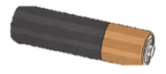

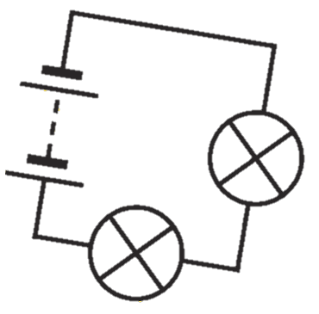
What will make a bulb dimmer or a buzzer quieter?
