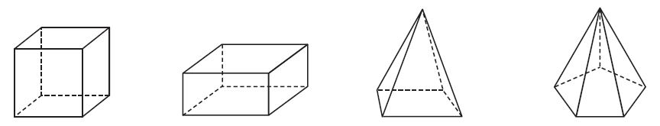
Look at these 3D shapes, which 2D shapes form their faces, don’t forget to say how many of each shape.

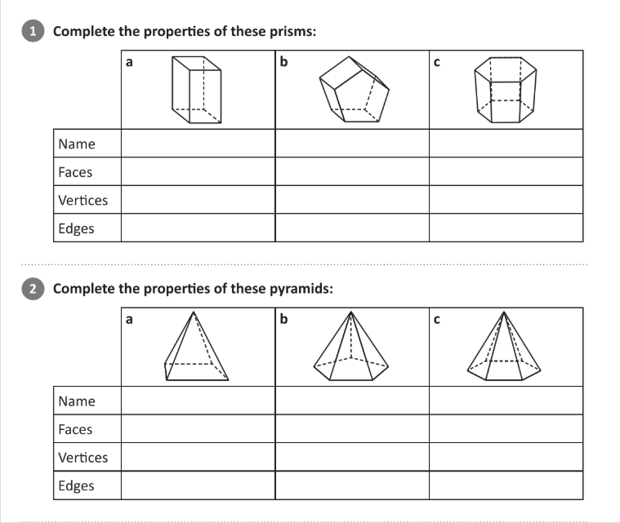
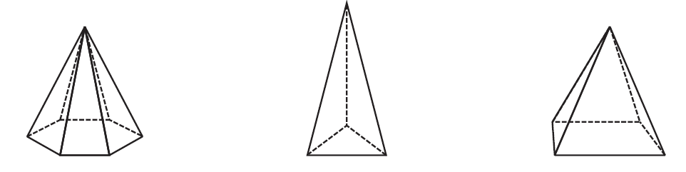
What do you notice about the number of sides on the base shape and the number of triangular faces?
What type of pyramids are these? Remember a pyramid is named after its base.
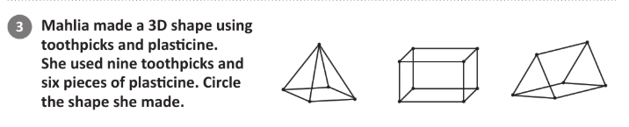
If you’ve got some straws/toothpicks and plasticine/blutack at home, try making your own shapes. I would love to see them!

