Challenge
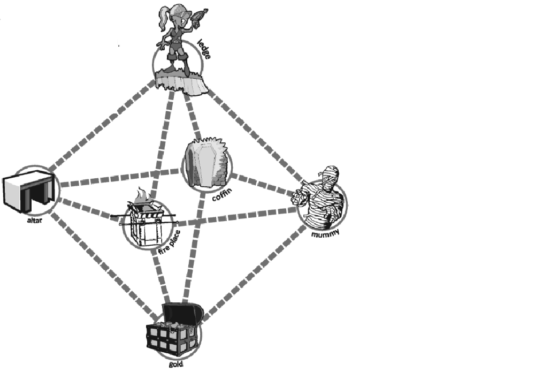
You are trapped in a tomb far underground. There are 6 key zones, the ledge, alter, coffin, mummy, fireplace, and gold.
There’s a route marked in red to get you started
Ledge – coffin - gold
To escape you must find 10 different ways to get from the ledge to the gold.

Present your findings to the Guardian of Power (that’s me!)
If they’re correct you may escape from the tomb…
If not…who knows?

Extra Challenge
There are 28 routes in total, can you find them all?

