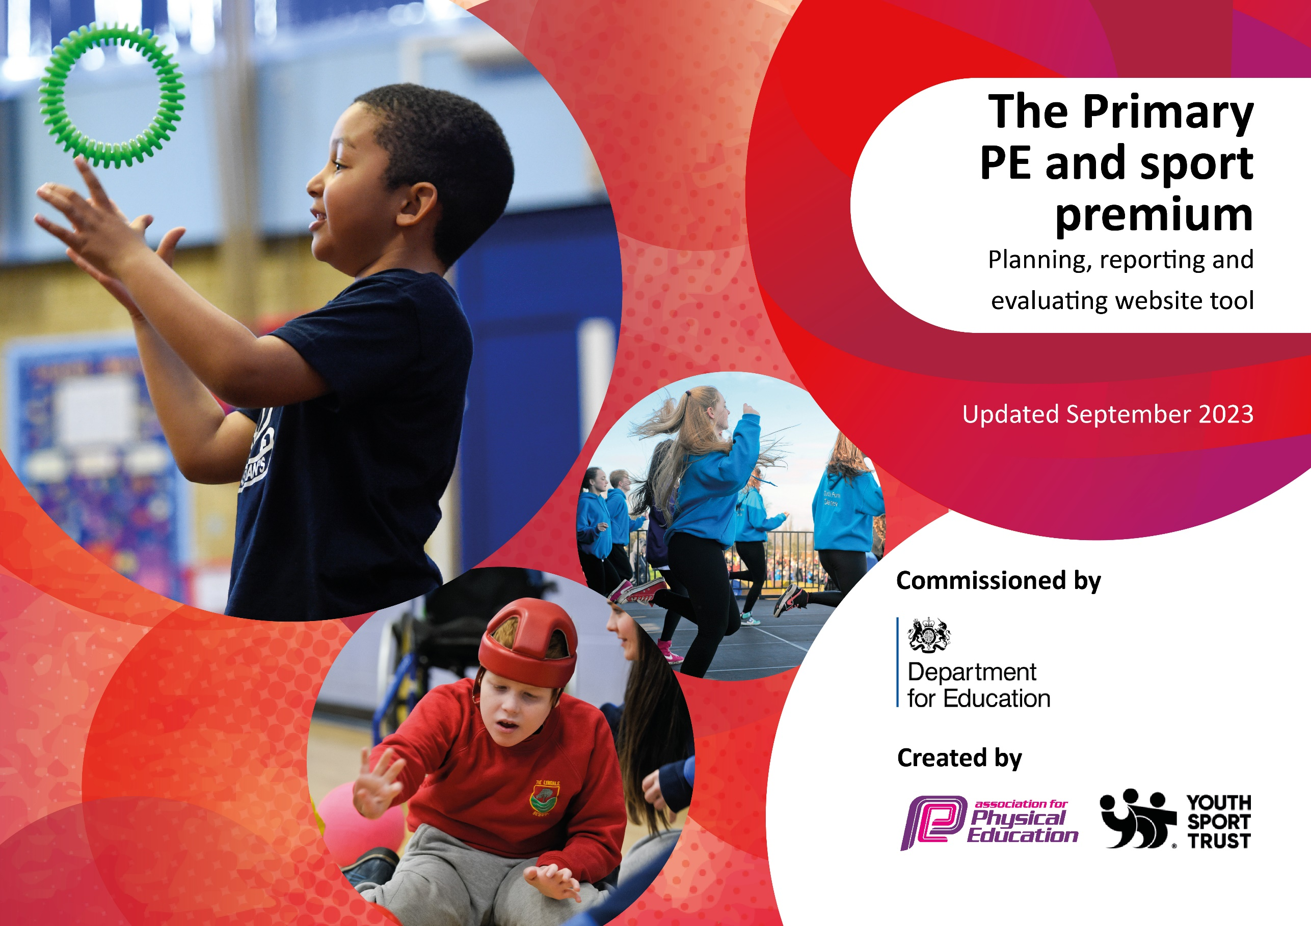

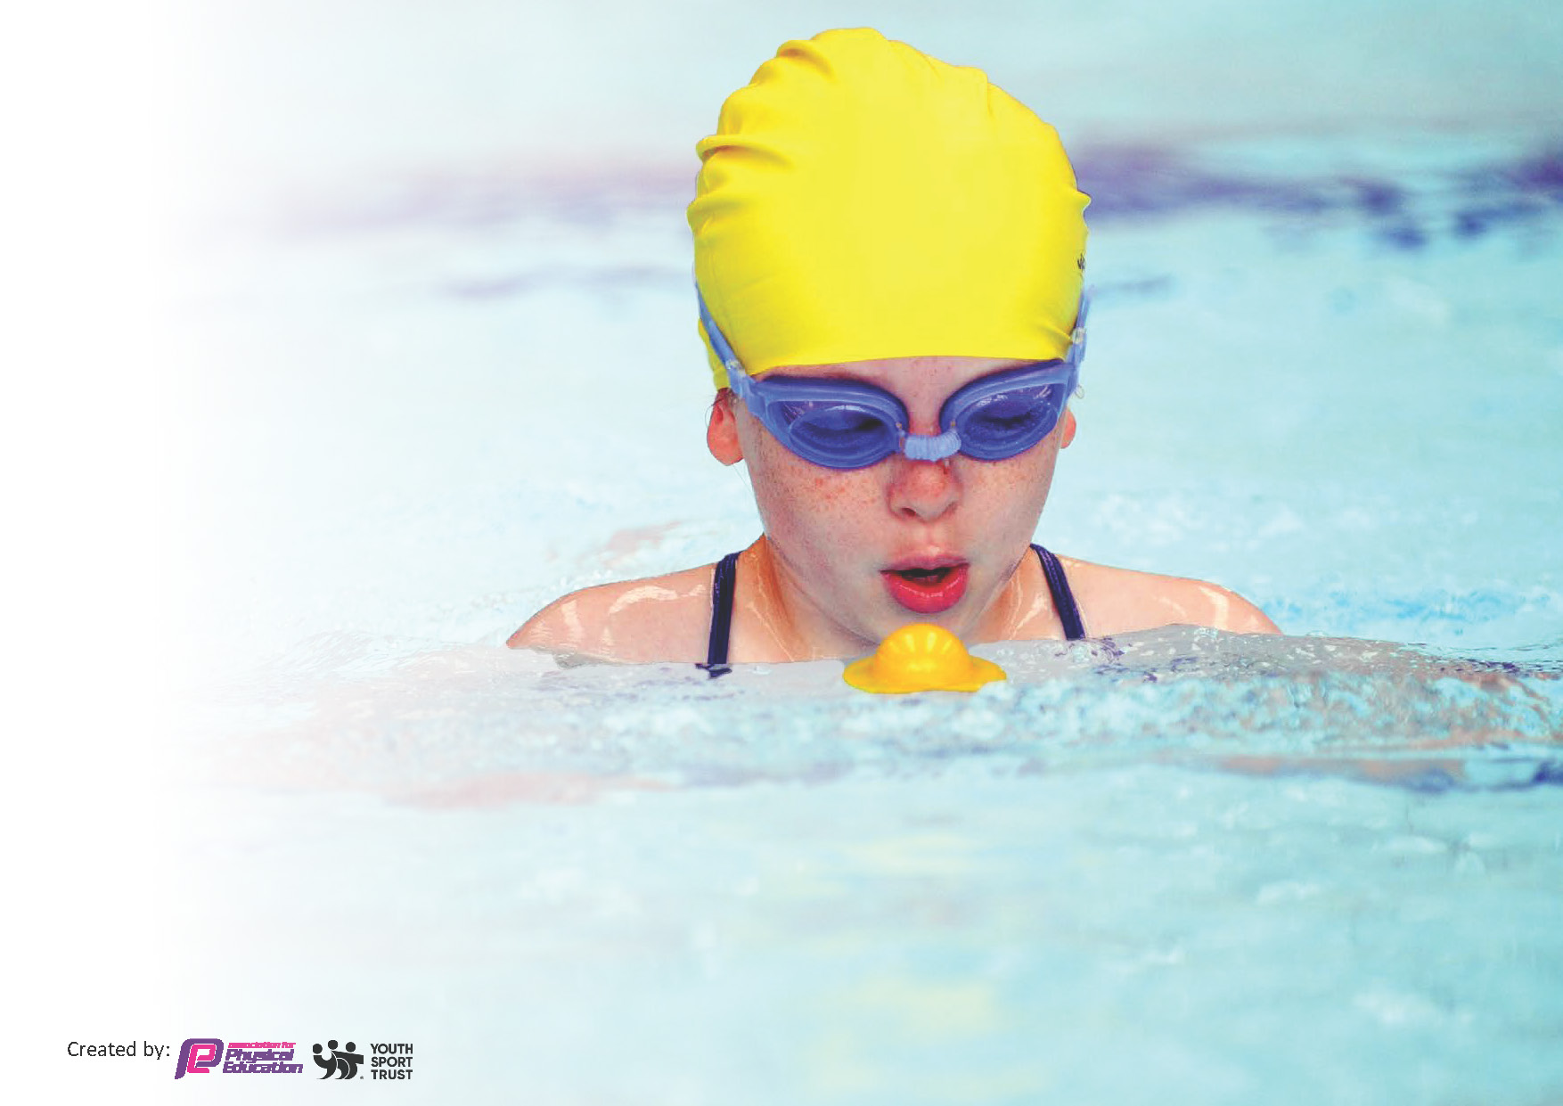
This template can be used for multiple purposes:
by:
- It enables schools to effectively plan their use of the Primary PE and sport premium
- It helps schools to meet the requirements (as set out in guidance) to publish information on their Primary PE and sport premium
- It will be an effective document to support Ofsted inspections enabling schools to evidence progress in Physical Education (PE) and evidence swimming attainment, which forms part of the PE National Curriculum. We would recommend schools consider
the Intent, Implementation and Impact of any spend, as examined within the Education Inspection Framework.

It is important that your grant is used effectively and based on school need.

Schools must use the funding to make additional and sustainable
improvements to the quality of the PE, School Sport and Physical Activity (PESSPA)
they offer. This means that you should use the Primary PE and sport premium to:

- Build capacity and capability within the school to ensure that improvements made now will benefit pupils joining the school in future years
- Develop or add to the PESSPA activities that your school already offers.

The Primary PE and sport premium should not be used to fund capital spend projects; the school’s core budget should fund these. Further detail on capital expenditure can be found in the updated Primary PE and sport premium guidance.

The Primary PE and sport premium guidance, outlines 5 key priorities that funding should be used towards. It is not

necessary that spending has to meet all the key priorities, you should select the priorities that you aim to use any funding towards.

Although completing this template is not a requirement for schools, schools are required to publish details of how they spend this funding. Schools must also outline what the impact this funding has had on pupils’ PE and sport participation and attainment and how any spending will be sustainable in the future. All funding must be spent by 31st July 2024.

The Department for Education has worked closely with the Association for Physical Education (afPE) and the Youth Sport Trust (YST) to develop this template and encourages schools to use it. This template is an effective way of meeting the reporting requirements of the Primary PE and sport premium.
Review of last year’s spend and key achievements (2023/2024)

We recommend you start by reflecting on the impact of current provision and reviewing your previous spend.

Activity/Action | Impact | Comments
- Minimum of two hour long PE sessions per week with at least one being taught by a coach or specialist. These have included Barrow Sports Coaches for football, basketball, multi-skills, cricket, rugby and orienteering.  - Make playtimes and lunchtimes active and increase physical activity levels during these times.  - Make breakfast and after school clubs active to increase physical activity levels.  - Ensure that all children take part in the daily mile using the daily mile track.  - Continue to invest in equipment as resource audits identify need and ensure the maintenance and repair of existing equipment (apparatus, PE mats etc).  - Strengthen staff skills, knowledge and capabilities of delivering high quality PE and School Sport.  - To strength teaching and learning by providing high quality organised PE LTP and lessons using IPEP.  - Employ a yoga instructor to work alongside class teachers in Reception, KS1 and KS2. | Pupils are more active in PE lessons and PE lessons are inclusive.  Pupils are active during playtimes and lunchtimes.  Children are active in breakfast and after school club.  Children’s stamina and well-being increased as well as an improvement in behaviour and concentration in lessons.  - Improved subject knowledge for all teachers in a range of sports.  - Staff feel confident to run PE sessions and necessary skills.  - Children have access to high quality PE and make good progress because of this.  - Improved pupil participation and attitude in yoga. | Children not mastering basic skills identified and lessons adapted appropriately.  New equipment purchased and Play Leaders working really well to increase physical activity and children are really motivated.  New equipment purchased working really well to increase physical activity and children are really motivated.  Children also performed really well at the town and county Cross-Country competitions.  Correct equipment always readily available to fulfill the PE LTP.

Key priorities and Planning for 2024 - 2025
This planning template will allow schools to accurately plan their spending.

Action – what are you planning to do | Who does this action impact? | Key indicator to meet | Impacts and how sustainability will be achieved? | Cost linked to the action
To increase participation and enjoyment in sports – taking part in a larger number of events with other schools. Target less active / less sporty children to attend SGO festivals and more able children attend the competitions organized by the FSSP  To give children the experience of working with sports coaches and provide quality first teaching and training to staff.  Specialist coaching in yoga, football, cricket, rugby, tennis etc.  To provide support to children with additional needs using Smart Moves programme. One additional member of staff to deliver 2x afternoons.  To ensure progression and coverage of the National Curriculum across school by using a scheme of work to plan.  To improve access to resources and equipment to ensure children are able to fully participate in PE lessons. To increase activity in playtimes through full access to playtime equipment. | Children gain a wide range of experiences attending festivals and competitions in other schools. They have the opportunity to try a number of new and different sports and gain confidence. More children take part.  Children  staff  Children with additional needs benefit from focused time on Smartmoves programme.  Children and staff  Children and staff | Take part in at least 18 events throughout the year – 9 being festivals and 9 being competitive.  All children receive specialist coaching throughout the year.  Staff subject knowledge increases and confidence in teaching a range of sports grows.  Children complete Smart Moves Programme and make good progress.  Staff use the PE Planner to plan whole units of work with the school LTP to ensure coverage and progression of skills through year groups.  More resources available and enough to fully access curriculum. | Children gain confidence.  Children gain new experiences.  Children gain further interest in sports.  Inclusive – more children getting the opportunity to take part.  Sustainability will be achieved by continuing to attend events both SGO and FSSP, signing up to join in with clusters for events and looking into transport.  Children experience highly skilled specialist coaching.  Levelling the playing field for children with additional needs / those who do not take part in sport / physical activity outside of school. | £4000 supply and transport  £600 FSSP  £4070 (Advantage Coaches)  £4000.00 Yoga  £1500.00  £1000.00  £2000.00  Total projected Spend:

Key achievements 2024-2025
This template will be completed at the end of the academic year and will showcase the key achievements schools have made with their Primary PE and sport premium spending.

Activity/Action | Impact | Comments

Swimming Data 2024 - 2025
Meeting National Curriculum requirements for swimming and water safety.
Priority should always be given to ensuring that pupils can perform safe self-rescue even if they do not fully meet the first two requirements of the National Curriculum programme of study

Question | Stats: | Further context  Relative to local challenges
What percentage of your current Year 6 cohort can swim competently, confidently and proficiently over a distance of at least 25 metres?
What percentage of your current Year 6 cohort can use a range of strokes effectively [for example, front crawl, backstroke, and breaststroke]?

What percentage of your current Year 6 cohort are able to perform safe self-rescue in different water-based situations? |  | Use this text box to give further context behind the percentage.
If your schools swimming data is below national expectation, you can choose to use the Primary PE and sport premium to provide additional top-up sessions for those pupils that did not meet National Curriculum
requirements after the completion of core lessons. Have you done this?
Have you provided CPD to improve the knowledge and confidence of staff to be able to teach swimming and water safety?

Signed off by:

Head Teacher:
Subject Leader or the individual responsible for the Primary PE and sport premium: | Jennifer Elliott
Governor:
Date:

