RE Progression of Skills
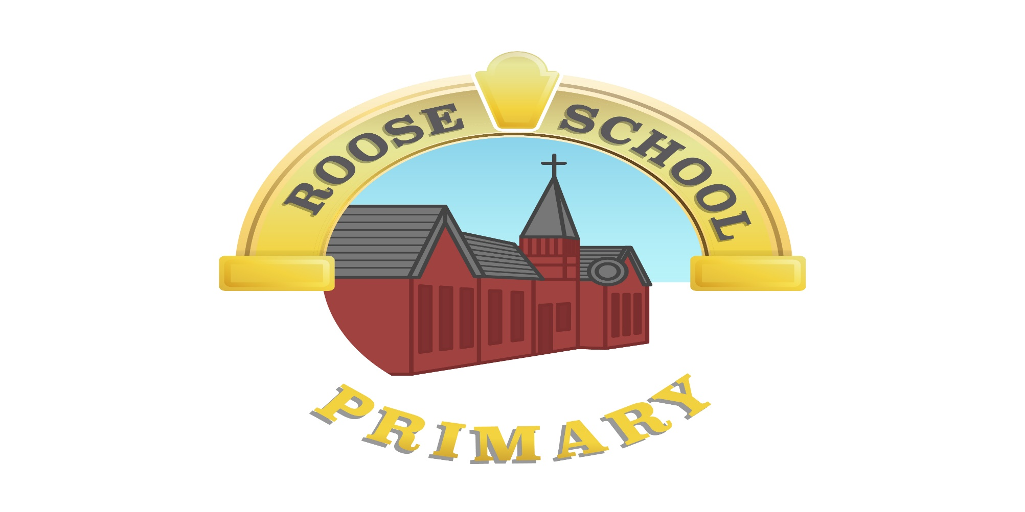

Roose Community Primary School

RE Progression at Roose Primary School

 | Year 1 | Year 2 | Year 3 | Year 4 | Year 5 | Year 6
AF1:  Thinking about Religion and Belief | - Recall features of Religious, spiritual and moral stories and other forms of religious expression  - Recognise and name features of Religions and beliefs | - Retell Religious, spiritual and moral stories  - Identify how Religion and belief is expressed in different ways  - Identify similarities and differences in features of Religions and beliefs | - Make links between beliefs, stories and practices  - Identify the impacts of beliefs and practices on people’s lives  - Identify similarities and differences between Religions and beliefs | - Comment on connections between questions, beliefs, values and practices  - Describe the impact of beliefs and practices on individuals, groups and communities  - Describe similarities and differences within and between Religions and beliefs | - Explain connections between questions, beliefs, values and practices in different belief systems  - Recognise and explain the impact of beliefs and ultimate questions on individuals and communities  - Explain how and why differences in belief are expressed. | - Use Religious and philosophical terminology and concepts to explain religions, beliefs and value systems  - Explain some of the challenges offered by the variety of Religions and beliefs in the contemporary world  - Explain the reasons for, and effects of, diversity within and between Religions, beliefs and cultures.
AF2:  Enquiring, Investigating and Interpreting | - Identify what they find interesting and puzzling in life  - Recognise symbols and other forms of religious expression | - Recognise that some questions about life are difficult to answer  - Ask questions about their own and others’ feelings and experiences  - Identify possible meanings for symbols and other forms of religious expression | - Investigate and connect features of Religions and beliefs  - Ask significant questions about Religions and beliefs  - Describe and suggest meanings for symbols and other forms of Religious expression | - Gather, select, and organise ideas about Religion and belief  - Suggest answers to some questions raised by the study of Religions and beliefs  - Suggest meanings for a range of forms of Religious expression, using appropriate vocabulary | - Suggest lines of enquiry to address questions raised by the study of Religions and beliefs  - Suggest answers to questions raised by the study of Religions and beliefs, using relevant sources and evidence  - Recognise and explain diversity within Religious expression, using appropriate concepts. | - Identify the influences on, and distinguish between, different viewpoints within Religions and beliefs  - Interpret Religions and beliefs from different perspectives  - Interpret the significance and impact of different forms of Religious and spiritual expression

 | Year 1 | Year 2 | Year 3 | Year 4 | Year 5 | Year 6
 | Recount outlines of | Retell Religious stories | Describe some | Describe the key | Explain how some | Make comparisons
 | some Religious stories | and identify some | Religious beliefs and | beliefs and teachings | beliefs and teachings | between the key
 |  | Religious beliefs and | teachings of Religions | of the Religions | are shared by different | beliefs, teachings and
Beliefs and Teachings (What people believe) |  | teachings | studied, and their importance | studied, connecting them accurately with other features of the Religions making some  comparisons between | Religions and how they make a difference to the lives of individuals and communities | practices of the Christian faith and other faiths studied, using a wide range of  appropriate language
 |  |  |  | Religions |  | and vocabulary.
 | Recognise features of | Identify some | Describe how some | Show understanding | Explain how selected | Explain in detail the
 | Religious life and | Religious practices, and | features of Religions | of the ways of | features of Religious | significance of
Practices and Lifestyles (What people do) | practice | know that some are characteristic of more than one Religion | studied are used or exemplified in festivals and practices | belonging to Religions and what these involve | life and practice make a difference to the lives of individuals and communities | Christian practices, and those of other faiths studied, to the lives of individuals and communities.
 | Recognise some | Suggest meanings in | Make links between | Show, using | Explain how some | Compare the different
 | Religious symbols and | Religious symbols, | Religious symbols, | technical | forms of Religious | ways in which people
 | words | language and stories | language and stories | terminology, how | expression are used | of faith communities
Expression and Language (How people express themselves) |  |  | and the beliefs or ideas that underlie them | Religious beliefs, ideas and feelings can be expressed in a variety of forms, giving meanings for some  symbols, stories and | differently by individuals and communities | express their faith.
 |  |  |  | language

 | Identify aspects of | Respond sensitively to | Compare aspects of | Ask questions about | Make informed | Discuss and express
 | own experience and | the experiences and | their own experiences | the significant | responses to | their views on some
 | feelings, in Religious | feelings of others, | and those of others, | experiences of key | questions of identity | fundamental questions
Identity and | material studied | including those with a | identifying what | figures from Religions | and experience in the | of identity, meaning,
Experience |  | faith | influences their lives | studied and suggest | light of their learning | purpose and morality
(Making sense |  |  |  | answers from own and |  | Related to Christianity
of who we are) |  |  |  | others' experiences, including believers |  | and other faiths.
 | Identify things they | Realise that some | Compare their own | Ask questions about | Make informed | Express their views
 | find interesting or | questions that cause | and other people’s | puzzling aspects of life | responses to | on some fundamental
Meaning and Purpose (Making sense of life) | puzzling, in Religious materials studied | people to wonder are difficult to answer | ideas about questions that are difficult to answer | and experiences and suggest answers, making reference to the teaching of Religions studied | questions of meaning and purpose in the light of their learning | questions of identity, meaning, purpose and morality Related to Christianity and other faiths
 | Identify what is of | Respond sensitively to the values and concerns of others, including those with a faith, in Relation to matters of right and wrong | Make links between | Ask questions about | Make informed | Make informed
 | value and concern to |  | values and | matters of right and | responses to people’s | responses to people's
 | themselves, in Religious |  | commitments, | wrong and suggest | values and | values and
Values and Commitment (Making sense of right and wrong) | material studied |  | including Religious ones, and their own attitudes or behaviour | answers that show understanding of moral and Religious issues | commitments (including Religious ones) in the light of their learning | commitments (including Religious ones) in the light of their learning They will use different  techniques to reflect
 |  |  |  |  |  | deeply

Skills and Processes to be developed through Religious Education
Progression in RE depends upon the development of the following generic learning skills applied to RE. These skills should be used in developing a range of activities for pupils to demonstrate their capabilities in RE. They ensure that teachers will move pupils on from knowledge accumulation and work that is merely descriptive to higher-level thinking and more sophisticated skills.

Reflection – this includes:
- Reflecting on feelings, relationships, experience, ultimate questions, beliefs and practices

Empathy – this includes:
- Considering the thoughts, feelings, experiences, attitudes, beliefs and values of others • Developing the ability to identify feelings such as love, wonder, forgiveness and sorrow • Seeing the world through the eyes of others, and seeing issues from their point of view

Investigation – this includes:
- Asking relevant questions
- Knowing how to gather information from a variety of sources
- Knowing what may constitute evidence for justifying beliefs in religion

Interpretation – this includes:
- Drawing meaning from artefacts, works of art, music, poetry and symbolism • Interpreting religious language
- Suggesting meanings of religious texts

Evaluation – this includes:
- Debating issues of religious significance with reference to evidence and argument

Analysis – this includes:
- Distinguishing between opinion and fact
- Distinguishing between the features of different religions

Synthesis – this includes:
- Linking significant features of religion together in a coherent pattern • Connecting different aspects of life into a meaningful whole

Application – this includes:
- Making the association between religion and individual, community, national and international life

Expression – this includes:
- Explaining concepts, rituals and practices
- Expressing religious views, and responding to religious questions through a variety of media

