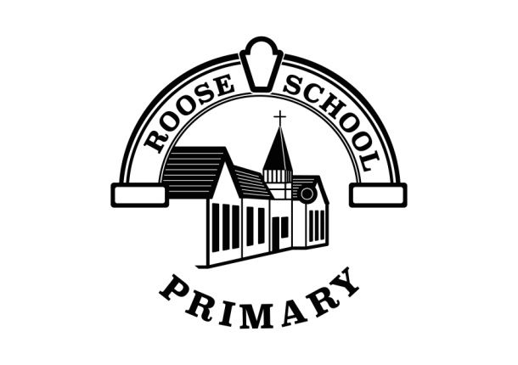
Roose Community Primary School
Religious Education Intent, Implementation and Impact
Intent

At Roose Primary School, we want our children to develop a secure understanding of Christianity and different religions and aim to promote curiosity and a love of learning through enquiry-based objectives. Our intent is to be ambitious with the curriculum, to use artefacts, historical places of worship, and plan activities that help our children to become independent and resilient. We want children to be not only equipped with the minimum statutory requirements of the Cumbria locally agreed syllabus for religious Education, but also prepared for the opportunities, responsibilities and experiences of later life. Through Religious Education we aim to develop pupils’ respect for all, educating our children to be tolerant and valued members of the community. Our R.E. curriculum supports our children to develop their own set of values and challenge negative opinions and actions, recognising diversity, respecting other’s viewpoints and developing tolerance of others outside of their community.

Implementation

At Roose Primary School, we use the ‘Discovery Programme’ as the basis for our teaching, which also covers the Cumbria locally agreed syllabus and the flowing religions have been selected for study:
Christianity
Judaism
Buddhism
Islam
Sikhism
Hinduism
This programme supports our enquiry-based learning to study the key traditions and beliefs of world religions. Children are taught to understand and respect the importance of religious beliefs in the world around them. The syllabus aims to allow pupils to explore themes and concepts within religion, drawing on beliefs from a range of different faiths and world views. We aim to ensure that the RE curriculum is challenging, dynamic and relevant to pupils of all ages – that is why an enquiry approach was implemented, encouraging higher-order thinking and allowing our children to explore in a way that is meaningful to them.

Impact

The pupils are assessed against the performance descriptors for each year group which have been carefully mapped out ensuring the skills in Religious Education are progressive. Assessment information is used to inform further curriculum developments and provision is adapted accordingly.

