We will email a list of activities for you to work through each week. If you want to email back examples of work or photos, it would be lovely to see some but we don’t need evidence of everything being done!
Keeping everyone healthy, safe and happy are the most important things.
e-mail: angela@roose.cumbria.sch.uk
Weekly Maths Tasks | Weekly Reading Tasks
- Working on Numbots/TTRockstars - your child will have an individual login to access this on the password protected page of the school website.  - If working on TTRockstars, they will need to log in and play their gig first.  - Play on Hit the Button - number bonds, halves, doubles and x2, x5 and x10 times tables.  - Recognise, find and write fractions for 1/3  1/4, 2/4, and 3/4 of a length. Go to:  https://whiterosemaths.com/homelearning/  year-2/  - Working from White Rose Maths Summer Term Week 1. These are tutor-based lessons for each day and answers are provided on the same page. Your child should be familiar with this learning as we used it in the classroom last term. | - Reading a variety of books at home. Your child could share a book everyday by reading aloud or they could share a book with an adult and talk about what they have read with them.  - Visit Storyline Online: https.www.youtube.com/watch?v=6s7aSNUCkiM&vl=en  and listen to ‘When a Dragon Moves in’ by Jodi Moore and read by Marc Duplass.  - Read a selection of books suitable for your child’s reading level online here - https://home.oxfordowl.co.uk/ you will need to register for free and then choose books suitable for your child.
Weekly Phonics/Spellings  Tasks | Weekly Writing Tasks
- The spellings this week are the /l/or /ɘl/ sound spelt le at the end of words  - Practise this week’s words using LSCWC grids sent with email.  - table  - apple  - bottle  - little  - middle  - example  - battle  - terrible  - struggle  - possible  - Interactive games found on link below.  - Phonics play to revise Phase 5  - Top Marks  - Spell common exception words  - Spelling City (there are some free activities available on this site). | - Look at the story of ‘When a Dragon Moves In’ again.  - Ask your child to write sentences about the exciting things they would do if they had a pet dragon. What would they teach him? Encourage your child to use as many adjectives (describing words) that they can to make their writing interesting.  - Our book this week is about friendship, imagination and family.  - Ask your child to write a new adventure story about their dragon for the whole family.  - Ask your child to write a letter or a postcard to a family member or a friend who they are not seeing at the moment telling them all about the things they will do when they meet up again.
On-going activities to choose from:
Science Activities 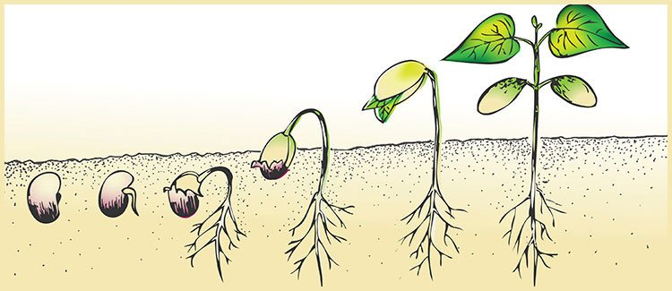

- In Science our topic is Plants where we will be finding out how plants need water, light and a suitable temperature to grow.
- Ask your child to look out for plants when they are walking or when they are in the garden.
- Get your child to draw pictures of the plants they find. They could use the internet to try and name them.
- Can they label the different parts that the plant has? Petals and stem for example?
- Go on Purple Mash on the learning wall: Go Home – Science – Plants and there are 3 paint projects on the page where your child can paint their own garden, flower of three flowers.
- In the weeks to come, try and plant some seeds and look after them and watch how they grow.
- Keep a diary of any seeds planted. A diary template has been included with the email.

Geography
- Look at The Lake District power point/PDF and locate The Lake District National park on a map of the UK.
- Design an information poster about The Lake District and all the important facts that they have found. Make sure to make it interesting, colourful and explain why people like to go there.

Art/ Craft Activities
- Draw and colour a picture of your very own dragon.
- Design a new castle/home that both you and your dragon could live in.
- Create a new meal for your dragon. Could you use any of the plants that you have found when out walking or in your garden?

Extra Activities
- There is also a workbook on the school website that can be downloaded and has lots of different activities that your child could choose from. There are lots of good activities in it which should last for a few weeks.

Additional support
If you have any problems at all accessing any of the websites, need a little more explanation please do not hesitate to contact me by email. Stay safe and take care.

